Chitosan Delaying Human Fibroblast Senescence through Downregulation of TGF-β Signaling Pathway
Tai-Horng Young, Institute of Biomedical Engineering, National Taiwan University, Taiwan

Abstract
This study evaluated the effect of chitosan, poly vinyl alcohol (PVA) and poly (2-hydroxyethyl methacrylate) (pHEMA) on delaying the human fibroblast senescence. Cells could form suspending multicellular spheroids on these biomaterials, but only chitosan was capable of decreasing the SA β-gal activity and increasing the proliferation ability of senescent fibroblasts. Therefore, in addition to the structure of multicellular spheroids, chitosan itself should play an important role in delaying fibroblast senescence. The main difference of senescence-related protein expressions for cells cultured on chitosan, PVA and pHEMA occurred on the TGF-β signaling pathway. In addition to the intracellular TGF-β expression, the extracellular TGF-β expression was also downregulated. Chitosan with cationic amino structure was assumed to bind with anionic TGF-β by forming polyelectrolyte complexes. This assumption was demonstrated by directly adding chitosan into the medium to downregulate the cell TGF-β expression and further to delay cell senescence, indicating TGF-β signaling pathway was involved in the chitosan-mediating fibroblast senescence process. Finally, the delaying cell senescence ability of chitosan increased with increasing the amount of amino groups in chitosan and its ionization degree. In summary, these results provide important information for considering the application of chitosan in the future cell therapy and regeneration medicine.

Image

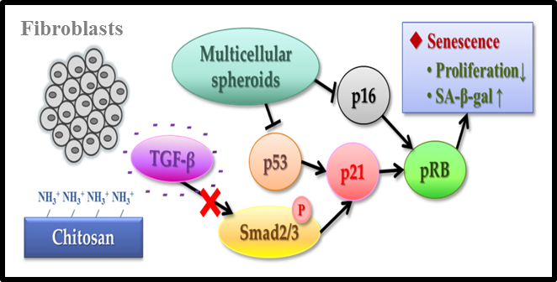

Fig.1 The diagram of chitosan affecting senescent-related pathways

Recent Publications
- CH Chang, D Mau-Hsu, KC Chen, CW Wei, CY Chiu, TH Young, Evaluation of digital real-time PCR assay as a molecular diagnostic tool for single-cell analysis, Sci. Rep., 8 (2018) 3432.
- CW Tsai, TH Young, CD44 expression trends of mesenchymal stem-derived cell, cancer cell and fibroblast spheroids on chitosan-coated surfaces, Pure. Appl. Chem., 88 (2016) 843-852.
- CW Tsai, YT Kao, IN Chiang, JH Wang, TH Young, Chitosan treatment delays the induction of senescence in human foreskin fibroblast strains, PLoS One, 10 (2015), e0140747.
- YH Chen, SH Chang, TJ Wang, IJ Wang, TH Young, Cell fractionation on pH-responsive chitosan surface, Biomaterials, 34 (2013) 854-863.
- PJ Lou, MY Chiu, CC Chou, BW Liao, TH Young, The effect of poly (ethylene-co-vinyl alcohol) on senescence-associated alterations of human dermal fibroblasts, Biomaterials, 31 (2010) 1568-1577.



Tai-Horng Young is currently Professor at National Taiwan University (NTU) in Taipei, Taiwan. Since 2000 he was a Full Professor at the Institute of Biomedical Engineering, National Taiwan University. He received several awards, including Outstanding Research Award of National Science Council, and has been Chair Professor of National Taiwan University since 2007. From 2008 to 2011, he served as the director of Institute of Biomedical Engineering, National Taiwan University. He has been a member of many academic societies and has been selected as the president of Formosa Association of Regenerative Medicine (2012-2016).
Email: thyoung@ntu.edu.tw

