P-type Cu₂O-based heterojunction solar cells fabricated with n-type ZnO thin film prepared by electrochemical deposition method.
Toshihiro Miyata, Dr. of Eng. Kanazawa Institute of Technology, Japan
Hiroki Tokunaga, B. of Eng. Kanazawa Institute of Technology, Japan
Tadatsugu Minami Dr. of Eng Kanazawa Institute of
Technology, Japa
Recently, substantially improved conversion efficiency has been reported in p-type Cu₂O sheet-based heterojunction solar cells with n-type oxide semiconductor thin films prepared by the pulsed laser deposition (PLD) method.¹⁻⁵ However, PLD has some disadvantages as a practical preparation method, such as low deposition rate, small deposition area, and high cost. On the other hand, the electrochemical deposition (ECD) method is a deposition technique that has potential to solve these problems. This paper describes the fabrication of Cu₂O-based heterojunction solar cells using n-type ZnO thin film prepared by the ECD method. The n-type ZnO thin film layer was prepared on a p-type Cu₂O:Na sheet using the following ECD process. Initially, a zinc nitrate aqueous solution was prepared with 0.22 M zinc nitrate and de-ionized water; after that, a 0.3 M HCl or 0.1 M KOH aqueous solution was added to adjust the pH. Next, a p-Cu₂O:Na sheet was immersed in the above solution.
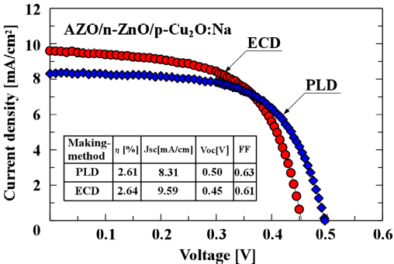
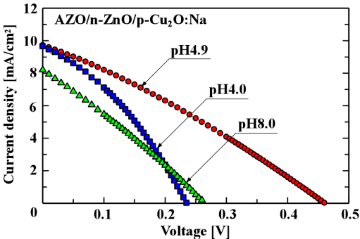
The photovoltaic properties were strongly dependent on the fabrication conditions of n-type ZnO thin films. For example, the current density-voltage (J-V) characteristics of AZO/n-ZnO/p-Cu₂O:Na solar cells showed strong dependence on the pH of the zinc acetate aqueous solution, obtaining significant improvement with a pH value of 4.9 (Fig.1). Figure 2 shows typical J-V characteristics for AZO/n-ZnO/p-Cu₂O solar cells prepared under optimized deposition conditions, such as film thickness of the n-ZnO thin film. The same structure of a Cu₂O heterojunction solar cell using n-type ZnO thin films was prepared by PLD, and the J-V characteristics are also shown in Fig. 2. It should be noted that the J-V characteristics of the AZO/n-ZnO/p-Cu₂O solar cells were the same as those when using the PLD method.

Fig. 2 Typical J-V characteristics of AZO/n-ZnO /p-Cu₂O heterojunction solar cell under optimized preparation conditions
Fig. 1 pH dependence of zinc acetate aqueous solution for J-V characteristics of AZO/n-ZnO/p-Cu₂O:Na solar cells

Recent Publications
1. T. Minami, J. Yamazaki, T. Miyata (2016) Efficiency enhanced solar cells with a Cu₂O homojunction grown epitaxially on p-Cu₂O:Na sheets by electrochemical deposition. MRS Communications 6: 416-420.
2. Y. Nishi, T. Miyata, T. Minami (2016) Electrochemically deposited Cu₂O thin films on thermally oxidized Cu₂O sheets for solar cell applications. Solar Energy Materials and Solar Cells 155:405-410.
3. T. Minami, T. Miyata, Y. Nishi (2016) Relationship between the electrical properties of the n-oxide and p-Cu₂O layers and the photovoltaic properties of Cu₂O-based heterojunction solar cells. Solar Energy Materials and Solar Cells 147:85-93.
4. T. Minami, T. Miyata, Y. Nishi (2014) Cu₂O-based heterojunction solar cells with an Al-doped ZnO/oxide semiconductor/thermally oxidized Cu₂O sheet structure. Solar Energy, 105:206-217.
5. T. Minami, T. Miyata, Y. Nishi (2014) Efficiency improvement of Cu₂O-based heterojunction solar cells fabricated using thermally oxidized copper sheets. Thin Solid Films 559:105-111.



Biography
Toshihiro Miyata is a professor at the Kanazawa Institute of Technology (KIT) in Japan, and a researcher of the Optoelectronic Device System R&D Center at KIT, where his interests center on optoelectronic devices, especially solar cells using Cu₂O. Toshihiro Miyata received his B.E. degree in electronics engineering from KIT in 1987, and his M.E. and doctor of engineering degrees from the KIT in 1989 and 1992, respectively. From 1992 to 1993, he was visiting scientist at the Micro Systems Technology Laboratory at MIT, USA..
Email:tmiyata@neptune.kanazawa-it.ac.jp

Notes/Comments:

