Realization of Conductive Aluminum Nitride Epitaxial Layer on Silicon Substrate by Forming Spontaneous Nano Size Via-holes
Kurose N Dr., Aoyagi Y Prof.,
Ritsumeikan University, Japan

Abstract
Statement of the Problem: The n-type aluminum gallium nitride (n-AlGaN) vertical field effect transistors on a Si substrate are promising devices for future super high power devices beyond Si, SiC and GaN devices currently being developed. The AlN buffer layer is indispensable for the growth of AlGaN epitaxial layer on the Si substrate. However, the AlN is an insulating material and we could not flow current through the buffer layer. We report formation of the conductive AlN buffer layer (hereafter v-AlN) and details of the formation mechanism of the v-AlN. Methodology: The v-AlN is grown on the Si substrate using metal organic chemical vapor deposition (MOCVD). Al metal dots are grown on the substrate to form Al-Si alloy dots with successive growth of AlN buffer layer. Spontaneous nano size via-holes (hereafter via-holes) are formed in AlN buffer layer due to the surface energy difference of Si and Si-Al alloy. The n-AlGaN is grown on it to fill out the via-holes. The conductive AlN buffer layer with via-holes is formed. Findings: We have converted the insulating AlN buffer layer to conductive one by forming cluster of via-holes in the buffer layer filled with n-AlGaN during the crystal growth. The size of the cluster and the density are controlled and are 0.2~1µm^{Φ} and 10⁷~10⁸/cm², respectively. The current flows through these clusters filled with n-AlGaN. The mirror like n-AlGaN epitaxial layer was successfully grown on it. It is confirmed that the vertical resistivity through the conductive AlN buffer layer was 0.2Ω/cm² which is about 10⁴ times smaller than that of conventional AlN. Conclusion & Significance: We have succeeded in growing the conductive AlN buffer layer on the Si substrate. Our technique and findings open a way to make vertical high power AlGaN FETs, UV-LEDs, UV sensors on the Si substrate and to realize Si-on-chip devices.

Image

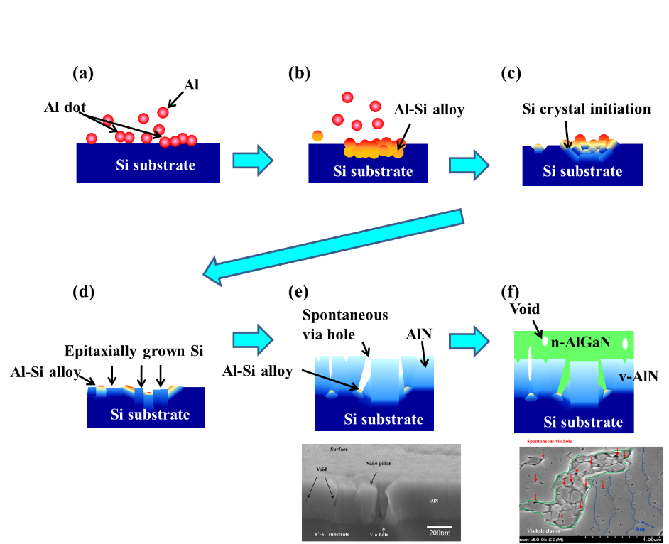

Figure 1 Steps of the formation of spontaneous via-holes.
At the beginning stage of the growth, a small amount of Tri-methyl Aluminum (TMA) is fed on the Si substrate to form small size Al dots (a). The Al embedded on the Si substrate interacts with the Si substrate to generate Al-Si alloy dots (b) during the Al feeding time and during the increase of temperature. At a Si content of approximately 35% β solid phase Si recrystallization is initiated as understood from the phase diagram of Si-Al alloy(c) and Si is epitaxially grown in the Al-Si alloy dots as shown in (d). No AIN growth occurs on the Al-Si alloy surface because of the difference of surface energy of Si and Si-Al alloy. Thus, via-holes of AlN are formed in the area where the Al dots are formed (e). A scanning electron microscope (SEM) image of via-holes is shown underneath of (e). Conductive n-AlGaN is filled in these via-holes by successive growth of n-AlGaN as shown in (f). Nano cluster via-holes observed by SEM is shown underneath of (f).

Recent Publications
- Kurose N, Matumato K, Yamada F, Roffi T. M, Kamiya I, Iwata N, Aoyagi Y (2018) Laser induced local activation of Mg-doped GaN with high lateral resolution for high power vertical devices. AIP Advances 8: 015329-1-015329-5.
- Kurose N, Aoyagi Y (2016) Development of high power, large area, deep ultraviolet light emitting devices using dynamic microplasma excitation (MIPE) of AlGaN multiple quantum wells. Electronics and Communications in Japan 99:3-11.
- Kurose N, Iwata N, Kamiya I, Aoyagi Y (2014) Formation of conductive spontaneous via holes in AlN buffer layer on n+Si substrate by filling the vias with n-AlGaN by metal organic chemical vapor deposition and application to vertical deep ultraviolet photo-sensor. AIP Advances 4: 123007-1-123007-7.
- Kurose N, Shibano K, Araki T, Aoyagi Y (2014) Development of substrate-removal-free vertical ultraviolet light-emitting diode (RefV-LED). AIP Advances 4: 027122-1-027122-6.
- Aoyagi Y, Kurose N (2013) A 2-inch, large-size deep ultraviolet light-emitting device using dynamically controlled micro-plasma-excited AlGaN. Applied Physics Letters 102: 041114-1-041114-3.

Biography
Noriko Kurose has her expertise in crystal growth engineering of nitride semiconductor using metal organic chemical vapor deposition to control the material properties. She found an insulating material can be converted to conductive one by introducing nano via-holes spontaneously inside the insulator using a crystal growth technique and she has clarified the conversion mechanism. Her invention opens a way to fabricate various vertical devices on Si substrate and Si-on-chip devices. Actually, she has succeeded in fabricating a vertical UV-LED and a vertical UV sensor using her technology. In addition she has succeeded in fabricating large area panel type micro-plasma-excited DUV light emitting devices with a size of more than 2 inches. She has invited to present her works in many international conferences.

Email: kurose@fc.ritsumei.ac.jp

Notes/Comments:

