A new laser induced local material engineering to convert from n-type to p-type nitride semiconductor to fabricate high power vertical AlGaN/GaN devices on Si substrate
Aoyagi Y Prof., Kurose N Dr.
Ritsumeikan University, Japan
Matsumoto K , Iwata T Prof., Kamiya I Prof.
Toyota Technological Institute, Japan

Abstract
Statement of the Problem: The n-type aluminum gallium nitride (n-AlGaN) vertical field effect transistors (FETs) are promising devices for future super high power FET electronics beyond Si, SiC and GaN devices. To realize n-AlGaN vertical FETs with carrier blocking layer to concentrate the current flow into the vertical channel region, the local p-type AlGaN formation is indispensable. So far, to realize this local p-type layer, crystal regrowth technique with lithography is carried out but this process is complicated and reduces the crystal quality. To proceed local carrier type conversion from n-type to p-type without any crystal regrowth method, the carrier blocking layer can be easily produced without any crystal damages. Methodology: We used an excimer laser (193nm) as an irradiation source for material engineering. The irradiation system has a scanning system of the sample to control the irradiation area and an in-situ monitoring system to observe the material surface during the laser irradiation. The material characteristics are observed using Hall effects, Kelvin probe and optical microscope measurement. Findings: We found the insulating or n-type as- grown Mg-doped GaN (Mg:GaN) was converted to p-type GaN (p-GaN) under a proper laser irradiation condition only at the specific local area of the laser irradiation. The lateral resolution for transition from the Mg:GaN to p-type was about 1 µm. The surface has no damage under the irradiation. Conclusion and Significance: A new technique has been established. This has achieved local activation of Mg:GaN to p-type GaN using the laser irradiation co-operated with in-situ observations of the surface during the laser processing. Using this method, local activation of carriers with the lateral resolution of about 1 µm is possible, thus establishing the potential for fabricating local p-GaN carrier blocking layer and vertical high-power devices without using any other fabrication techniques such as crystal regrowth.

Image

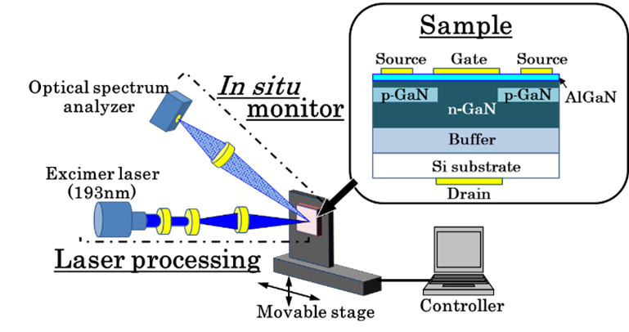

Figure 1. Experimental setup and sample to be converted locally from n type to p-type GaN.

The sample placed on the X–Y stage was scanned using a controller. The PL and scattered light from the processing region of the GaN were monitored in-situ to feed the actual irradiation conditions back to the laser. The inset shows a schematic view of a vertical FET with a p-GaN carrier-blocking layer which is locally converted from n-GaN by our method.

Recent Publications
- Tanaka, S, Iwai S, Aoyagi Y (1996) Self-assembling GaN quantum dots on AlxGa1-xN surfaces using a surfactant.
Appl. Phys. Lett. 69: 4096-4098.
- Tanaka S, Takeuchi M, Aoyagi Y (2000) Anti-surfactant in III-nitride epitaxy - Quantum dot formation and dislocation termination. Jpn. J. Appl. Phys. 39: L831-L834.
- Aoki K, Miyazaki H T, Hirayama H, Inoshita K, Baba T, Sakoda K, Shinya N, Aoyagi Y (2003) Microassembly of semiconductor three-dimensional photonic crystals. Nature Materials 2: 117-121.
- Matsuda K, Saiki T, Nomura S, Mihara M, Aoyagi Y, Nair S, Takagahara T (2003) Near-field optical mapping of exciton wave functions in a GaAs quantum dot. Phys. Rev. Lett. 91: 177401-1-177401-4.
- Aoyagi Y, Kurose N (2013) A 2-inch, large-size deep ultraviolet light-emitting device using dynamically controlled micro-plasma-excited AlGaN. Applied Physics Letters 102: 041114-1-041114-3.

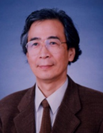Biography
Yoshinobu Aoyagi has his expertise in nano technology and creation of advanced materials for developing new devices. Recent his work is a discovery of anti-surfactant phenomena to create spontaneously GaN quantum dots even on the lattice matched substrate, for example GaN quantum dots on a GaN substrate which is impossible under common crystal growth condition. He has also succeeded in developing a new technology to fabricate a 3D photonic crystal, DUV LED, a large scale DUV light emitter of more than 2 inches size. Laser processing is also his another main work. He has also succeeded in pioneer works on laser induced atomic layer deposition and atomic layer etching at the beginning stage of the research. He published more than 500 articles in scientific journals and presented a lot of invited talks..

Email: yaoyagi@gst.ritsumei.ac.jp

Notes/Comments:

