Synthesis of 2D layered Semiconductor GaSe for the application of Terahertz Non-Destructive Inspection
Yutaka Oyama, Dep. MS&E, Tohoku University, Sendai 980-8579, Japan

Abstract

Terahertz (THz) wave has both superior characteristics of radio wave and light, in which high permeability for non-polar materials and efficient reflection from metal surface are principal features. Thus THz wave reflected from the opaque coated metal surface can be used for nondestructive testing (NDT). In addition, specific inter-molecular vibrations (finger print spectra) of soft and hard materials are appeared in THz frequency region. We have developed various THz wave generators by careful control of lattice vibrations in semiconducting GaSe crystals.

THz wave has low quantum photon energy, thus it is safe for human tissues even for radiation. We have established a database of terahertz permeability characteristics for industrial materials, and successfully constructed non-destructive THz diagnosis of building blocks, polymers[1], insulated copper cable and hot-dip galvanized steel sheet etc[2].

For the efficient THz light sources, two-dimensional (2D) layered GaSe has been attracted much interest because of its superior crystallographic, optical features and even for spintronics[3]. Layered crystals combine thin sheets by out-of-plane van der Waals interactions. For the use of practical applications, mechanical strength needs to be improved. However, no direct experimental determination has been performed up to now for van der Waals bonding energy. In our group, a precise tensile testing machine was constructed for the quantitative determination of the interlayer van der Waals bonding force [4].

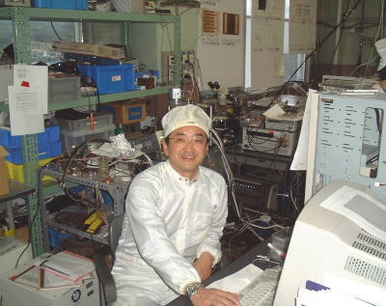
In this study, low temperature liquid phase growth of GaSe and its characterization are shown with the improvement of Van der Waals bonding energy by the addition of Te and In. Then, some killer applications of THz wave for the health evaluation of infrastructures will be shown[5].
Image
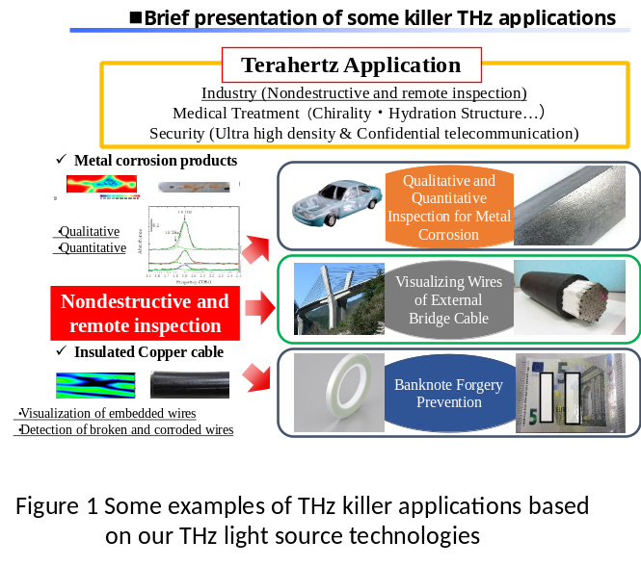
Recent Publications
- Tanabe T,Watanabe K,Oyama Y,Seo K (2010) Polarization sensitive THz absorption spectroscopy for the evaluation of uniaxially deformed ultra-high molecular weight polyethylene. NDT&E International 43 329-333.
- Hasegawa R,Kimura T,Tanabe T,Nishihara K,Taniyama A,Oyama Y (2018) Analysis of the specific vibration modes of goethite (α-FeOOH) by terahertz spectroscopy and calculations of the vibration frequencies of a single molecule using density functional theory. Journal of Biomedical Graphics and Computing 8(1) 29-34.
- Takasuna S,Shiogai J,Matsuzaka S,Kohda M,Oyama Y,Nitta J (2017) Weak antilocalization induced by Rashba spin-orbit interaction in layered III-VI compound semiconductor GaSe thin films. Phys. Rev. B,96 161303(R).
- Tanabe T, Zhao S, Sato Y,Oyama Y (2017) Effect of adding Te to layered GaSe crystals to increase the van der Waals bonding force. Journal of Applied Physics 122(16) 165105
- Takahashi S,Hamano T,Nakajima K,Tanabe T,Oyama Y (2014) Observation of damage in insulated copper cables by THz imaging NDT&E International 61 75-79.

Biography
Yutaka Oyama was born in Sendai, Japan. He received the B.S., M.S., and Ph.D. degrees in electronics from Tohoku University, Japan. He was a Researcher with the Semiconductor Research Institute (SRI) in Japan and became a Senior Researcher with SRI. He was a Group Leader of the Nishizawa Teraherz Project of the Research Development Corp. of Japan (JRDC). He has been an Associate Professor, and Professor with Materials Science and Engineering, Graduate School of Engineering, Tohoku University. He was a visiting researcher with IHP (Institute fur halpleiter physik) at Frankfurt (Oder) Germany, and also EPFL (École polytechnique fédérale de Lausanne) at Lausanne Swiss. He is the author or coauthor of over 300 international journal and conference publications on material science and its application for ultrafast semiconductor devices.
Email: oyama@material.tohoku.ac.jp
Notes/Comments

