Growth of Single Wall Carbon Nanotubes (SWCNTs) by PECVD Technique for Gas Sensing and Field Emission Applications
Mohd Yaseen Lone¹, Avshish Kumar², M. Zulfequar¹, Ravi Chand Singh³, Mushahid Husain^{1,#}
¹Department of Physics, Jamia Millia Islamia, New Delhi-110025, India
²Department of Physics, Guru Nanak Dev University, Amritsar 143005, India
# Corresponding author: yaseenlone786@gmail.com

Abstract
Gas sensors are getting much attention and are being highly focussed by scientific community in the field of nanoscience and nanotechnology since last decade. A good sensor must possess high sensitivity, high selectivity, and good response recovery characteristics. The existing sensors may lack in one of the property or another and are being operated at high temperature. To obtain such a highly modified and efficient sensor is very difficult task. However, we have approached our best to design and fabricate the best possible gas sensor. For this approach we have grown single walled carbon nanotubes (SWCNTs) on Fe based silicon substrate by plasma enhanced chemical vapour deposition (PECVD) technique at low temperature 650⁰C with optimization of parameters like temperature, pressure and deposition time. From the as grown SWCNTs, SWCNT gas sensors have been fabricated with gold electrodes having distance 2mm. The as grown SWCNTs have been properly investigated by field emission scanning electron microscope (FESEM), High resolution transmission electron microscope (HRTEM) and Raman spectroscopy. The as fabricated SWCNT gas sensors have been tested on the exposure of ammonia (NH₃) gas in a self-assembled apparatus. All the characteristics of the sensor like sensor response, recovery time, repeatability, selectivity, effect of concentration and temperature has been investigated at room temperature. In addition of this, we have also investigated the field emission properties of as grown SWCNTs. High value of current density at low turn on voltage has been observed. The higher value of field enhancement factor has also been calculated.
Keywords—Keywords-SWCNTs, RF-Sputtering, PECVD, FESEM, HRTEM, Raman Spectroscopy.

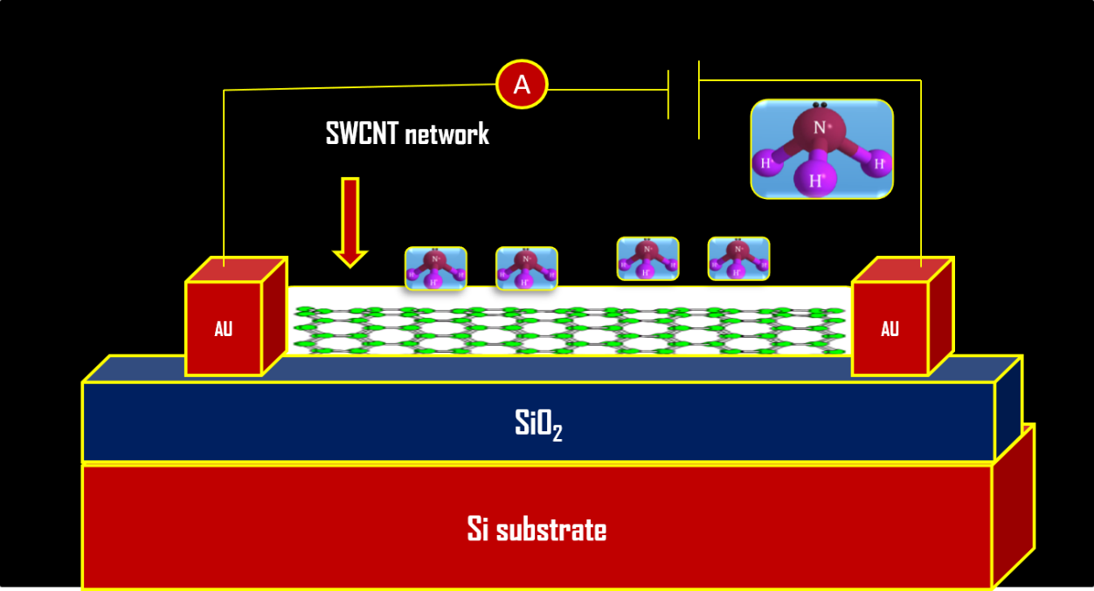

Fig.1. SWCNT Sensor
Recent Publications (minimum 5)
- “Enhancement of Sensor Response of as Fabricated SWCNT Sensor with Gold Decorated Nanoparticles”
Mohd Yaseen Lone, Avshish Kumar, Samina Husain, Mohammad Zulfequar and Mushahid, Sensors and Actuators A 274, , (2018) 85-93.
- “Growth of Carbon Nanotubes by PECVD and its Applications: A Review”
Mohd Yaseen Lone, Avshish Kumar, Samina Husain, Mohammad Zulfequar and M. Hushahid, Current Nanoscience 13 (2017) 1-11.
- “Growth of single wall carbon nanotubes using PECVD technique: An eﬃcient chemiresistor gas sensor” Physica E 87 (2017) 261–265.
- “Selective Growth of Single Wall Carbon Nanotubes Uniformly Grown by PECVD Technique”
Mohd Yaseen Lone, Avshish Kumar, Shama Parveen, Samina Husain, Mohammad Zulfequar, Mushahid Husain, Advance Science Letters, 21, (2015) 2887-2890.

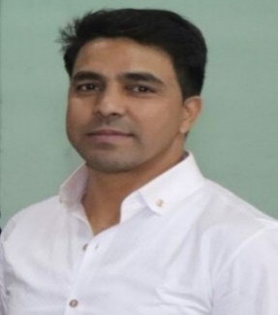

Biography
- Mohd Yaseen Lone has completed his M.sc and M.Phil with first division from Barkatullah University Bhopal (M.P) India and has completed his Ph.D in Physics (Nanotechnology) from Jamia Millia Islamia New Delhi India. His area of interest is Synthesis, Characterization of Single Wall Carbon Nanotubes by PECVD Technique and their Gas Sensor and Field Emission applications.
Email: yaseenlone786@gmail.com

