MB-UiO-66-NH2 Metal-Organic Framework as Chromogenic and Fluorogenic Sensor for Hydrazine Hydrate in Aqueous Solution
Aasif Helal, PhD, Center of Research Excellence in Nanotechnology, King Fahd University of Petroleum and Minerals, Saudi Arabia.

Abstract (300 word limit)
Zirconium(IV)-based MOFs UiO-66-NH₂ and UiO-66-NH₂ encapsulated with methylene blue (MB) MB-UiO-66- NH₂ were successfully prepared using a facile solvothermal method and were characterized by X-ray diffraction (XRD), transmission electron microscopy (TEM), field emission scanning electron microscopy (FESEM), nitrogen physisorption analysis (BET), and X-ray and photoelectron spectroscopy(XPS). Both the materials were 60–80 nm size and had large surface areas. MB-UiO-66- NH₂ appears to be a potential candidate for the sensing of hydrazine hydrate. Selective chemically reversible changes in both the chromogenic and fluorogenic characteristics of MB-UiO-66- NH₂ were observed upon treatment with hydrazine hydrate in an aqueous solution. The change in the photophysical properties of the MB-UiO-66-NH₂ was attributed to the selective conversion of methylene-blue-encapsulated UiO-66-NH₂ to leucomethylene blue (LB) after the addition of hydrazine hydrate to the aqueous solution. The hydrazine hydrate detection limit for MB-UiO-66- NH₂ was found to be 0.012 ppm in the aqueous solution.

Image

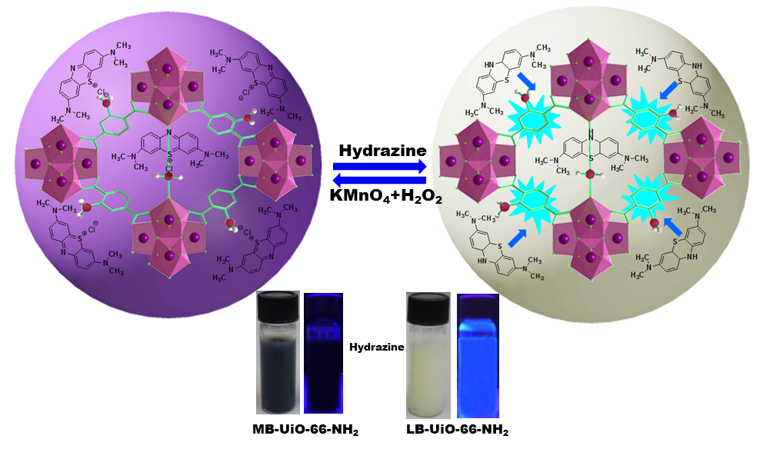

Recent Publications (minimum 5)
- Lima C, Seo H, Choi JH, Kim KS, Helal A, Kim HS (2018) Highly selective fluorescent probe for switch-on Al³⁺ detection and switch-off F⁻ detection. Journal Photochemistry Photobiology A 356:312–320.

- Shaikh MN, Aziz MA, Helal A, Kalanthoden AN, Yamani ZH (2017) PdNPs@ZIF-​8 Micro-​Nanostructured Catalyst of Regioselective Mizoriki-​Heck Olefination. ChemistrySelect 2:9052-9057.

- Helal A, Qamaruddin M, Aziz MA, Shaikh MN, Yamani ZH (2017) MB-​UiO-​66-​NH₂ Metal-​Organic Framework as Chromogenic and Fluorogenic Sensor for Hydrazine Hydrate in Aqueous Solution. ChemistrySelect 2:7630-7636.

- Helal A, Yamani Z H, Cordova KE, Yaghi OM (2017) Multivariate metal-organic frameworks. National Science Review 4:296-298.

- Trickett CA, Helal A, Al-Maythalony BA, Yamani ZH, Cordova KE, Yaghi OM (2017) The chemistry of metal-​organic frameworks for CO₂ capture, regeneration and conversion. Nature Review Materials 2:17045.

Biography (150 word limit)
Dr. Aasif Helal completed his PhD in 2010 in “Synthesis and Ion Sensing Properties of Thiazole based Receptors” from Kyungpook National University, South Korea in applied organic chemistry. The same year he was awarded “Best Researcher of the year 2009” by Kyungpook National University. In August 2012 he joined Department of Material Science and Engineering at Seoul National University of Seoul, South Korea as a Post-Doctoral Fellow for “the synthesis of novel molecular materials and metal organic frameworks and their application in Organic Solar Cells, and sensors”. In December 2013 he joined CENT as Research Scientist III. His research interests include design and synthesis of novel organic molecular materials, and metal organic framework as sensors, carbon capture and catalysts. Modification and functionalization of nanomater​ials for tuning their photophysical and other properties.
Email: aasifh@kfupm.edu.sa

Notes/Comments:

