Driving Flexible Electronics by Hybrid Materials
Rodrigo Martins and Elvira Fortunato
CENIMAT/i3N and CEMOP-UNINOVA, Departamento de Ciência dos Materiais, Faculdade de Ciências e Tecnologia, Universidade NOVA de Lisboa, Campus de Caparica, 2829-516 Caparica, Portugal

Abstract
Printable electronics and flexible electronics are key areas of development worldwide, once offer the potential to add functionality to everyday objects at very low costs that would be difficult with conventional technologies. This was pushed by the large success of organic electronics over the past few decades due to their attractive features such as low process temperatures, good mechanical flexibility, light weigh and the possibility to use a wide range of substrates and being recyclable. Besides that we can prepare these devices using inexpensive solution processes over large areas. These benefits offered by printable and embedded electronics have being recognized in many sectors. Nevertheless the bottleneck here is the low electronics performances so far achieved.
On the other hand, metal oxide electronic materials are quite attractive since they are reliable, able to be processed at low temperatures and present excellent electronics performances at 1-2D scales, providing so a large variety of different and possible applications, going from low costs to high complex systems able to compete with silicon in applications like transparent electronics, optoelectronics, magneto electronics, photonics, spintronics, thermoelectrics, piezoelectrics, power harvesting, hydrogen storage and environmental waste management.
In terms of production techniques RF magnetron sputtering has been well established and has demonstrated high performance devices, as ALD. However these require complex equipment’s, especially if we are targeting low cost applications. In contrast, the solution process has many advantages such as large-area deposition, roll-to-roll capability, and easy control of composition, atmospheric processing, and low cost.
In parallel we have been observing a rapid and growing interest concerning the utilization of biological materials for a wide range of applications. One of the most representative example is cellulose, not only in the form of raw material mainly for pulp and paper production, but also in the development of advanced materials/products with tailor-made properties, especially the ones based on nanostructures, for low cost and disposable applications. In this presentation we will review the main applications of vegetal and bacterial cellulose in electronics, either as substrate (passive) or as a real electronic material (active), taking into account the expertise as well as the major developments already done at CENIMAT|i3N in the area of Paper Electronics.

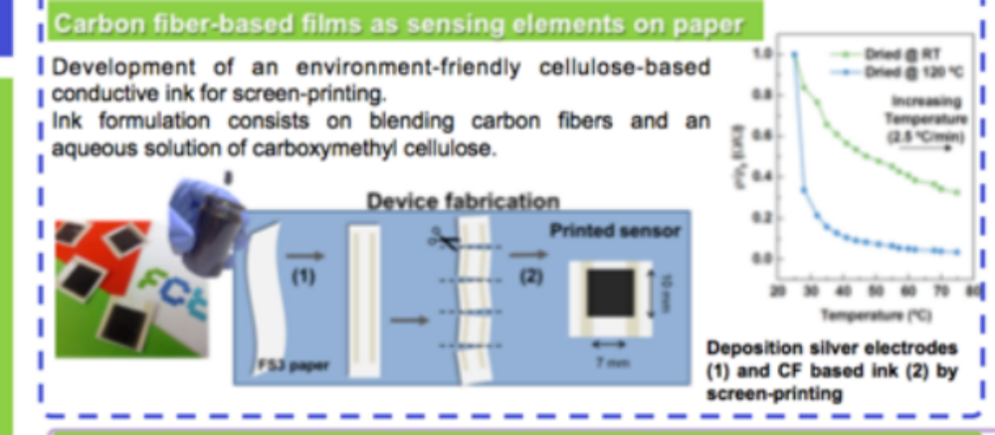
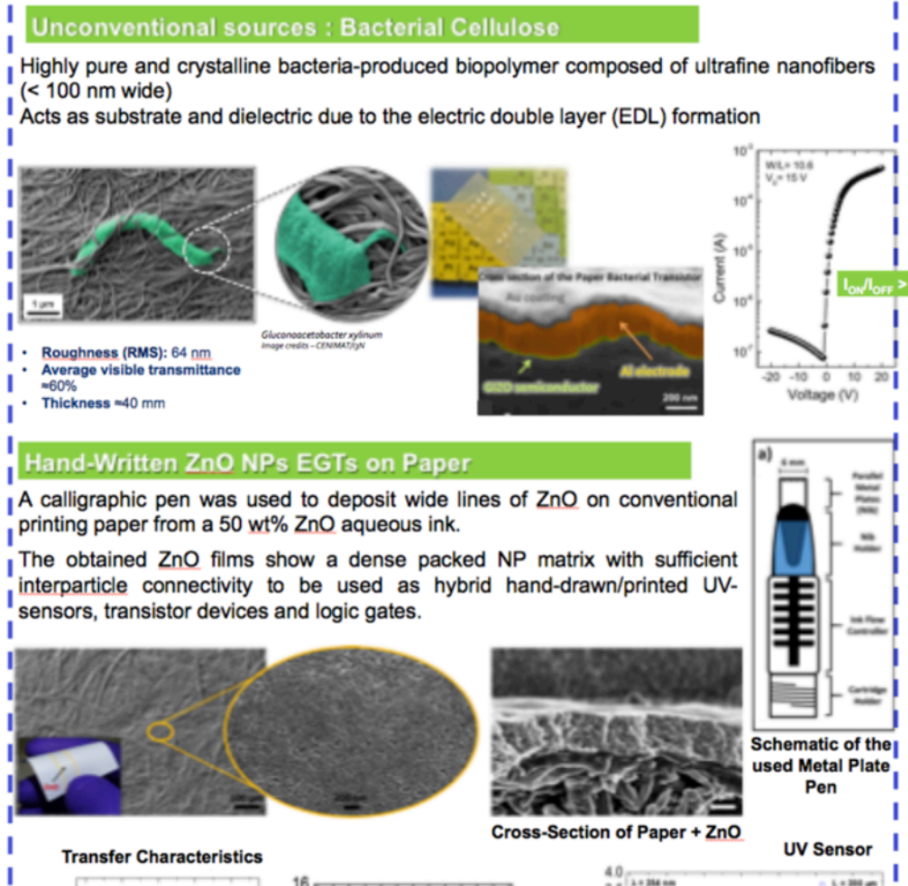

Recent Publications (minimum 5)
- António T. Vicente, Andreia Araújo, Manuel J. Mendes, Daniela Nunes, Maria J. Oliveira, Olalla Sanchez-Sobrado, Marta P. Ferreira, Hugo Águas, Elvira Fortunato and Rodrigo Martins, Multifunctional cellulose-paper for light harvesting and smart sensing applications, Journal of Materials Chemistry C, 20 23), 2018, DOI: 10.1039/c7tc05271e.
- I Cunha, R Barras, P Grey, D Gaspar, E Fortunato, R Martins, L Pereira, Reusable Cellulose‐Based Hydrogel Sticker Film Applied as Gate Dielectric in Paper Electrolyte‐Gated Transistors, Advanced Functional Materials 27 (16) (2017), 1606755.
- P. Grey, D. Gaspar, I. Cunha, R. Barras, JT Carvalho, José Tiag, JR Ribas, Joao Rafael, E. Fortunato, R. Martins, L. Pereira, Handwritten Oxide Electronics on Paper, Advanced, Materials, Technologies, Vol. 2 (6), (2017), article nº1700009, DOI: 10.1002/admt.201700009
- A. Araujo, A. Pimentel, M.J. Oliveira, M.J. Mendes, R. Franco, E. Fortunato, H. Águas, R. Martins, Direct growth of plasmonic nanorod forests on paper substrates for low-cost flexible 3D SERS platforms, Flexible and Printed Electronics, Vol. 2 (1), (2017), article nº 0140016.
- R. Barras, I. Cunha, D. Gaspar, E. Fortunato, R. Martins, L. Pereira, Printable cellulose-based electroconductive composites for sensing elements in paper electronics, Flexible and Printed Electronics, Vol. 2 (1), (2017), article nº 014006. DOI: 10.1088/2058-8585/aa5ef9
- A. Pimentel, A. Araujo, BJ Coelho, D. Nunes, MJ Oliveira, MJ Mendes, H. Aguas, R. Martins, E. Fortunato, 3D ZnO/Ag Surface-Enhanced Raman Scattering on Disposable and Flexible Cardboard Platforms, Materials, Vol. 10(12), (2017), article nº 1351.

- R.B. d' Agua, R. Branquinho, MP Duarte Duarte, ME. Mauricio, AL Fernando, R. Martins, E. Fortunato, Efficient coverage of ZnO nanoparticles on cotton fibres for antibacterial finishing using a rapid and low cost in situ synthesis, New Journal of Chemestry, Vol. 42 (2) (2018), pp. 1052-1060, DOI: 10.1039/c7nj03418k.
- S. Goswami, S. Nandy, AN Banerjee, A. Kiazadeh, GR Dillip, JV. Pinto, SW Joo, R. Martins, E. Fortunato, Electro-Typing" on a Carbon-Nanoparticles-Filled Polymeric Film using Conducting Atomic Force Microscopy, Advanced Materials, Vol. 47 (47), (2017), article 1703079, DOI: 10.1002/adma.201703079
- Shrabani Panigrahi, Santanu Jana, Tomás Calmeiro, Daniela Nunes, Rodrigo Martins, and Elvira Fortunato, Imaging the Anomalous Charge Distribution Inside CsPbBr3 Perovskite Quantum Dots Sensitized Solar Cells, ACS Nano, Vol 11 (2017), pp. 10214-10221, DOI: 10.1021/acsnano.7b04762, 2017.
- Sumita Goswami, Suman Nandy, Jonas Deuermeier, Ana C. Marques, Daniela Nunes, Shashikant P. Patole, Pedro M. F. J. Costa, Rodrigo Martins, and Elvira Fortunato, Green Nanotechnology from Waste Carbon–Polyaniline Composite: Generation of Wavelength-Independent Multiband Photoluminescence for Sensitive Ion Detection, Adv. Sustainable Syst. 2017, 1700137, DOI: 10.1002/adsu.201700137.
- A. Liu, HH Zhu, ZDGuo, Y. Meng, GX Liu, E. Fortunato, R. Martins, FK Shan, Solution Combustion Synthesis: Low-Temperature Processing for p-Type Cu:NiO Thin Films for Transparent Electronics, Advanced Materials, Vol. 29 (34), (2017), article nº: 1701599Heilig M, Egli M (2006) Pharmacological treatment of alcohol dependence: Target symptoms and target mechanisms. Pharmacology and therapeutics 111:855-876.


Rodrigo Martins (orcid.org/0000-0002-1997-7669) is Full Professor and head of Materials Science Department at Faculty of Science and Technology of New University of Lisbon, director of the Centre of Excellence in Microelectronics and Optoelectronics Processes of the Institute of New Technologies; President of the European Academy of Science; Head of the group of Materials for Electronics, Optoelectronics and Nanotechnologies of the Research Materials Center of the Institute for Nanostructures, Nanomodeling and Nanofabrication, CENIMAT/I3N (http://www.cenimat.fct.unl.pt/); Chair of the European Committee Affairs of European Materials Research Society and of The Global Leadership and Service Award Committee of the International Union of Materials Research Societies; Member of the journal management committee for the journal npj 2D Materials and Applications. His area of expertise is related to functional materials for electronics and energy applications. He pioneers worldwide work in the field o transparent electronics and is one of the inventors of paper electronics.
Email: rm@uninova.pt

Notes/Comments:

