The effect of annealing temperature on structural and optical properties of ZnGa₂O₄: Cr³⁺ synthesized by citrate sol-gel method.
M.K.Hussen^{1,*}, F. B. Dejene¹, G. G.Gonfa ²
¹Department of physics, University of the Free State (Qwaqwa Campus), Private Bag X13,
Phuthaditjhaba, 9866, South Africa
²Department of physics, Dire Dawa University, PO Box 1362,Dire Dawa ,Ethiopia

Abstract

This paper reports the material properties of Cr³⁺ (1 mol %) doped ZnGa₂O₄ nano-powder prepared by citric acid assisted sol-gel method. The effect of annealing temperature on optical, structural and morphological properties of ZnGa₂O₄:Cr³⁺ (1mol %) nano-sized particle were investigated. The x-ray diffraction (XRD) results showed that the synthesized nano particles are cubic structured and the annealing temperature did not affect the crystal structure. The average crystallite size of ZnGa₂O₄: Cr³⁺ was observed to increase from 11.85 nm to 30.88 nm as the annealing temperature increased from 600 to 1000 °C. The analysis of high resolution transmission electron microscope (HR-TEM) show that with increase of annealing temperature the average particle size increase and also the HR-TEM image show clear lattice fringe which is indicative of increase in crystallity with increase in annealing temperature. Ultraviolet –visible (UV-Vis) spectrophotometer measurement shown an increase in reflectance in visible region and also energy band gap found to be increase with increase of annealing temperature. The photoluminescence (PL) intensity was found to be maximum with sample annealed at high temperature (1000 °C) and least with sample annealed at low temperature (600 °C). An increase in annealing temperature leads significantly increment in PL intensity. The degree of crystallinity also increased with annealing temperature from XRD, SEM and HR-TEM analysis. The emission spectra, photoluminescence lifetimes and particle size are comparable with reports on bio imaging applications.

Image
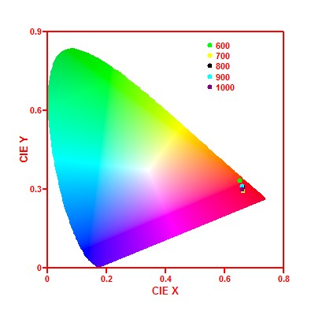
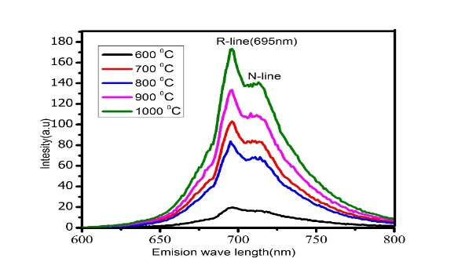
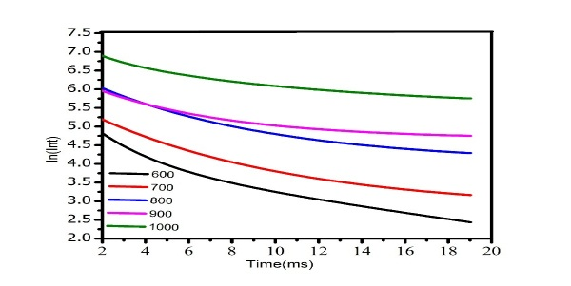
(c)
(a)
(d)
(b)

Figure 1(a) Emission PL spectra (b) HR-TEM image sample annealed at 1000 °C (c) CIE chromaticity diagram (d) PL decay curve (The solid lines are the fitted curves) Of ZnGa₂O_{4:}Cr³⁺ (1mol %) nano powder annealed in temperatures range of 600-1000 °C.

Recent Publications (minimum 5)
- Effect of citric acid on material properties of ZnGa₂O₄: Cr³⁺ nano powder prepared by sol-gel method(accepted for publication under applied physics A(material science and engineering)
- Effect of Cr³⁺ doping on structural and optical property of ZnGa₂O₄ for bio imaging application (SAIP 2017 under review)

The effect of annealing temperature on structural and optical properties of ZnGa₂O₄: Cr³⁺ synthesized by citrate sol-gel method.



Biography (150 word limit)
Mr.Megersa kasim has completed his MSc education from Addis Ababa, university in 2005G.c .He has been working as lecturer, head of physics department and director for continuing education of Dire Dawa University in Ethiopia for past ten years. He is now second year PhD students at university of the Free State South Africa. I have one paper accepted for publication in Applied Physics A in tittle” Effect of citric acid on material properties of ZnGa₂O₄: Cr³⁺ nano powder prepared by sol-gel method”. I have also two paper under review.

Email:megekasim@gmail.com

