Ag⁺ ion emission from a sharp tip of Ag⁺ ion conducting glass and Schottky-model analysis
Yusuke Daiko, Sawao Honda, Yuji Iwamoto
Life Science and Applied Chemistry, Nagoya Institute of Technology, Gokiso-cho, Showa-ku, Nagoya, 466-8555 Japan

Abstract
Ion implantation is one effective method for surface modification of materials, and has been applied for various field including semiconductor industry and bio-technology. For example, proton (H⁺) implantation, so-called proton therapy, has recently used most often in the treatment of cancer, in which accelerated protons are irradiated directly to cancer cells. In general, discharge plasma (gas) or liquid (e.g. liquid gallium (Ga) focused ion beam (FIB)) has been utilized for an ion source. However, in these cases, side reactions (generation of radicals or various ions with different mass such as H₂⁺ and H₃⁺ etc.) are unavoidable. Also, ion (particle) accelerators are huge and expensive.
On the other hand, ion emission from solid electrolytes such as YSZ has also been considered. Hosono et al. showed that O⁻ ions exist inside cages of 12CaO·7Al₂O₃ (C12A7) crystal, and they successfully observed O⁻ ion emission from the C12A7 by applying a high voltage. In the case of these ion emissions from solid electrolyte, one crucial aspect is its high ion conductivity, and ion emission current increases with increasing ion conductivity of electrolyte [8]. Compared with gas and liquid ion sources, ion emission mechanism of such solid-emitter is simple and almost ~100% of emitted ions are O⁻ ion in the case for C12A7.
We have studied high ion conducting glasses and those applications for ion emission gun. One big advantage of glass is its good formability, and we anticipate such ion conducting glasses can be applied for an emitter of ionic gun since the strength of the electric field is concentrated around the tip of the sharp-edged glass emitter. Here we show preparation and emission properties of Ag⁺ ions from a tip of Ag⁺ ion conducting glass fiber. A good linear correlation was obtained between log(current) and square root of the voltage, suggesting the emission of Ag⁺ ion from the tip of glass fiber is expressed by Schottky model.

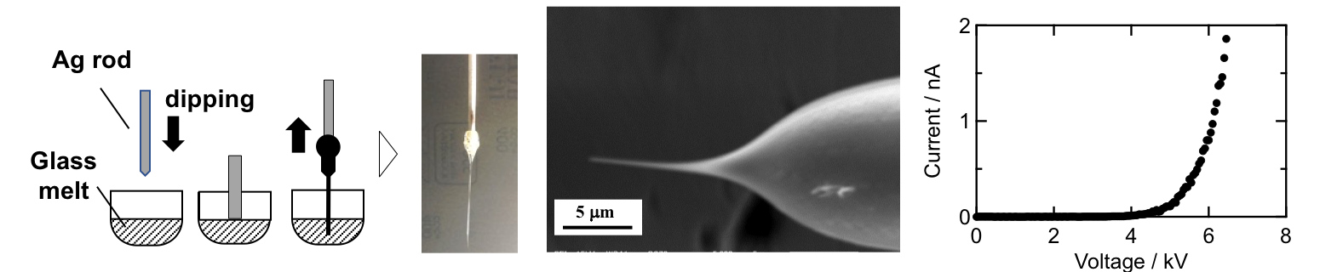
Schematic diagram of fiber preparation, SEM image of the fiber tip, and Ag⁺ ion emission current as a function of voltage.

Recent Publications
- Y. Daiko, S. Mizutani, K. Segawa, S. Honda, Y. Iwamoto, Proc. IEEE 16th Int. Conf. Nanotechnol. 351 (2016)
(DOI: 10.1109/NANO.2016.7751521)
- Y. Daiko, S. Mizutani, K. Machida, H. Imataka, S. Honda, Y. Iwamoto, J. Sol-Gel. Sci. Technol. 83 (2017) 252.
- Y. Daiko, K. Segawa, S. Honda, Y. Iwamoto, Solid State Ionics (in press)

Biography
Yusuke Daiko has his expertise in ion conducting materials including glasses, ceramics and organic-inorganic hybrids. He received Donald R. Ulrich Award 2013, International Sol-Gel Sciety(ISGS) and the 67th Ceramic Society of Japan (CerSJ) Awards (for Advancements in Ceramic Science and Technology) in 2013 for his research development about proton conducting glasses.

Email: daiko.yusuke@nitech.ac.jp

