Effect of electrolyte aging on the morphology and mechanical properties of anodic titanium dioxide
Junzhe Dong, Department of Chemical and Materials Engineering, The University of Auckland, New Zealand
Thomas Loho, Department of Chemical and Materials Engineering, The University of Auckland, New Zealand
Wei Gao, Department of Chemical and Materials Engineering, The University of Auckland, New Zealand

Abstract (300 word limit)
Titanium dioxide (TiO₂) has attracted extensive attention as multifunctional semiconductors in various applications, such as sensors, photocatalysis and medical devices. Electrochemical anodization is a simply and cost-effective way to produce one dimensional TiO₂ nanotubes with large surface area and tunable morphology. Recently great efforts have been made on understanding the formation mechanism behind the regular morphology and influencing anodization parameters. However, rare studies were reported focusing on the mechanical properties of anodic TiO₂, such as hardness, modulus and adhesion, which are vital to practical application of TiO₂. The purpose of this study is to explore the effect of electrolyte aging on the morphology and mechanical properties of anodic TiO₂ nanotube arrays. Electrochemical anodization of Titanium foil was conducted in different aging electrolyte to produce regular self-organized TiO₂ nanotube arrays. Nanoindentation test was then performed on as-synthesized TiO₂ nanotube surface to measure their mechanical properties. The regularity of obtained TiO₂ nanotube improves in short aging electrolyte while deteriorates in long aging electrolyte with pore size decreases from 146.58nm to 46nm. However, the hardness and reduced modulus increase with prolonging aging time as well as adhesion strength. The electrolyte aging has a significant role in the morphology and mechanical properties during titanium anodization. It improves the hardness, modulus and tribological behavior of anodic TiO₂ nanotube arrays, but reduces their pore size and surface area. Therefore, the proper aging time of electrolyte should be selected according to the specific applications.

Image

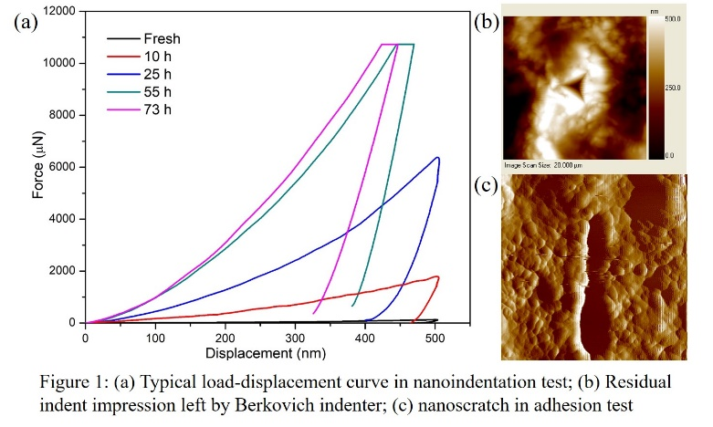

Recent Publications (minimum 5)
- J. Dong et al. (2018) Enhancing photocatalytic activities of titanium dioxide via well-dispersed copper nanoparticles. Chemosphere 204: 193-201.
- D. Ariyanti, L. Mills, J. Dong, et al. (2017) NaBH₄ modified TiO₂: Defect site enhancement related to its photocatalytic activity. Materials Chemistry and Physics 199: 571-576.
- J. Dong et al. (2017) Patterned titania nanostructures produced by electrochemical anodization of titanium sheet. International Journal of Modern Physics B 31: 1744049.
- J. Dong et al. (2016) [HTML] Self-organized ZnO nanorods prepared by anodization of zinc in NaOH electrolyte. RSC Advances 6: 72968.
- J. Dong, R. Ullal, J. Han, S. Wei, X. Ouyang, J. Dong, and W. Gao (2015) Partially crystallized TiO2 for microwave. Journal of Materials Chemistry A 3: 5285.

Biography
Junzhe Dong receives his bachelor degree in Materials Physics from Southwest University, China in 2011. Then he goes to Northwestern Polytechnical University (China) with project of research on Ti alloy deformation and graduates in 2014. After that he comes to University of Auckland, New Zealand for his PhD study in transition metal oxide and their applications. Junzhe has his expertise in Micro- and nano-indentation test, electrochemical anodization technique, Raman signal enhancement and photocatalysis.
Email: jdon296@aucklanduni.ac.nz

Notes/Comments:

