Fabrication of transparent anti-fogging hollow silica nanocomposite thin film on glass substrate
Akbar Eshaghi
Faculty of Materials Engineering, Malek Ashtar University of Technology, Shahin Shahr, Esfahan, Iran

Abstract:
Statement of the Problem: Antireflective antifogging thin films can effectively enhance the light transmission and prevent ghost images in optical surfaces. In recent years, designing and fabrication of transparent and antifogging (AF) coatings are developed for using in variety of applications such as optical and optoelectronic materials. These coatings can effectively enhance transmittance of light and thus leading to increase efficiency of optical devices. Methodology & Theoretical Orientation: Many researcher indicated that hollow silica nanocomposite film showed good features such as easy structural regulation, high level wettability, low density, larger specific surface area, high mechanical and thermal stability as contrast with other materials, and thus very useful for variation applications in drug delivery, solar cells, adsorptive filters and antireflection and antifogging thin films. In this work, hollow silica nanocomposite thin film was deposited on a glass substrate by a sol-gel dip-coating method. The morphology, surface wettability, optical and antifogging properties of the thin films were studied. Findings: The results revealed that the diameter and shell thickness of the hollow silica nanoparticles were 80 and 20 nm, respectively. In addition, the maximum transmission of the glass coated substrate increased from 91.3 to 97.1 % and reduced the water contact angle from 59 to 2 degrees. Also, hollow silica nanocomposite thin film showed antifogging effect. Conclusion & Significance: Results showed that the hollow silica nanocomposite thin film exhibited excellent antireflective, superhydrophilic and antifogging properties. In other words, hollow silica nanocomposite thin film can be increased the transmittance and reduced minimum reflectance of glass slide. Therefore, hollow silica nanocomposite film can be used as an antireflective and antifogging coating for optical instruments.

Image

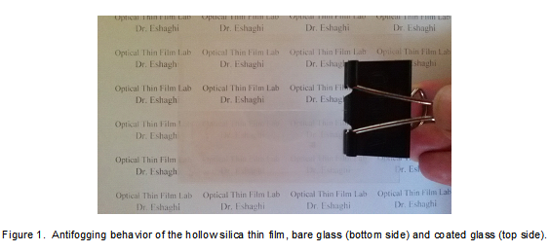

Recent Publications
1. Xu L, He J (2012) Fabrication of Highly Transparent Superhydrophobic Coatings from Hollow Silica Nanoparticles. Langmuir 28: 7512-7518.
2. Sobahan K M A, Park Y J, Kim J J , Hwangbo C K (2011) Nanostructured porous SiO₂ films for antireflection coatings.Opt. Commun. 284: 873-876.
3. Han J, Dou Y, Wei M, Evans D G, Duan X (2011) Antireflection/antifogging coatings based on nanoporous films derived from layered double hydroxide. Chem. Eng. J. 169: 371-378.
4. Park M S, Lee Y, Kim J K (2005) One-Step Preparation of Antireflection Film by Spin-Coating of Polymer/Solvent/Nonsolvent Ternary System. Chem. Mater. 17: 3944-3950.
5. Li X, He J (2012) In situ assembly of raspberry- and mulberry-like silica nanospheres toward antireflective and antifogging coatings. ACS Appl. Mater. Interfaces. 4: 2204-2211.

Biography


Dr. Akbar Eshaghi received his B.Sc. at Isfahan University of Technology (2002). He received his Master’s degree from Shiraz University (2005) in Materials Engineering where he also completed his PhD degree (2010). He serves as an assistant Professor in the Faculty of Materials Engineering at Malek Ashtar University of Technology (2010-present), the head of surface engineering research center from 2014 to 2017. Now he is one of the members of Iranian surface Engineering. His current research focuses on optical Thin Films, TCO thin films, Functional Thin Films, DLCD and Diamond, Thin film Solar Cells, Super-hydrophilic, photocatalytic , superhydrophobic, oleophobic, Self-cleaning and Anti-icing Coatings. He has published 90 papers in journals and conferences. He has edited 2 books. He is a member of the editorial board of the SF Journal of Nanochemistry and Nanotechnology.
.
Email: eshaghi.akbar@gmail.com

