Corrosion study of sintered 304 austenitic stainless steel reinforced with titanium nitride in chloride media.
Samuel O. Akinwamide, M. Eng, University of Johannesburg, South Africa.
Serge M. Lemika. B. Tech, University of Johannesburg, South Africa.
Ojo J. Akinribide, M. Eng, University of Johannesburg, South Africa.
Babatunde A. Obadele, PhD. University of Johannesburg, South Africa.
Bolanle T. Abe, PhD, Tshwane University of Technology, South Africa.
Peter A. Olubambi. PhD, University of Johannesburg, South Africa.
Abstract
Hazards emanating from corrosion in industries such as oil and gas where stainless steels are inevitable in ensuring smooth passage of petroleum products has led to development of materials that can withstand corrosive environments. Effects of corrosion on sintered austenitic stainless steel reinforced with varying proportion of titanium nitride produced by powder metallurgy route was investigated. Reinforcing austenitic stainless steel with titanium nitride are expected to improve corrosion resistance of austenitic stainless steel. Sintered samples were reinforced with 2, 4 and 6 weight percent of titanium nitride respectively. Corrosion behaviour of these samples in addition to sample sectioned from as-received austenitic stainless steel plate were studied in 3.5% NaCl solution. Open circuit potential (OCP), chronoamperometry and potentiodynamic polarization were performed using a Versa studio Potentiostat. Evidence of pits formation were clearly visible on as-received and unreinforced austenitic stainless steel samples when studied scanning electron microscope. Sintered samples reinforced with 4% titanium nitride recorded the best corrosion resistance.
Image
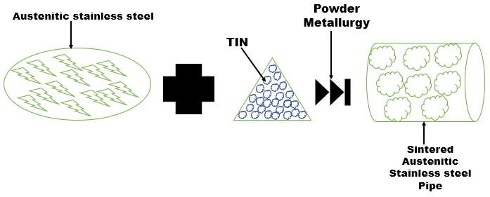
Recent Publications
- Fouad B Abudaia, Steve J Bull, and Adrian Oila (2012) 'Surface Wear Resistance of 304 Austenitic Stainless Steels Modified by Colossal Carbon Supersaturation and Tin Coating Journal of Materials Science and Engineering B 2:103-111
- Samantha Michelle Gateman, Lisa Irene Stephens, Samuel Charles Perry, Robert Lacasse, Robert Schulz, and Janine Mauzeroll (2018) The Role of Titanium in the Initiation of Localized Corrosion of Stainless Steel 444 npj Materials Degradation 2:5
- Cheng-Hsun Hsu, Hong-Tsair Liu, Wei-Che Huang, and Meng-Ru Lin (2015) 'Effect of Post Heated Tin Coating on Pitting Corrosion of Austenitic Stainless Steel Journal of Coating Science and Technology 2:93-99
- J Aghazadeh Mohandesi, and A Nazari (2007) Kinetics of Nitriding in Titanium Bearing Austenitic Stainless Steel Multidiscipline Modeling in Materials and Structures 3:515-526
- PM Perillo (2006) Corrosion Behavior of Coatings of Titanium Nitride and Titanium-Titanium Nitride on Steel Substrates Corrosion 62:182-185

Biography
Akinwamide Samuel Olukayode is a doctoral student at university of Johannesburg. He is specialized in corrosion of stainless steel and development of nanocomposite materials using powder technology technique. He currently works with a research institute with the name centre for nanoengineering and tribocorrosion.

Email: akinwamidekayode@gmail.com

