Low-cost printable hybrid heterostructures for energy harvesting and lighting
Prof. Sylvain G. Cloutier, PhD,
Ecole de Technologie Superieure, Canada

Abstract
The urgent demand for better and cheaper optoelectronic device architectures is a crucial roadblock towards a better use of our energy resources. As such, we explore new additive manufacturing paradigms in printable electronics to realize ultra low-cost, lightweight and fully-integrated light-harvesting and energy-efficient optoelectronic devices using commercial-grade printing capabilities.
While solution-processing techniques have yielded a wide range of new hybrid nano-engineered materials for optoelectronic applications, many key parameters including compatibility, interface engineering, surface treatment and processability are essential to achieve the best device performances. More recently, new solution-processed materials including organometallics, new high-mobility conductive polymers and nanoparticle inks have shown tremendous potential for low-cost optoelectronic device integration. For example, power-conversion efficiencies from printable organometallic solar cells have now surpassed 20%.
These advances have also transposed into new photodetector devices with high responsivities. Just in the last year, our team made tremendous ground-breaking progress towards viable devices (1) by dramatically enhancing structure and material properties, (2) enhancing conductivities by several orders of magnitude using hybrids, (3) significantly improving stability and lifetime and (4) dramatically improving the performances through advanced processing.
In this invited presentation, we will summarize our work from the last 5 years exploring new hybrid heterostructures for low-cost optoelectronic applications, including mainly light harvesting and lighting. We will present new printable sol gel-based TiO2 collector architectures, which then led to promising low-cost solar cell architectures for production using commercial-grade inkjet or aerosol printing capability. We will also describe in details how methylammonium lead-halide perovskite deposition and chemistry was adapted to produce low-cost photodetectors and LEDs using commercial-grade inkjet printing capability.

Image
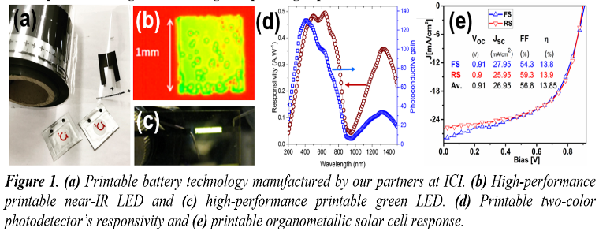
Recent Publications
- D. Banerjee, X. Guo and S. G. Cloutier, Solar RRL (In Press)
- C. Trudeau et al., MRS Advances, 1-6 (2018). doi:10.1557/adv.2018.172
- M. Bolduc et al., Scientific Reports 8, 1418-1426 (2018)
- I. Ka et al., Scientific Reports 7, 45543-8 (2017)
- S. Sepulveda et al., Journal of Nanomaterials 2012, 286104-7 (2012)


Prof. Sylvain G. Cloutier received his PhD from Brown University in 2006. At the University of Delaware, he then received the DARPA Young Faculty Award for his work on the use of nano-engineered materials for lasers. In 2011, he joined ÉTS, where he leads both the Canada Research Chair on printable hybrid optoelectronic materials & devices and the ArianeGroup Industrial Research Chair on emerging materials for aerospace & space. He was lead investigator on several large-scale research projects in the USA and Canada. He contributed over 80 publications and was elected at the College of the Royal Society of Canada in 2014.
Email: sylvaing.cloutier@etsmtl.ca

Notes/Comments:

