A new interfacial bio-sensing approach for detecting aberrant protein phosphorylation in cancer

Mostak Ahmed*, Laura G. Carrascosa, Paul Mainwaring, and Matt Trau

Centre for Personalized Nanomedicine, Australian Institute for Bioengineering and Nanotechnology (AIBN), The University of Queensland, Brisbane, QLD 4072, Australia

Abstract

Protein phosphorylation is one of the most prominent post-translational mechanisms for protein regulation, which is frequently impaired in cancer. Through the covalent addition of phosphate groups to certain amino-acids, the interactions of former residues with nearby amino-acids are drastically altered, resulting in major changes of protein conformation that impacts its biological function. Herein, we report that these conformational changes can also disturb the protein's ability to interact with and adsorb onto bare gold surfaces. Based on the direct interaction of proteins with the gold interface, we further developed an extremely simple method for aberrant phosphorylation detection that circumvents the current need for phospho-specific antibodies. The novel interfacial bio-sensing method, which only requires 50 ng of purified protein, was applied to EGFR phosphorylation analysis in several lung cancer cell lines and also enabled monitoring their cell sensitivity to tyrosine kinase inhibitors (TKI) ― a drug frequently used in the clinic for lung cancer treatment.

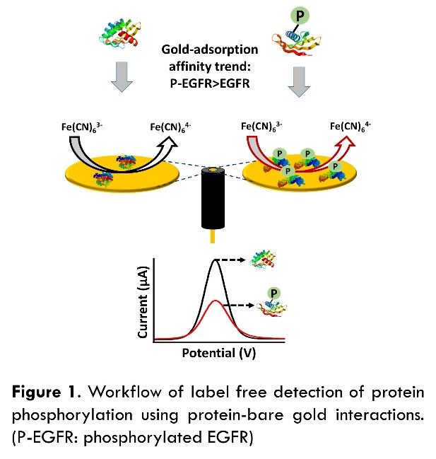

References
- Ahmed, M.; Carrascosa, L. G.; Sina, A. A. I.; Zarate, E. M.; Korbie, D. Ru, K.-l.; Shiddiky, M. J.; Mainwaring, P.; Trau, M. Biosens. Bioelectron. 2017, 91, 8-14.
- Karve, T. M., & Cheema, A. K. Journal of amino acids, 2011, 2011.
- Pierobon, M., Wulfkuhle, J., Liotta, L., Petricoin, E., Oncogene 2015, 34 (7), 805–814.
- Camidge, D.R., Pao, W., Sequist, L.V., Nat. Rev. Clin. Oncol. 2014, 11 (8), 473–481.
- Paez, J.G., Jänne, P.A., Lee, J.C., Tracy, S., Greulich, H., Gabriel, S., Herman, P., aye, F.J., Lindeman, N., Boggon, T.J., Science 2004, 304 (5676), 1497–1500.

Biography
Mr. Mostak Ahmed is a PhD student at the Centre for Personalized Nano-medicine, AIBN, UQ. He has completed B.Sc. (Honours with first class) and M.S. (with Distinction) degrees in Chemistry from Shah Jalal University of Science and Technology (SUST), Sylhet, Bangladesh. Before joining the AIBN, he served as a Scientific Officer at Bangladesh Council of Scientific and Industrial Research (BCSIR). He is currently researching “Detection Protein modifications using Protein-Gold affinity interactions”. He has seven publications in highly reputed peer reviewed journals.

Email: m.ahmed2@uq.edu.au

Notes: We believe that this simple method may potentially provide a clinically applicable platform for lung cancer diagnostics and therapeutics.

