Boron carbide-based ceramics for thermostructural application: sintering by SPS and mechanical performances
A. Maître, Prof., IRCER, University of Limoges, France
G. Antou, PhD, IRCER, University of Limoges, France
N. Pradeilles, PhD, IRCER, University of Limoges, France
R. Belon, PhD student, IRCER, University of Limoges, France

Abstract
Boron carbide is a promising ceramic in the armor field and in nuclear reactors due to its low weight, its high hardness, and its high capacity to absorb neutrons. These excellent properties result from unusual characteristics of B-B and B-C chemical bond^{1,2}. In the literature, there is a general agreement about the existence of solid solubility of carbon with the stable phase BxC, and a large range extending from 8 to 20 at.% C. So, the mechanical properties of boron carbide monoliths depend on their chemical composition (i.e. carbide stoichiometry, presence of secondary phases such as free carbon) and on microstructural characteristics (i.e. porosity level, grain size).
In the present work, fully-dense boron carbide monoliths exhibiting fine microstructure (i.e. submicrometric grain size) are shaped and sintered by spark plasma sintering. Two different commercial powder batches, exhibiting different stoichiometries and various amounts of secondary phases are used. Their chemical composition is well-defined by coupling different methods (TEM, XRD, IGA), and are correlated with their mechanical properties, characterized from meso- to macro-scopic scales by nano-indentation and ultrasonic pulse echography.
The presence of secondary phases (graphite and boric acid) is noticed in various proportions in each powder batch. Their effect on the mechanical features of the corresponding boron carbide-based ceramics has been investigated. So, if the boric acid disappears during the sintering step, the graphite remains. However, for the considered amounts of graphite (lower than 1 wt.%), the low variation in graphite content have no significant effect on hardness and elasticity. At the opposite, the presence of oxygen in solid solution, leading to a boron oxycarbide phase, induces a decrease of both hardness and elasticity.

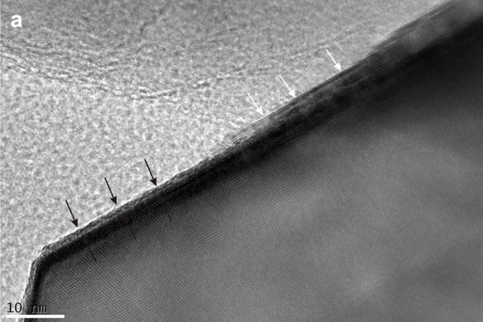

Figure 1: TEM observation of a particle of boron carbide (batch HD) exhibiting free carbon under the graphite form (indicated by the white arrows) and an amorphous layer (black arrows).
Recent Publications
- Aselage TL, Tissot RG. Lattice Constants of Boron Carbides. J. Am. Ceram. Soc. 1992;75:2207–2212.
- Niihara K, Nakahira A, Hirai T. The Effect of Stoichiometry on Mechanical Properties of Boron Carbide. J. Am. Ceram. Soc. 1984;67;C-13.
- Belon R, Antou G, Pradeilles N, Maître A . Mechanical behaviour at high temperature of spark plasma sintered boron carbide ceramics. Ceram. Int. 2017:43:6631–6635 (2017).
- Moshtaghioun BM, Gómez-García D ,Domínguez-Rodríguez A et al. Enhancing the spark-plasma sinterability of B4C nanopowders via room-temperature methylation induced purification. J. Eur. Ceram. Soc. 2016;36:2843–2848.
- Sairam K, Sonber JK, Murthy TS et al. Influence of spark plasma sintering parameters on densification and mechanical properties of boron carbide. Int. J. Refract. Met. Hard Mater. 2014;42:185–192.

Biography
Alexandre Maître is professor at IRCER at Limoges in France. His thesis diploma (1995-1998) was devoted to the kinetic and thermodynamic aspects of the synthesis of transition metal carbides by carbothermal reduction. In october 2000, he obtained a permanent position as CNRS researcher at the Laboratory LCSM (Laboratory of Chemistry of Inorganic Solid) at Nancy to develop investigations concerning the thermodynamic modelling, the electrochemical behaviour in corrosive environment, the metallurgical aspects of lead-based alloys. In September 2004, he became assistant professor in IRCER to implement research activities about the elaboration by Polymer Derived Ceramics (PDCs) route and the mechanisms of sintering of high temperature ceramics. His scientific production (h index: 22) is now composed of 82 publications in international journals, 25 invited conferences, 98 oral communications, 3 chapters of books, 3 grants.
Email: alexander.maitre@unilim.fr

