Cu doped Co₃O₄ thin film for nonenzymatic glucose detection
Mahabubur, Chowdhury, Cape Peninsula University of Technology, RSA
Micaela, Harry, Cape Peninsula University of Technology, RSA
Franscious, Cummings, University of the Western Cape, Bellville-9535, RSA
Christopher, Arendse, University of the Western Cape, Bellville-9535, RSA

Abstract
One of the major causes of death and disability in the world is due to diabetes mellitus. The frequent testing of physiological blood glucose levels to avoid grave emergencies is vital for the confirmation of effective diabetic treatment. The current glucose sensors that are being used by diabetic patients are glucose oxidase sensors. However, due to problems associated with fabrication of enzymatic glucose sensors, non-enzymatic glucose sensors has been of main focus recently. In this study, a simple solution based deposition process has been utilized to fabricate a Cu doped Co₃O₄ electrode for non-enzymatic glucose detection. The substitution of Cu into the Co₃O₄ host lattice resulted in an enhanced electrochemical performance compared to the pristine Co₃O₄ as was measured from the Hall effect measurement. The sensor exhibited two distinctive linear ranges covering upto 7.6 mM at an applied potential of + 0.65 V vs. Ag/AgCl in 0.1 M NaOH solution. The sensor depicted good repeatability (R.S.D of <10%), stability and reproducibility (R.S.D of <10%). The sensitivity of the sensor was determined to be 1333 uA/cm² mM (lower concentration range) and 141 uA/cm² mM (upper concentration range), with a lower detection limit of 0.15 uM (S/N=3). The as prepared electrode showed a response time of <10 s and was very selective towards glucose in the presence of various interference species (Figure 1). The ease of fabrication, good electrochemical activity and good inter and intra electrode reproducibility makes this electrode a promising candidate for non-enzymatic glucose detection.

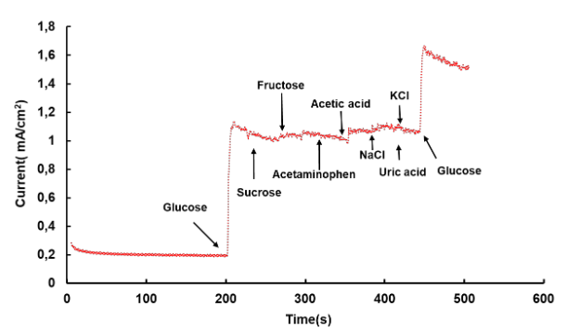
Figure 1: Amperometric response of the sensor in the presence of glucose and other interfering species
Recent Publications (minimum 5)
- T. Gota, M. Chowdhury*, T. Ojumu, Non-enzymatic Fructose Sensor Based on Co₃O₄ Thin Film, Electroanalysis, 29 (2017) 2855-2862.
- Chowdhury, M*., Ossinga, C., Cummings, F., Chamier, J. and Kebede, M. (2017), Novel Sn Doped Co3O4 Thin Film for Nonenzymatic Glucose Bio-Sensor and Fuel Cell. Electroanalysis. doi:10.1002/elan.201700184
- Chowdhury, M. R*., Fransciuos Cummings., Mesfin Kebede., Fester, V. G.(2017). Binder less solution processed Zn doped Co₃O₄ film on FTO for rapid and selective non-enzymatic glucose detection. Electroanalysis, 29, 578-586.
- Chowdhury, M.R*., Shoko, S., Cummings, F., Fester, V& Ojumu, T., (2017). Charge transfer between biogenic jarosite derived Fe³⁺ and TiO₂ enhances visible light photocatalytic activity of TiO_{2.} Journal of Environmental Sciences, 54, 256-267.
- Chowdhury, M. R*., Oghenochuko Oputu., Mesfin Kebede., Fransciuos Cummings., Oscar Cespedes., Aliwa Maelsand., Fester, V. G.(2015). Rapid and large-scale synthesis of Co₃O₄ octahedron particles with very high catalytic activity, good supercapacitance and unique magnetic properties. RSC Advances, 5, 104991–105002.

 Biography
Mahabubur Chowdhury holds a doctoral degree in Chemical Engineering and is currently a senior lecturer in the department of chemical Engineering at Cape Peninsula University of Technology. His research is on advanced functional materials for bio sensing and water treatment. His interest is on the relationship of electronic structure and ionic transport properties in semiconductor electrodes. He has published many journal articles, conference proceedings, book chapter and patent.
Email: chowdhurym@cput.ac.za
Notes/Comments:

