Comparative photoluminescence study of GdBO₃:Eu phosphor in bulk and nano phase for its implication in solid state lightening

Ramya Nair, Sandeep Nigam and V. Sudarsan*
Chemistry Division, Bhabha Atomic Research Centre, Trombay, Mumbai 400 085

Abstract

Rare-earth borates are excellent candidates for solid state lightening application due to its robust nature and brilliant optical properties.GdBO₃:Eu³⁺ is one of the finest phosphors existing amongst borate phosphors for primary red color. In this work we investigate the nature of structure–composition–optical relationships in both nano and bulk forms of GdBO₃:Eu³⁺.Nanophosphors have unique physical and chemical properties as compared to their bulk counterpart and so their emission efficiencies vary which can finely be tuned and considerably improved. GdBO₃ exists in both monoclinic and triclinic phase. GdBO₃ containing 1at.% Eu³⁺ were prepared in nano-crystalline, monoclinic and triclinic forms by hydrothermal and polyol route. Techniques like XRD, FTIR, TEM, luminescence and lifetime measurements were used to characterise the samples.SAED pattern illustrate phase formation while presence of nano rods with 200nm length and width less than 10nm are confirmed from TEM images (Figure 1).Boron was found in both trigonal and tetrahedral coordination in nanorods and triclinic phase, whereas only BO₄ structural units exists in monoclinic GdBO₃. Based on bond angle and bond length values obtained from Rietveld refinement of the XRD patterns it is inferred that local environment around Eu³⁺ in the triclinic form is more distorted compared to monoclinic form. This explains increase in the relative intensity of electric dipole allowed transition of Eu³⁺ in triclinic form compared to monoclinic form. Red to orange ratio of Eu³⁺ in triclinic and nanorods (2 and 2.3) is found to be higher than the monoclinic phase(1.4). From the results it is inferred that the nanorods have improved red colour characteristics compared to the other two forms. By size tuning we improvised optical parameters of the phosphor to develop materials with optimum luminescence characteristics.

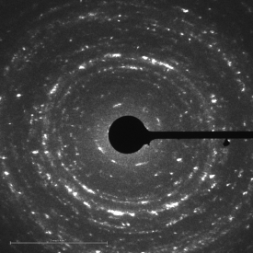  (b)  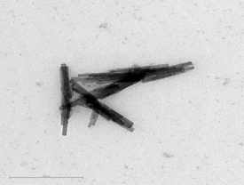  (a)  Fig1:GdBO₃ prepared by hydrothermal route (a) SAED pattern from a representative region and (b) HRTEM showing nano rod shaped particles | 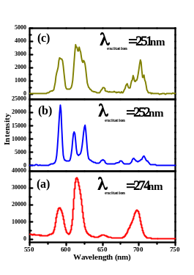Fig2: Emission spectra (a)nanocrystalline GdBO₃ excited at 274nm (b) monoclinic phase excited at 252nm and (c) triclinic phase excited at 251nm
Recent Publications:
1) Nair RG, Nigam S, Vishwanadh B, Sudarsan V, Vatsa RK, Majumder C and Jain V K (2016) Size induced modification of boron structural unit in YBO₃: systematicinvestigation by experimental and theoretical methods. RSC Adv, 6:64065.
2) Nair RG, Nigam S, Sudarsan V, Vatsa RK and Jain VK (2018) YBO₃ versus Y₃BO₆ host on Tb³⁺ luminescence.J. Lumin. 195:271–277.
3) Nair RG, Nigam S, Sudarsan V, Dhabekar BS, Vatsa RK, (2016) Luminescence studies of Eu-doped YBO₃ host. AIP Conference Proceedings 1731, 060003
4) Nair RG, Nigam S, SudarsanV, VatsaR K(2017)Photoluminescence investigation of Y₂O₃ : Eu phosphor co-doped with CaAIP Conference Proceedings 1832, 140011
5)Nair RG, Mazumdar S,Modak B, Bapat R, AyyubbP and Bhattacharyyaa K (2017)The role of surface O-vacancies in the photocatalytic oxidation of Methylene Blue by Zn-doped TiO2: A Mechanistic approach. Journal of Photochemistry and Photobiology A: Chemistry 345:36–53

 Biography
Ms. Ramya Nair completed her M.Sc. from University of Mumbai with an outstanding grade in the year 2012. During the masters program, she successfully completed six month dissertation work at Tata Institute of Fundamental Research (TIFR), Mumbai. Afterwards she got selected in prestigious DAE fellowship scheme for Ph.D. in basic sciences and currently she is pursuing her research work as senior research fellow at Chemistry Division of Bhabha Atomic Research Center, Mumbai. She has five papers published in journals of international repute and participated in several international conferences and workshops. Her topic of interest is synthesis of nano materials for environmental and energy applications.
Email: ramyagnair7@gmail.com

Notes/Comments:

