Strong Hydrogels Fabricated by 3D Printing with Oppositely Charged Polymers
Huijun Li, Nanyang Technological University, Singapore
Lin Li*, Nanyang Technological University, Singapore

Abstract
Hydrogels are commonly used to prepare bioinks, as they are soft and hydrophilic as well as possess similarities to biological tissues. Natural hydrogels, such as alginate, gelatin, collagen, and chitosan, which show good biocompatibility with nontoxic degradation products, have received great attention in the field of biomedical engineering. However, these natural hydrogels have limitations for their broad applications because they are weak by nature. Therefore, many studies focus on improving mechanical properties of hydrogels.

3D printing is a layer-by-layer printing process, where there are often layer defects or weak interface adhesion in 3D-printed layered structures with hydrogels. As a new approach, alternate printing of two kinds of hydrogels maybe possible to overcome the drawbacks of printing one hydrogel alone. Furthermore, alternate printing of two oppositely charged ionic hydrogels is expected to result in a strong interface adhesion between layers, but it has not been found in the literature.

In this study, we report a new strategy and approach for fabrication of strong hydrogel constructs with strong interfacial bonding by utilizing the ionic interaction between two oppositely charged hydrogels. Six natural ionic polymers are chosen as the representatives of anionic and cationic hydrogels, respectively. Specific properties such as rheological properties of the prepared hydrogels, shape fidelity of a printed structure, structure integrity of a printed construct in the cell culture medium are investigated. These properties help us to find the best concentration of each hydrogel and the best combinations for bioprinting. The interfacial adhesion properties between the printed hydrogel layers are also examined. Additionally, the biocompatibility of the best pair of bioink is also investigated.

.

Image
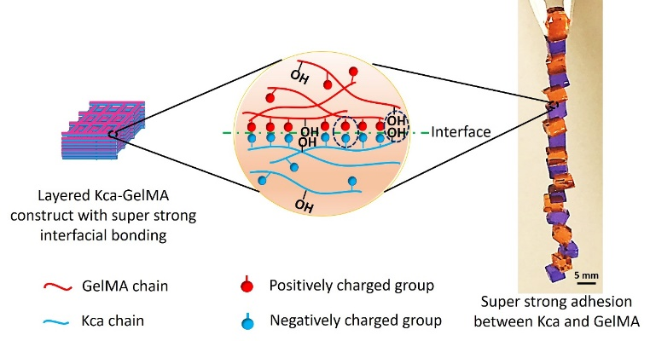
Recent Publications
- Liu S, Bastola AK, Li L (2017), A 3D Printable and Mechanically Robust Hydrogel Based on Alginate and Graphene Oxide, ACS Applied Materials & Interfaces, 9(47): 41473-41481.
- Liu S, Li L (2017), Effect of Functionalized Graphene Oxide on Gelation and Scaling Law of Alginate in Aqueous Solution, European Polymer Journal, 95:462-473.
- Liu S, Li L (2017), Ultra-stretchable and Self-healing Double Network Hydrogel for 3D Printing and Strain Sensor, ACS Applied Materials & Interfaces, 9(31):26429-26437.
- Li H, Tan YJ, Leong KF, Li L (2017), 3D Bioprinting of Highly Thixotropic Alginate/ Methylcellulose Hydrogel with Strong Interface Bonding,” ACS Applied Materials & Interfaces, 9 (23):20086–20097.
5. Bastola AK, Hoang TV, Li L (2017), A Novel Hybrid Magnetorheological Elastomer Developed by 3D Printing, Materials and Design, 114: 391–397.

 Biography (150 word limit)
Lin Li received his PhD degree in Polymer Science in 1989 from Kyoto University, Japan. During the period from 1989 to 1999, he worked as a R&D scientist, research fellow, and senior scientist at several industrial and academic laboratories in Japan and Canada. He did his postdoctoral research in the group of Professor Mitchell A Winnik in Department of Chemistry, University of Toronto, Canada. Since August 1999, he has been an Associate Professor in the School of Mechanical & Aerospace Engineering, Nanyang Technological University (NTU). His research interests and activities include (i) synthesis of nanocarriers for drug & gene delivery, (ii) development of advanced polymer nanocomposites, (iii) rheological studies of polymer gels and hydrogels, (iv) 3D printing with hydrogels, (v) 4D printing with smart materials, etc. He has authored and co-authored 205 journal papers. His journal papers have garnered more than 7,100 citations (Web of Science) with a Hirsch-index of 46 (Web of Science).

Email: mlli@ntu.edu.sg

Notes/Comments:

