www.vbripress.com/eamc, DOI: 10.5185/eamc.2017 Published online by the VBRI Press in 2017

Electrochemical method for Research on Anticorrosion performance of Graphene-like materials composite coating on carbon steel
Xia Zhao¹*, Hongling Li¹, Baorong Hou¹
¹ Institute of Oceanology, Chinese Academy of Science, Qingdao, 266071, China
*Corresponding author. Tel: (+86)352-82898731; Fax: (+86)532-82880498; E-mail:zx@qdio.ac.cn

Table of contents

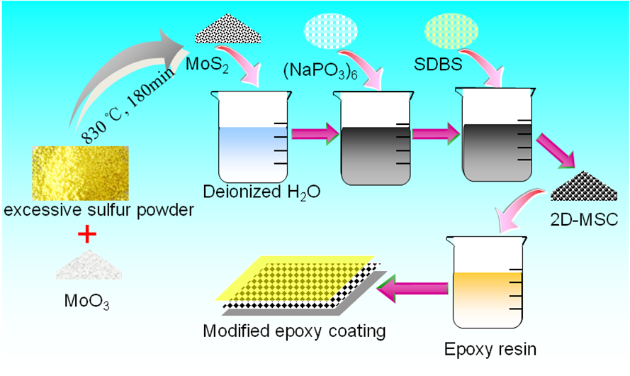

Schematic diagram of epoxy coating modified by MoS₂ nanosheet
Abstract

MoS₂ nanosheet has distinct and complementary properties to those of graphene, making it more appealing for several applications ^{[1]}. In this paper, MoS₂ nanosheet was used for modifying epoxy resin to improve the anticorrosion ability of the epoxy coating. The anticorrosion properties of the scratched coating/carbon steel system were determined by EIS method. The results indicated that MoS₂ could reduce the penetration rate of water into coating in both horizontal and vertical directions. Fig.1 showed that the corrosion rate of the scratched composite coating was clearly slower that the pure epoxy coating, indicating that MoS₂ nanosheet player an important role in preventing the coating delamination and base-metal corrosion. The 3D images of pure epoxy coating and coating with 0.5wt.% MoS₂ was scanned by X-CT technique(Fig.2), which proved that MoS₂ nanosheet could effectively fill the natural pores of the epoxy coating. Finally, the adhesive strength after 1500h salt fog test was conducted for long-term evaluation of coating system. It showed that the adhesive strength of the epoxy coating with MoS₂ nanosheet decreased slower with time than that of pure epoxy coating. MoS₂ nanosheet could inhibit the transportation of corrosion ions and enhance the anticorrosion ability of the epoxy coating.

Keywords: MoS₂; anticorrosion ability; delamination

Acknowledgements
This work was supported by the National Natural Science Foundation of China under Grant No. 51378269
Reference
1.Joon Young Kwak, Jeonghyun Hwang, Brian Calderon, Hussain Alsalman, Nini Munoz, Brian Schutter, Michael G. Spencer. Nano Lett., 2014, 14 (8):4511-4516.

