www.vbripress.com/eamc, DOI: 10.5185/eamc.2017 Published online by the VBRI Press in 2017

Anticorrosive performance of the scratched coating systems on carbon steel in marine environment by electrochemical technique
Hongling Li¹*, Xia Zhao¹, Baorong Hou¹
¹ Institute of Oceanology, Chinese Academy of Science, Qingdao, 266071, China
*Corresponding author. Tel: (+86)352-82898731; Fax: (+86)532-82880498; E-mail: lhl6619@@163.com

Table of contents
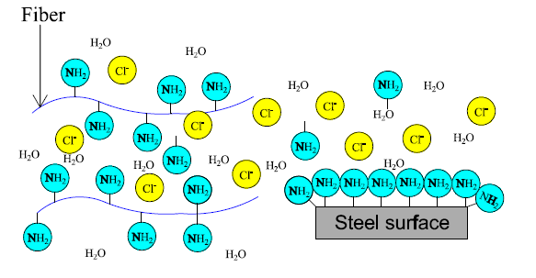
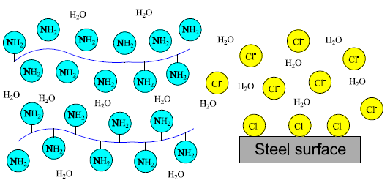

Illustrated diagram of the role of thiourea for protection of coating system

Abstract

In practice engineering, defects were inevitable for protective coating systems on steel surface. In this paper, a composite coating system, including primer, middle coat as well as top coat, were used to protect the carbon steel against corrosion in marine environment. Among them, two environmental additives, glass fibers and thiourea were applied in middle coat to modify the coating system. The long-term corrosion durability and the self-healing ability of the scratched coating system were evaluated by multiple methods. Results of electrochemical technologies indicated that the coating system containing 0.5 wt.% fibers and 0.5 wt.% thiourea presented a good performance of corrosion protection and self-healing for carbon steel as immersing in 3.5% NaCl for 120d. The evolution of localized corrosion factor with time obtained from current distribution showed that fibers combined with thiourea could effectively inhibit the occurrence of the local corrosion for the scratched coating systems and greatly delay the development of corrosion process. Surface characterization suggested that adequate of thiourea could be uniformly absorbed on fibers for a long time to play an important role in protecting the carbon steel. At last, the schematic models were established to demonstrate the action of fibers and thiourea on the exposed surface of the carbon steel and the scratched coating system in the whole deterioration process.
Keywords: glass fiber; anticorrosion ability; thiourea

Acknowledgements
This work was supported by the National Natural Science Foundation of China under Grant No. 51378269

