Confined Nanoscale geometries to enhance sensitivity of Plasmonic Immunoassays
Rishabh Rastogi,¹ Suresh Poovanthingal,² Pierre Michel Adam,³ Jewgeni Starikov,⁴ Saulius Juodkazis,⁵and Sivashankar Krishnamoorthy*¹
- Institute of Science and Technology, Belvaux, Luxembourg.

- Luxembourg Center for Systems Biomedicine, Esch-sur-Alzette, Luxembourg
- LNIO, Université de Technologie de Troyes, Troyes, France
- Karlsruhe Institute of Technology, Karlsruhe, Germany
- Swinburne University of Technology, VIC, Australia

Abstract
Sensitive transduction of bio-molecular binding events on chip carries profound implications to the outcome of a range of biological sensors. This includes biosensors that address both research as well as diagnostic questions of clinical relevance, e.g. profiling of biomarkers, protein expression analysis, drug or toxicity screening and drug-efficacy monitoring. Nanostructured biosensors constitute a promising advance in this direction owing to their ability in catering to better sensitivity, response times, and miniaturization. Plasmonic sensors are particularly interesting among nano-biosensors as they exploit light matter interactions in the nanoscale to transduce bio-recognition events with high sensitivity and miniaturized measurement footprints. Examples of plasmonic sensors include localized surface plasmon resonance spectroscopy (LSPR), surface enhanced Raman spectroscopy (SERS) and metal-enhanced fluorescence (MEF). The performance of the plasmonic sensors critically relies on ability to engineer nanoscale geometric attributes at length scales that typically overlap with the size of small proteins. Such geometries invariably introduce constraints on the molecular binding response, thus altering the interaction outcomes, viz. density and kinetics of adsorption, molecular orientations, in a manner that would impact the resulting optical response. A careful engineering of the nanoscale geometries can simultaneously take advantage of EM field enhancements together with molecular interaction within nanoscale geometries. To this end, this project aims at an engineered nanoscale interface with geometry tailored to simultaneously favour molecular adsorption and plasmonic enhancements for application to plasmonic sensors based on surface-enhanced Raman and Fluorescence spectroscopies.

Image
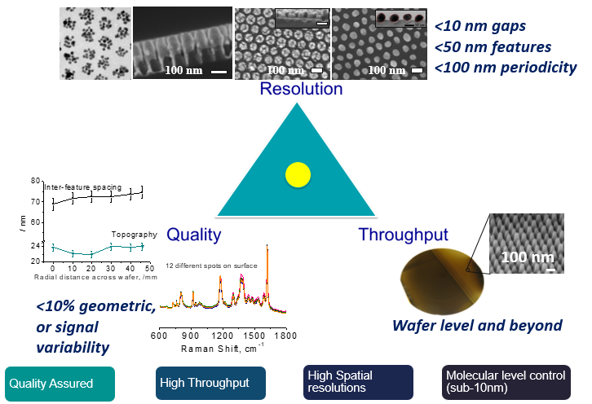
Figure 1: Representation of the three critical characteristics of the substrates proving them potentially advantageous for SERS application.
Recent Publications (minimum 5)
- Yap, F. L., Thoniyot, P., Krishnan, S., & Krishnamoorthy, S. (2012). Nanoparticle cluster arrays for high-performance SERS through directed self-assembly on flat substrates and on optical fibers. ACS Nano, 6(3), 2056–2070.
- Dinda, S., Suresh, V., Thoniyot, P., Balčytis, A., Juodkazis, S., & Krishnamoorthy, S. (2015). Engineering 3D Nanoplasmonic Assemblies for High Performance Spectroscopic Sensing. ACS Applied Materials and Interfaces, 7(50), 27661–27666.
- Krishnamoorthy, S., Van Den Boogaart, M. A. F., Brugger, J., Hibert, C., Pugin, R., Hinderling, C., & Heinzelmann, H. (2008). Combining micelle self-assembly with nanostencil lithography to create periodic/aperiodic micro-/nanopatterns on surfaces. Advanced Materials, 20(18), 3533–3538.
- Dinda, S., Yap, F. L., Suresh, V., Gupta, R. K., Das, D., & Krishnamoorthy, S. (2013). Quantitative detection with surface enhanced raman scattering (SERS) using self-assembled gold nanoparticle cluster arrays. Australian Journal of Chemistry, 66(9), 1034–1038.
- Krishnamoorthy, S., Krishnan, S., Thoniyot, P., & Low, H. Y. (2011). Inherently reproducible fabrication of plasmonic nanoparticle arrays for SERS by combining nanoimprint and copolymer lithography. ACS Applied Materials and Interfaces, 3(4), 1033–1040.
- Current Opinion in Biotechnology, 2015, 34, 118.


Biography
Rishabh Rastogi is a PhD. Student from Delhi, India. During his studies he worked within different laboratories learning scientific skills and gaining experience in nanofabrication, which made him motivated towards this field. He is working on fabrication of structures that engineered nanoscopically in order to achieve enhancement in electromagnetic waves due to confinement effects. At LIST he is working towards developing plasmonic immunoassays with extreme sensitivity.
Email: Rishabh.rastogi@list.lu
Contact no: +352-671533872
Track name: Biosensors and Bioelectronic Materials
Notes/Comments

