Novel and versatile solid-state chemiluminescnce sensor based on TiO₂-Ru(bpy)₃²⁺ nanoparticles for pharmaceutical drugs detection
Entesar Al-Hetlani, PhD, Kuwait University, Kuwait
Mohamed O. Amin, BSc, Kuwait University, Kuwait
Metwally Madkour, PhD, Kuwait University, Kuwait

Abstract
This work describes a novel and versatile solid-state csensor for analytes detection using Ru(bpy)₃²⁺⁻Ce(IV). Herein, we report the synthesis, characterization, optimization and application of a new type of hybrid nanoparticles (NPs). Mesoporous TiO₂-Ru(bpy)₃²⁺ NPs were prepared using a modified sol-gel method by incorporating Ru(bpy)₃²⁺ into the initial reaction mixture at various concentrations. The resultant bright orange precipitate was characterized via: TEM, N₂ sorpometry, ICP-OES, Raman and UV-Vis spectroscopy techniques. The concentration of Ru(bpy)₃²⁺ complex in the NPs was quantified and its chemiluminescnce (CL) response was compared to the same concentration in the liquid phase using oxalate as model analyte. The results showed that this type of hybrid material exhibited higher CL signal compared to the liquid phase due to enlarged surface area of the hybrid NPs (~149.6 m²/g). The amount of TiO₂-Ru(bpy)₃²⁺. NPs and the effect of the oxidant flow rate were also investigated to optimize the CL signal. The optimized system was further used to detect oxalate and two pharmaceutical drugs; imipramine and promazine. The linearity of both drugs was in the range of 1-100 pM with limits of detection (LoD) of 0.1 and 0.5 pM, respectively. This approach is considered simple, low cost, facile and can be applied to a wide range of analytes.

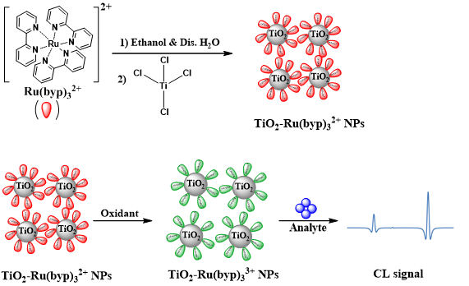

Figure 1:A schematic represntation of the newly synthesised solid-state TiO₂-Ru(bpy)₃²⁺ NPs as a new approach chemilunminescnce sensor for analyte detection.
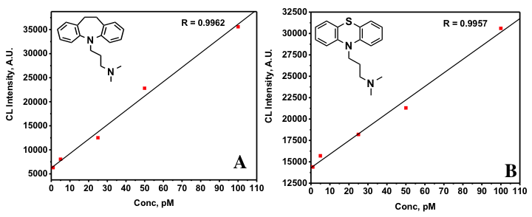

Figure 2: Calibration curves for A) imipramine drug with linear range of 1-100 pM and LoD of 0.1 pM and B) promazine drug with linear range of 1-100 pM and LoD of 0.5 pM.

Recent Publications

- Al-Hetlani E, Amin M, Madkour M (2017) Detachable photocatalysts of anatase TiO₂ nanoparticles: Annulling surface charge for immediate photocatalyst separation. Applied Surface Science. 411: 355-362.


Mohamed O. Amin is a graduate of Kuwait University and currently pursuing an MSc in medicinal chemistry. Despite being passionate about medicinal chemistry he is always looking for other research opportunities in other research laboratories in Kuwait University. This quest for knowledge and experience lead him to work in Dr. Al-Hetlani and Dr. Madkour laboratory and learn about nanomaterials synthesis, characterization and vast range of applications. He has published his first research paper in the area of photocataysis using TiO_{s} NPs. Furthermore, He participated in using this type of nanomaterial as solid support for detection applications namely, chemiluminesscnce (CL) due to their large surface area. This work is the first of its kind in the area of solid state CL and was used for the detection of oxalic acid and two pharmaceutical compounds achieving enhanced LoD.
Email:mohamed.o.amin@hotmail.com / Mohamed.o.amin@iCloud.com

Notes/Comments:

