Study of the mechanical and surface properties of the composites commonly used in lightweight constructions
Donata Kuczynska, Agata Sotniczuk, Piotr Kwasniak PhD, Jaroslaw Pura, Halina Garbacz professor
Warsaw University of Technology

Abstract
Audiometric screening tests are carried out in lightweight, mobile capsules. In this case, compliance with specific environmental conditions, in particular acoustic, necessitates the selection of suitable sound absorbing materials. The assignment of the materials into the group of sound absorbing materials depends on the value of the absorption coefficient. Sound absorbing materials should have and absorption coefficient α>0,1 in any frequency, what can be achieved for materials characterized by both high porosity or high surface perforation. Materials of this type include, modern layered materials and sandwich structured as “honeycomb” type. In mentioned applications, the mechanical properties of these materials are also important in addition to the sound absorption properties. This study presents systematic comparison between commonly used and commercially available construction composites. Two of analyzed composites, layered and sandwich structured, are typically used as lightweight constructions elements, because of their unique properties and advantageous weight to flexural strength ratio. Both analyzed composites, exhibit high absorption of the sound. The analyzed composites were characterized in terms of mechanical and surface properties. Special emphasis was placed on the characteristic of the connection between composite structural components. For this purpose, the following methods were used: scanning electron microscopy, optical profilometry, contact angle measurements and 3-point bending. Presented systematic analysis will be useful to select appropriate materials for lightweight constructions. The main results if the study can be summarized in the following conclusions. 1) Both composites demonstrate that they are several times more rigid compared to commonly used polymer composites. 2) Comparative analysis revealed many times higher mechanical properties of the sandwich structured panels compared to layered composites. 3) Studies showed that layered composite is characterize by the absence of delimitation of the lightweight panel. The results show high potential of the analyzed composites as lightweight construction materials with simultaneous sound absorption.

Image

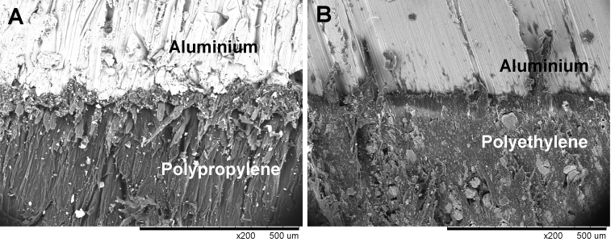

Figure 1. SEM micrograph of the core/filling connections in A) sandwich structured, B) Layered composite.

Recent Publications
- M.W. Simons, J. Waters (2004) Sound Control in Buildings. Blackwell Publishing Ltd
- Lee, W. R., J. E. J. John, and F. Fowweather. (1963) A vehicle for use as an audiology unit. Occupational and Environmental Medicine 20.1: 57-62.
- Wen-chao, Huang, and Ng Chung-fai. (1998) Sound insulation improvement using honeycomb sandwich panels. Applied Acoustics 53.1-3: 163-177.
- Gibson, Ronald F. (2010) A review of recent research on mechanics of multifunctional composite materials and structures. Composite structures 92.12: 2793-2810.
- Zhou, Ran, and Malcolm J. Crocker. (2010) Sound transmission loss of foam-filled honeycomb sandwich panels using statistical energy analysis and theoretical and measured dynamic properties." Journal of Sound and Vibration 329.6: 673-686.
- Davies, John Michael, ed. (2008) Lightweight sandwich construction. John Wiley & Sons.


Biography
Donata Kuczynska is a PhD student and has her expertise in evaluation of surface properties of the materials, especially in biomaterials. Her main interest is interaction of titanium surface with the plasma proteins (albumin and fibronectin) and cells. She deals with comprehensive surface characterization of physicochemical properties such as: chemical composition, roughness, topography, wettability and surface free energy. She has experience in surface analysis techniques - AFM Atomic Force Microscopy, Optical Profilmetry, XPS Spectroscopy, Auger AES Spectroscopy and Fourier FTIR Spectroscopy. Currently she is working on laser surface texturing of titanium and its alloys.
Email: donatakuczynska@gmail.com

Notes/Comments: This research was financially supported by The National Centre for Research and Development under Grant STRATEGMED1/248664/7/NCBR/2014.

