Contrastive analysis between Hydrothermal and Co-precipitation methods for the synthesis of Cerium oxide nanoparticles and their anti inflammatory activities
Malatesh S. Pujar, M.Sc, Department of Physics, Karnatak University, Dharwad-580 003, India.
Shirajahammad M. Hunagund, M.Sc, Department of Physics, Karnatak University, Dharwad-580 003, India.
Vani R. Desai, M.Sc, Department of Physics, Karnatak University, Dharwad-580 003, India.
Shivaprasadgowda Patil, M.Sc, Department of Physics, Karnatak University, Dharwad-580 003, India.
Ashok H. Sidarai, Ph.D, Department of Physics, Karnatak University, Dharwad-580 003, India.

Abstract
The foolproof work has been studying for the cerium oxide (CeO₂) nanoparticles via various methods i.e, by Hydrothermal and Co-precipitation methods. With these contrastive methods, Herein we synthesized CeO₂ nanoparticles in one-step using the Cerium (III) nitrate hexahydrate (Ce(NO₃)₃.6H₂O) and Sodium hydroxide (NaOH). UV-Vis spectroscopy, X-ray diffraction (XRD), Fourier transforms infrared spectroscopy (FT-IR) and Thermo gravimetric analysis (TGA) were used to characterize for to analyze it’s optical, structural, functional group and thermal decompositions respectively. These results reveal the following significance; UV-Vis spectroscopy shows the absorption maxima at 283 nm and 274 nm for Hydrothermal and Co-precipitation methods and their corresponding energy gap was estimated using the Kubelka – Munk equation i.e, 3.85 eV and 4.05 eV respectively. XRD analysis confirmed that they are in cubic system and the estimated average crystalline size from the Scherrer’s formula is 9.50 nm and 5.35 nm for Hydrothermal and Co-precipitation methods respectively. FT-IR spectroscopy analysis firmly suggests that there is an akin conjugation of organic and inorganic species to the CeO₂ nanoparticles for Hydrothermal and Co-precipitation methods. From the TGA curves we observed thermal decomposition from ambient temperature to 800 ̊̊ c and the corresponding weight loss are observed around 11% for Hydrothermal and Co-precipitation methods. With these desire results we applied both synthesized CeO₂ nanoparticles to the anti inflammatory studies and the final results suggested that the Hydrothermal synthesized CeO₂ nanoparticles act more effective than Co-precipitation method.

Graphical Abstract

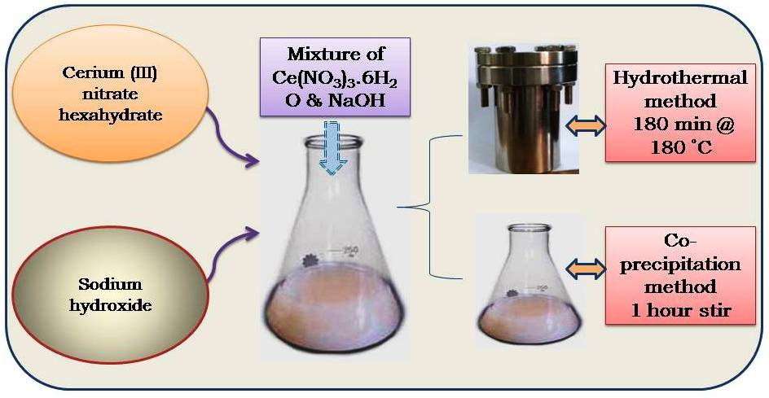Recent Publications
- Desai VR, Hunagund SM, Pujar MS et al. (2017) Spectroscopic interactions of titanium dioxide nanoparticles with pharmacologically active 3(2H)-pyridazinone derivative. Journal of Molecular Liquids 233:166-172.
- Hunagund SM, Desai VR, Delicia AB, Pujar MS et al. (2017) Photocatalysis effect of a novel green synthesis gadolinium doped titanium dioxide nanoparticles on their biological activities. Journal of Photochemistry and Photobiology A: Chemistry 346:159-167.
- Desai VR, Hunagund SM, Pujar MS et al. (2017) Photophysical Properties of a Novel and Biologically Active 3(2H)-Pyridazinone Derivative Using Solvatochromic Approach. Journal of Fluorescence DOI: 10.1007/s10895-017-2117-z.
- Pujar MS, Hunagund SM, Desai VR et al. (2017) Synthesis and characterization of Zinc oxide nanoparticles. JABINTRONICS-ISBN-978-81-931806-8-6.

 Biography
Malatesh S. Pujar has his cleverness in the field of materials science and has specially interested in Nanoscience and Nanotechnology. He is life member of the Indian Science Congress Association (ISCA) and International Association of Advanced Materials (IAAM). He completed his master degree in Physics with specialization of Condensed Matter Physics at ALVA’S college, Moodbidri, D K Karnataka, India. Currently, he is Research fellow, working under the guidance of Prof. Ashok H. Sidarai, Department of Physics, Karnatak University (K U) Dharwad, Karnataka, India. He has published 3 research articles in esteemed journals and more than 10 conference papers. He is also awarded for University Research Studentship (URS) from K U Dharwad, Karnataka, India. At present he is actively working on synthesizing nanopartricles by various methods and giving captivating results in Physics, Engineering, Bio-Physics and Medical fields etc.
Email: malateshpujar014@gmail.com

Notes/Comments:

