Synergistic effect of UV light photocatalytic on ytterbium doped titanium dioxide nanoparticles against Gram strain bacteria’s
Shirajahammad M. Hunagund, M. Sc, Department of Physics, Karnatak University, Dharwad-580 003, India.
Vani R. Desai, M. Sc, Department of Physics, Karnatak University, Dharwad-580 003, India.
Jagadish S. Kadadevarmath, Ph.D., Department of Physics, Karnatak University, Dharwad-580 003, India.
Ashok H. Sidarai, Ph.D., Department of Physics, Karnatak University, Dharwad-580 003, India.

Abstract
A novel Up-conversion ytterbium material was doped with titanium dioxide (YbT) nanoparticles (NPs) for to analyze the effect on antibacterial activities in two conditions (without UV-irradiated and with UV-irradiated) against two Gram strain bacteria’s (Staphylococcus aureus and Escherichia coli). For the synthesis of YbT NPs, we have employed a bottom-up approach in that the green route was adopted. In the green route, there are a number of bioreductants were used due to their potentiality. In our synthetic route, a novel Piper Betel leaf extract was chosen due to their rich constituents (Phytochemicals). In order to confirm their optical, functional, surface morphological, structural and thermal stability observations, YbT NPs was subjected to various characterization techniques. The obtained results were signified that they having an absorption maximum around at 373 nm, the presence of N-H, C-H, C=O and C-O on YbT FT-IR spectrum indicates that the possible presence of bioreductants which are responsible for the reduction and stabilizing the YbT NPs. The size of the particles was in nano nature and they consist size of about 7 nm. They are having a tetragonal crystal structure, later compared the crystalline size from Scherrer’s and Williamson-Hall (W-H) methods, this may signify that estimated crystalline size from the W-H method is more appropriate for the TEM image as compared to the Scherrer’s method. The YbT NPs are thermally stable. After the satisfactory results, we have further studies their antibacterial activities. The obtained results may indicate that YbT NPs have shown more potent antibacterial activities against Staphylococcus aureus and Escherichia coli bacteria in both the conditions. But we have got more zone of inhibition for with UV-irradiated YBT NPs. So this may indicate that YbT NPs can be used for various biological activities. Furthermore, this synthesis route can be utilized for the mass productions of NPs; it may help for the industrial uses.

Graphical Abstract
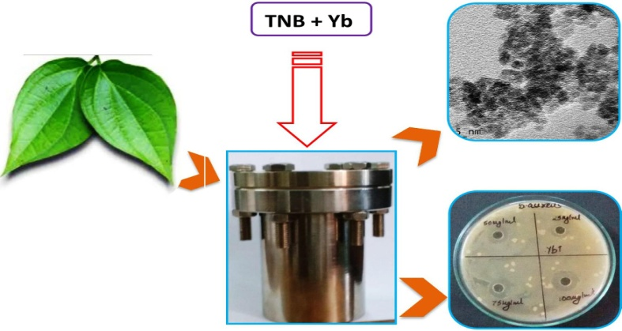
Recent Publications
- Hunagund SM, Desai VR et al. (2017) Photocatalysis effect of a novel green synthesis gadolinium doped titanium dioxide nanoparticles on their biological activities. Journal of Photochemistry and Photobiology A: Chemistry 346:159-167.
- Desai VR, Hunagund SM et al. (2017) Spectroscopic interactions of titanium dioxide nanoparticles with pharmacologically active 3(2H)-pyridazinone derivative. Journal of Molecular Liquids 233:166-172.
- Desai VR, Hunagund SM et al. (2017) Spectroscopic studies on newly synthesized 5-(2-hydroxy-5-methoxy-phenyl)-2-phenyl-2H-pyridazin-3-one molecule. Journal of Molecular Liquids 225:613-620.
- Hunagund SM, Desai VR et al. (2016) Biogenic and chemogenic synthesis of TiO2 NPs via hydrothermal route and their antibacterial activities. RSC Advances 6: 97438-97444.
- Desai VR, Sidarai AH, Hunagund SM et al. (2016) Steady state absorption and fluorescence study: Estimation of ground and excited state dipole moments of newly synthesized pyridazin-3(2H)-one derivatives. Journal of Molecular Liquids 223:141-149.

 Biography
Shirajahammad M. Hunagund has expertise in the field of Material Sciences and Fluorescence Spectroscopy. He is a life member of Society for Material Chemistry. He completed his master degree in Physics with the Second rank to the Rani Channamma University, Belagavi, Karnataka State, India. He published one book and more than fifteen research articles in peer-reviewed journals. Among this one of the research article has been selected for the “Best Research Publication in Science-2016” from the Karnatak University (K.U), Dharwad, Karnataka State, India. Currently, he is a senior research fellow working under the guidance of Professor Ashok H. Sidarai, Department of Studies in Physics, K.U. Dharwad. Presently, he is working on biosynthesized nanoparticles and their photocatalytic effect on biological activities.
Email: shiraj.034@gmail.com

Notes/Comments:

