Encapsulation of oxynitride phosphors into sintered

Li₂O-ZnO-B₂O₃-P₂O₅-CaF₂ glass body

N. Akiyama*¹, H. Kuwahara¹, H. Kuroe¹, H. T. Hintzen² and K. Itatani¹
¹Department of Materials and Life Sciences, Sophia University, 7-1, Kioi-cho, Chiyoda-ku, Tokyo 102-8554, Japan;
²Faculty of Applied Sciences, Delft University of Technology, Mekelweg 15, 2629 JB Delft, The Netherlands

Abstract
The conditions for the fabrication of transparent glass body in the Li₂O-ZnO-B₂O₃-P₂O₅-CaF₂ system were examined by a pressureless firing and subsequent oxygen-supplied hot isostatic pressing (O₂-HIP). The starting glass was prepared by melting the mixture of LiOH, ZnO, H₃BO₄, H₃PO₄ and CaF₂ at 1100ºC in air, followed by quenching on copper plates cooled by liquid nitrogen. The glass powder compact was pressurelessly-fired at 370ºC for 1 h in order to remove the open pores, and the subsequent O₂-HIP treatment at 370 ºC for 24 h under the pressure of 130 MPa made the clear light transmission possible, regardless of the formation of β-Ca₂P₂O₇ on the surface. The glass body obtained by firing at 370˚C for 1 h and the subsequent O₂-HIP treatment at 370 ºC for 24 h was hydrothermally-treated in water at 100˚C for 1 h, and found that the mass loss of this body was as low as 0.25%, showing excellent water resistance.
When the oxynitride phosphors, i.e., blue-emitting (La_{0.96}Ce_{0.04})₃Si₈O₄N₁₁ and yellow-emitting (Ca_{0.97}Eu_{0.03})Si₂O₂N₂, were encapsulated into the glass, no peak shifts in the emission/excitation spectra were found, which demonstrated that no significant degradation of phosphors has occurred during the encapsulation operation. Pseudo-white light emission was observed by the equi-mass addition (total amount: 3 mass%) of (La_{0.96}Ce_{0.04})₃Si₈O₄N₁₁ and (Ca_{0.97}Eu_{0.03})Si₂O₂N₂.
Overall, the transparent glass body could be fabricated by the pressureless firing and subsequent O₂-HIP treatment, and the phosphors were encapsulated into the glass without significant degradation.

Image
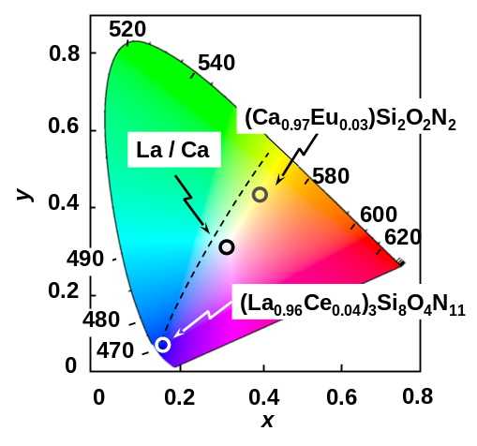

Figure 1: Chromaticity coordinate of glass body with (La_{0.96}Ce_{0.04})₃Si₈O₄N₁₁ and (Ca_{0.97}Eu_{0.03})Si₂O₂N₂ addition（Excitation WL：370 nm）

Recent Publications (minimum 5)
- Li YQ, Delsing ACA, With GD and Hintzen HT (2005) Luminescence Properties of Eu²⁺-Activated Alkaline-Earth Silicon-Oxynitride MSi₂O_{2-δ}N_{2+2/3δ} (M = Ca, Sr, Ba): A Promising Class of Novel LED Conversion Phosphors. Chem. Mater. 17:3242-3248.
- Li YQ, Van Steen JEJ, Van Krevel JWH, Botty G, Delsing ACA, DiSalvo FJ, With GD and Hintzen HT(2006) Luminescence properties of red-emitting M₂Si₅N₈:Eu²⁺ (M = Ca, Sr, Ba) LED conversion phosphors. J. Alloys Compd. 417:273-279.
- Mihara S, Yamaguchi K, Hintzen HT, Delsing ACA, Koda S and Itatani K(2010) Synthesis and Luminescence Properties of Rare-Earth Doped Gadolinium Silicon Oxynitride with Cuspidine Structure. Adv. Sci. Technol. 62: 95-100.
- Yamaguchi K, Hintzen HT, Delsing ACA, Kuwahara H, Koda S and Itatani K(2011) Preparation of Eu²⁺-doped Ca₂Si₅N₈ by Carbothermal Reduction / Nitridation of Spray-pyrolyzed Oxide/nitride Powder and Its Luminescence Properties. J. Light & Vis. Env. 35:207-213.
- Morishita H, Delsing ACA, Hintzen HT, Kuwahara H and Itatani K(2014) Preparation of red-emitting Eu²⁺-doped barium calcium silicon oxynitride by solid-state reaction and its luminescence properties. Key Eng. Mater. 617: 149-152.

 Biography (150 word limit)
Nanako Akiyama is a student of Sophia graduate school. Her research interest is the luminescence properties of oxide, oxynitride and nitride phosphors, and the encapsulation technique of the phosphors in the glass.

Email: nanako.jennifer@gmail.com

Notes/Comments:

