Kovacs effect and the relation between glasses, supercooled liquids and crystals
Francesco Aliotta, CNR-IPCF, Messina, ITALY

Abstract
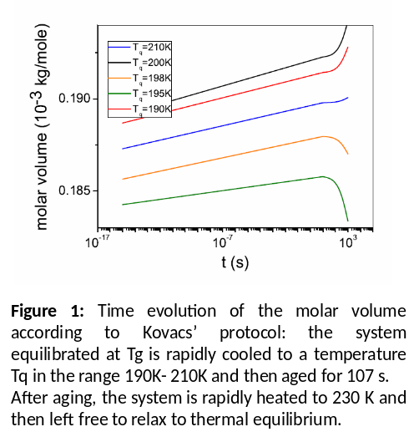
We revisit Kovacs’ effect, which concerns the way the volume of a glass-forming liquid, originally driven out of equilibrium, changes with time while the system evolves towards a metastable state. The theoretical explanation of this phenomenon has attracted a deep interest even in recent years, because of its relation with some subtle aspects of the still elusive nature of the glass transition. In fact, even if there is a rather general consensus on the fact that what is experimentally observed on cooling is the dramatic effect produced by the dynamical arrest of slower degrees of freedom over the experimental time scale, it is not at all obvious whether this phenomenology can be justified by an underlying (possibly, high order) phase transition at a lower temperature. We show how the phenomenon investigated by Kovacs can be explained in terms of the relaxation undergone by slow motions, on a time scale comparable with the experimental time windows. The results from a simple model system, namely o-therphenyl, are compared with indications from other glass formers, including water. The mechanisms underlaying the formation of crystals (dendrites) when a supercooled liquid escape metastability are also explored within the adopted perspective.
The ability of a simple out-of-equilibrium approach in reproducing a wide class of phenomena related with the glass transition suggests the idea that the hypothesis of a thermodynamic phase transition should be reconsidered in favor of alternative scenarios.

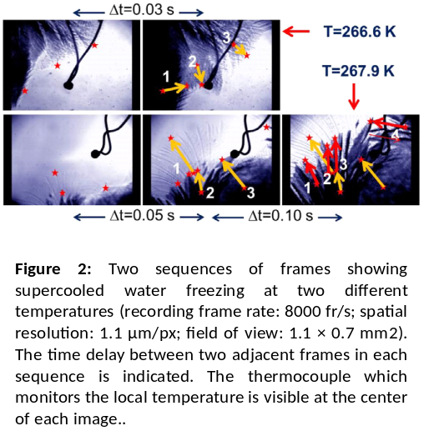
Image

Recent Publications
- Aliotta F, Giaquinta PV, Ponterio RC, Prestipino S, Saija F, Salvato G, Vasi C (2014) Supercooled water escaping from metastability, Scientific Reports 4:7230.
- Aliotta F, Giaquinta PV, Pochylski M, Ponterio RC, Prestipino S, Saija F, Vasi C (2013), Volume crossover in deeply supercooled water adiabatically freezing under isobaric conditions, J. Chem. Phys. 138: 184504.
- Aliotta F, Gapinski J, Pochylski M, Ponterio RC, Saija F, Salvato G, Vasi C (2013), High-frequency propagating density fluctuations in deeply supercooled water: Evidence of a single viscous relaxation, Phys. Rev. E 87: 0220303.
- Aliotta F, Calandra P, Pochylski M, Ponterio RC Salvato G, Vasi C (2014), AIP Advances 4: 097105.
5. Aliotta F, Ponterio RC, Saija F, Giaquinta PV (2017), Kovacs effect and the relation between glasses and supercooled liquids, to appear on Many-body approaches at different scales : a tribute to N. H. March on the occasion of his 90th birthday, edited by Angilella GGN and , Amovilli C.

Biography
Francesco Aliotta has his main expertise in the field of Thermodynamics of irreversible processes. In particular he is involved in the investigation of the collective processes emerging when a system is driven out of thermodynamic equilibrium condition. As a collateral activity he is involved in the development of instrumentation for material investigation. As an example, he was the leader of the Italian team which designed and built the energy selective neutron tomography device now installed at the IMAT beam line of ISIS (STFC, UK) and officially inaugurated on October 10, 2016. Actually he take the position of Research Director at IPCF-CNR, Messina, Italy.
Email: aliotta@ipcf.cnr.it

Notes/Comments:

