Cast Multi-Material Components Using 3D Printed Sand Molds and Cores
Alan Druschitz, PhD, Virginia Tech, USA
Christopher Williams, PhD, Virginia Tech, USA
Romesh Batra, PhD, Virginia Tech, USA
Robert Wood, ExOne, USA

Abstract

Cast multi-material components can now be easily produced using 3D printed sand molds and cores. First, components are designed in CAD. The CAD files for the molds or cores are then produced using Boolean subtraction. The mold or core CAD files are then sliced to produce layers that allow monolithic ceramic or metallic objects, such as tiles, tubes or solid bars, to be added. Ferrous or non-ferrous metals can be cast around these objects forming a one piece, integrated structure. The heat of the cast metal degrades the polymer binder that holds the 3D printed sand molds and cores together allowing for easy shake-out and cleaning. Heat treatment of these integrated structures can then be performed if desired. Examples of lightweight energy absorbing structures (lattice structures), structures with high ballistic penetration resistance (lattice structures with embedded ceramic or metallic tiles, Figure 1), advanced heat exchanger concepts (stainless steel tubing embedded in high thermal conductivity copper), and structures that exhibit tensegrity behavior are described.

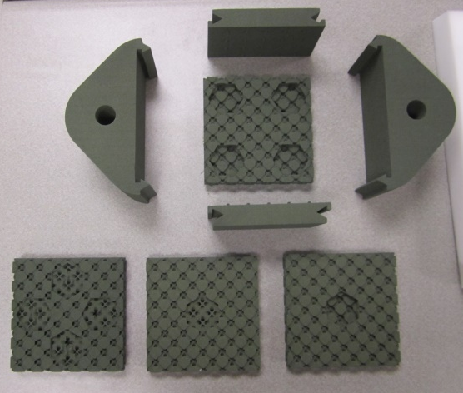

Figure 1. 3D printed sand mold for producing lattice structure castings with embedded ceramic or metallic tiles for penetration resistance.

Recent Publications
- A.P Druschitz, C.B. Williams, B. Wood, “Metal-Monolithic Ceramic/Metal Composite Castings Produced Using 3D Printed Sand Molds and Cores,” TechConnect World Innovation Conference & Expo, Washington, DC (2017).
- Snelling, D.A., Williams, C.B., Suchicital, C.T.A., Druschitz, A.P., “Binder jetting advanced ceramics for metal-ceramic composite structures,” Int J Adv Manuf Technol (2017). doi:10.1007/s00170-017-0139-y
- A.P. Druschitz, S. Cowden, A. Dudley, S. Walsh, A. Weir, C.B. Williams, B. Wood, “Metal-ceramic composite lattice structures using 3D printed sand molds and cores,” International Solid Freeform Fabrication Symposium Proceedings, Austin, TX (2016).
- N. Jorapur, R. West, C.B. Williams, A. Druschitz, “Design of fiber-reinforced cellular structures with tensegrity behavior manufactured using 3D printed sand molds,” International Solid Freeform Fabrication Symposium Proceedings, Austin, TX (2016)
- D. Snelling, Q. Li, N. Meisel, C. B. Williams, R. C. Batra, and A. P. Druschitz, “Lightweight Metal Cellular Structures Fabricated via 3D Printing of Sand Cast Molds,” Advanced Engineering Materials, published online March 11, 2015 (DOI: 10.1002/adem.201400524.
- D. Snelling, C. B. Williams, C. Suichital, A. Druschitz, “Fabrication of Cordierite Preforms via Binder Jetting,” International Solid Freeform Fabrication Symposium, Austin, TX (2015).
- D.A. Snelling, R. Kay, A. Druschitz, C.B. Williams, “Mitigating gas defects in castings produced from 3D printed molds,” International Foundry Research/Giessereiforschung 66 (2014) No. 2, pp. 2-8.

Biography
Alan Druschitz has 34 years of industrial materials research, product development, manufacturing support, management and teaching experience. He specializes in cast metals, component manufacturing, materials characterization, and corrosion. He has extensive experience with automotive components, product design, failure analysis, heat-treating, welding, materials and component testing and nondestructive testing. He has over 80 publications and holds six patents. He is a Fellow of the Society of Automotive Engineers and the Chair of the ASM International Handbook committee. He is a member of the AFS, ASM International, TMS, AIST, and NACE International.
Email: adrus@vt.edu

Notes/Comments:

