Processing and Characterization of Intercritically Austempered Ductile Iron (IADI)
Alan Druschitz, PhD, Virginia Tech, USA

Abstract

Intercritically austempered ductile iron (IADI) has a microstructure of well-formed graphite nodules in a matrix of ferrite and ausferrite, Figure 1. This microstructure produces a material that has better strength and ductility compared to ferrite/pearlite microstructures and better ductility, improved resistance to environmentally assisted cracking, and better machinability compared to fully ausferritic microstructures (conventional austempered ductile iron). The austenite in the ausferrite particles can undergo transformation induced plasticity but this transformation is a function of particle morphology and chemistry. This microstructure is also a challenge to produce in thick section sizes since the ability to produce ausferrite is a function of cooling rate and chemistry. The production and characterization of IADI will be discussed in an effort to encourage the further development of this material.

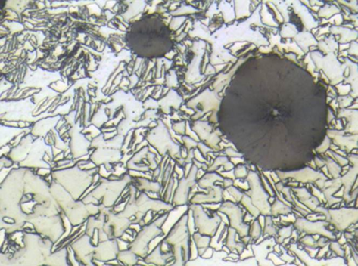
ferrite
ausferrite
graphite nodule

Figure 1. Microstructure of Intercritically Austempered Ductile Iron Showing Well-Formed Graphite Nodules in a Matrix of Ferrite and Ausferrite.

Recent Publications
- A.P Druschitz, P. Kim, “The Hardenability of Ausferrite for Intercritically Austempered Ductile Iron,” ADI World Conference Proceedings, Atlanta, GA (2016).
- A. Druschitz, M. Ostrander, R. Aristizabal, “The science of intercritically austempered ductile iron,” International Foundry Research/Giessereiforschung 66 (2014) No. 4, pp. 30-42.
- A.P Druschitz, R. Aristizabal, M. Ostrander, “Advanced Heat Treatments for Ferrous Alloys,” SAE Technical Paper #2013-01-0950, Society of Automotive Engineers, Warrendale, PA (2013).
- R. Aristizabal, R. Foley, A. Druschitz, “Intercritically Austempered Quenched and Tempered Ductile Iron,” International Journal of Metalcasting, American Foundry Society, Vol. 6, Issue 4 (2012) pp. 7-14.
- A.P. Druschitz, R.E. Aristizabal, E. Druschitz, C.R. Hubbard, T.R. Watkins, L. Walker, M. Ostrander, “In-Situ Studies of Intercritically Austempered Ductile Iron (IADI) Using Neutron Diffraction,” Met Trans A, Vol. 43, No. 5 (2012) pp.1468-1476.
- A.P. Druschitz, H. Folz, D. Devor, S. Kapoor, A. Balasubramanian, K. Bronk, J. Bussema, M. Glowik, N. Malkewicz, S. Etling, P. Hedge “Machinability of MADITM,” SAE Technical Paper #2005-01-1684, Society of Automotive Engineers, Warrendale, PA (2005).
- A.P. Druschitz, D.C. Fitzgerald, “MADITM: Introducing A New, Machinable Austempered Ductile Iron,” SAE Technical Paper #2003-01-0187, Society of Automotive Engineers, Warrendale, PA (2003).

Biography
Alan Druschitz has 34 years of industrial materials research, product development, manufacturing support, management and teaching experience. He specializes in cast metals, component manufacturing, materials characterization, and corrosion. He has extensive experience with automotive components, product design, failure analysis, heat-treating, welding, materials and component testing and nondestructive testing. He has over 80 publications and holds six patents. He is a Fellow of the Society of Automotive Engineers and the Chair of the ASM International Handbook committee. He is a member of the AFS, ASM International, TMS, AIST, and NACE International.
Email: adrus@vt.edu

Notes/Comments:

