Towards conductive textiles: coating polymeric fibres with graphene
Ana I. S. Neves, Elias Torres Alonso, Saverio Russo, Monica F. Craciun, University of Exeter, UK
Daniela P. Rodrigues, Helena Alves, University of Aveiro, Portugal

Abstract
The concept of smart-textiles is witnessing a rapid development with recent advances in nanotechnology and materials engineering. Bearing in mind that the concept of textiles is much wider than clothes and garments, the potential is immense. While most current commercial applications rely on conventional hardware simply mounted onto fibres or fabrics, a new approach to e-textiles consisting in using functionalised textiles for several technological applications has the potential to change the paradigm of wearable electronics completely.
Conducting fibres are an important component of any e-textile, nor only because they can be used as wiring for simple textile-based electronic component, but also because they can be used to build electronic devices directly on textile fibres. We have reported a new method to coat insulating textile fibres with monolayer graphene to make them conductive while preserving their appearance. [1] There are a number of factors that can greatly influence the sheet resistance achieved by graphene-coated textile fibres. In order to understand the influence of the topography of the fibres on the effectiveness of the graphene coating, an extensive study encompassing microscopy techniques like Atomic Force Microscopy and Scanning Thermal Microscopy, as well as Raman spectroscopy was performed. [2]
This method has proven to be a versatile tool to achieve flexible, transparent and conducting fibres of different materials, sizes and shapes. The first applications of electronic devices built on such fibres are demonstrated, with an alternating current electroluminescent device, following previous work in our group on similar devices in flexible substrates. [2] This opens up the way for the realisation of wearable devices on textiles.

Image
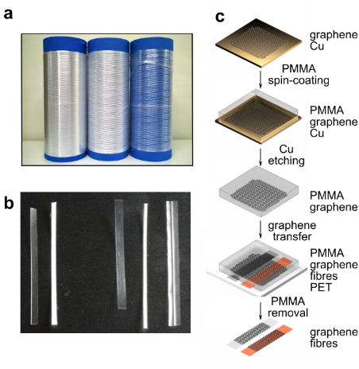
Figure 1. a) Photo of the fibres in reels. b) Photo of the fibres cut to ca. 3 cm length. c) Schematic representation of the graphene transfer onto textile fibres.
Recent Publications (minimum 5)
- Neves AIS, et al. (2017) Towards conductive textiles: coating polymeric fibres with graphene (accepted in May2017)
- Neves AIS, et al. (2015) Transparent conductive graphene textile fibres. Sci. Rep. 5:09855.
- Torres Alonso E, et al. (2015) Homogeneously bright, flexible, and foldable lighting devices with functionalized graphene electrodes. ACS Appl. Mater. Interfaces, 8:16541-16545.
- Pinto RM, et al. (2015) Ultrasensitive organic phototransistors with multispectral response based on thin-film/single-crystal bilayer structures. Appl. Phys. Lett. 107:223301.
- Pinto RM, et al. (2015) Effects of molecular stacking on exciton diffusion in crystalline organic semiconductors. J. Am. Chem. Soc.
37:7104-7110.

Biography
Dr Ana Neves has a background in Chemistry, with a PhD awarded by IST, University of Lisbon, Portugal, for work carried out at the Solid State Group of ITN (Lisbon), on the molecular engineering of materials with magnetic and electric properties. Pursuing the path of applications, she joined the Organic Electronics group at INESC –Microsystems and Nanotechnology in Lisbon in 2013 as a postdoctoral researcher. Dr Neves joined the University of Exeter in October 2014 as an Associate Research Fellow under the project "Wearable light emitting transistors for future communication devices". Since October 2016 she is a Lecturer in Engineering, and currently holds a Marie Sklodowska-Curie Individual Fellowship with project E-TEX "All-organic devices in textiles for wearable electronics". She is also a member of the Nano-Engineering, Science and Technology Group (NEST). Dr Neves research interests include applications of molecular materials, graphene and 2D materials in wearable electronic and sensing devices.
Email: a.neves@exeter.ac.uk

Notes/Comments:

