Electrochemical decoration of MoS₂ nanoplatelet arrays with Pt quantum dots for high efficient water splitting

Arnas Naujokaitis, PhD student, Vilnius University, NCPTS, Lithuania
Kestutis Arlauskas, Prof., Vilnius University, Lithuania
Rokas Zalneravicius, PhD student, NCPTS, Lithuania
Arunas Jagminas PhD, NCPTS, Lithuania
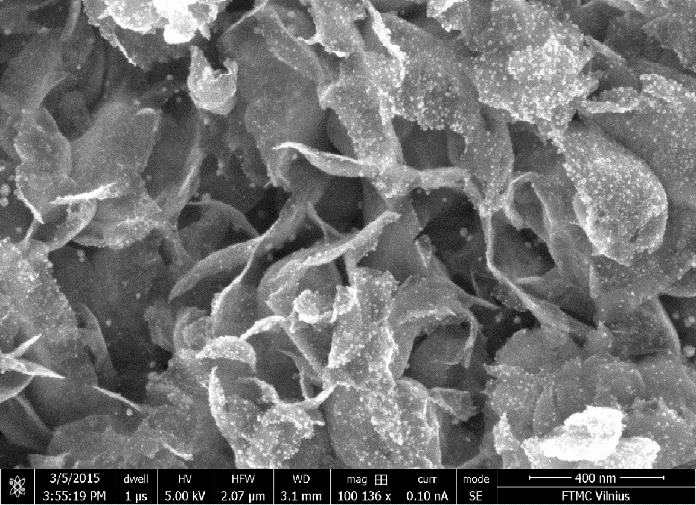
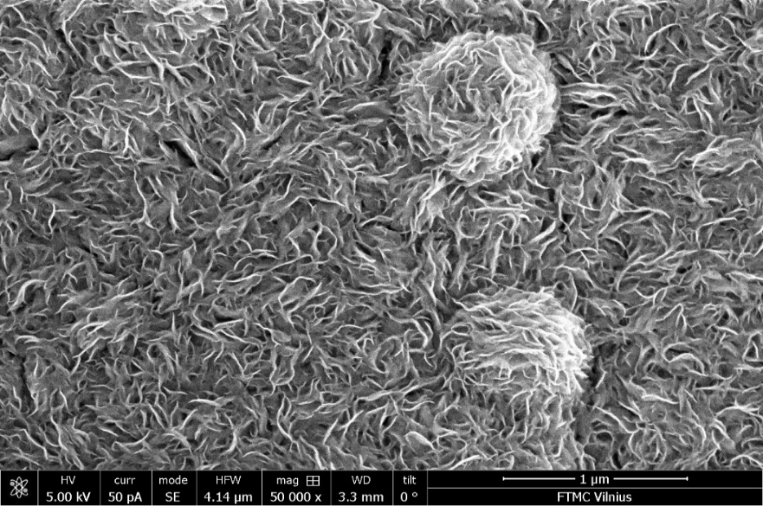
400 nm
(a)
(b)

Abstract
Statement of the Problem: Water splitting via low-cost electrocatalysis is crucial for the development of clean energy from renewable sources.¹ However, high cost of the prior Pt and Ir/Ru-based catalysts hinder their wide usage. Consequently, development of cost-effective electrocatalysts recently is of great significance. Currently, molybdenum disulfide (MoS₂) nanoplatelet arrays are extensively investigated as electrocatalysts for hydrogen evolution reaction (HER) in the acidic solutions proceeding preferentially at the exposed edge sites of MoS₂ nanosheets. In fact, MoS₂-based catalysts with increased active for HER sites, as well as doped with Ni and Co atoms, enhance HER efficiency.² Nevertheless, they still demonstrate the HER efficiencies in times lower than at the surface of bulk Pt. The purpose of this study is to describe our experience of seeking markedly enhance the efficiency of MoS₂ electrocatalysts for HER throughout decoration with numerous Pt quantum dots (QDs). Methodology: Crystalline nanoplatelet-shaped MoS₂ arrays were formed at the surface of various substrates by hydrothermal synthesis. FE-SEM, HR-TEM, EDX analysis and cyclic voltammetry were employed. Findings: We have showed that a significant improvement of HER efficiency at the nanoplatelet MoS₂ substrates can be obtained via a simple decoration with extremely low amount of Pt QDs, ca ≤ 6.0 mg/cm², deposited both at the nanoplatelet edges and at the basal planes (Figure 1b). To the best of our knowledge, the reported by us decoration approach of MoS₂ nanoplatelets with Pt QDs and Nps³⁻⁵ has not been explored for superior improvement of HER efficiency. Conclusion & Significance: This work opens new further opportunities for significant improving the efficiency of HER at nanoplatelet MoS₂ substrates.

Figure 1: Top-side FESEM images of nanoplatelet MoS₂ array before (a)
and after (b) electrochemical decoration with plentiful amount of Pt QDs.
Recent Publications

- S. Banerjee, S. C. Pillai, P. Falaras. K. E. O’Shea, J. A. Byrne, D.D. Donysiou. New Insights into the Mechanism of Visible Light Photocatalysis. J. Phys. Chem. Lett. 2014, 5, 2543.
- Wang H, Tsai C, Kong D, Chan K, Abild-Pedersen F, Nørskov JK, Cui Y (2015). Transition-metal doped edge sites in vertically aligned MoS2 catalysts for enhanced hydrogen evolution. Nano Research 8:566-575.
- A. Naujokaitis, R. Žalneravičius, K. Arlauskas, V. Pakštas and A. Jagminas. MoS2 Nanoplatelet Arrays as a Support for Decoration with Pt Nanoparticles and its Effect on Electrochemical Water Splitting. Journal of Nanomaterials & Molecular Nanotechnology. DOI: 10.4172/2324-8777.1000208
- J. Kovger, A. Naujokaitis, G. Niaura, J. Juodkazyte, G. Valusis and A. Jagminas. Research on Hydrothermal Decoration of TiO2 Nanotube Films with Nanoplatelet MoS2 Species. Nanomaterials and Nanotechnology. DOI:10.5772/64094.
- A. Jagminas, A. Naujokaitis, R. Zalneravicius, V. Jasulaitiene , G. Valusis. Tuning the Activity of Nanoplatelet MoS2-Based Catalyst for Efficient Hydrogen Evolution via Electrochemical Decoration with Pt nanoparticles. Applied Surface Science. DOI: 10.1016/j.apsusc.2016.05.094.


Arnas Naujokaitis is a PhD student in Vilnius University and also working as junior scientific researcher at The National Centre of Physical and Technological Sciences (NCPTS). He already has decent experience in MoS₂ layers formation and characterization. As a result, there are three publications in this research. Another fields of interest are materials deposition, synthesis and growth techniques, also electron microscopy and material characterization methods. Email:arnas.naujokaitis@gmail.com

