Functionalized Well-defined Polymeric Nanostructures for Biomedical Applications
Thomas J. Gibson, Marie Finnegan, Efrosyni Themistou
School of Chemistry and Chemical Engineering, Queen’s University Belfast, BT9 5AG, UK

Abstract
Statement of the Problem: Novel polymers bearing functional groups are essential in various biomedical applications. Biocompatible polymeric nanostructures including star polymers and amphiphilic block copolymers that self-assemble to polymer micelles and vesicles in aqueous solutions, enable the intracellular delivery of hydrophobic and hydrophilic drugs, antibodies, proteins and DNA, without affecting cell metabolic activity. Amphiphilic block copolymers can be also used for the functionalisation of nanofibres for tissue engineering applications. The purpose of this study is to explore the preparation of biodegradable star polymers and amphiphilic block copolymers using reversible addition-fragmentation chain transfer (RAFT) polymerisation and ring opening polymerisation (ROP). Methodology & Theoretical Orientation: For the synthesis of the amphiphilic block copolymers the biocompatible water-soluble poly[2(methacryloyloxy)ethyl phosphorylcholine) (MPC) and oligo(ethylene glycol) methacrylate (OEGMA) monomers were used for the formation of the RAFT macro- chain transfer agent (CTA). Various hydrophobic monomers were used for the efficient chain extension of these macro-CTAs, leading to the formation of amphiphilic block copolymers (either by RAFT polymerisation or ROP). For the preparation of star polymers by aqueous RAFT polymerisation, a degradable acetal-based cross-linker was used to connect the hydrophilic macro-CTA linear chains together to form star-shape polymeric nanostructures. All polymers were characterized by NMR and GPC, where the formation of the polymeric nanostructures, achieved either by self-assemble methods or chemical cross-linking, was indicated by TEM and DLS studies. Findings: RAFT polymerisation and ROP are great methods for producing well-defined polymeric nanostructures. Thin film rehydration, pH-switch, solvent-switch and polymerisation-induced cell-assembly (PISA) can be used for the formation of various polymer morphologies in aqueous solutions (micelles and vesicles), which are important for biomedical applications. Conclusion & Significance: The polymers prepared in this work are currently being evaluated for site-specific delivery of biologically important molecules, as well as for their use as protein sensors and tissue engineering matrices.

Image
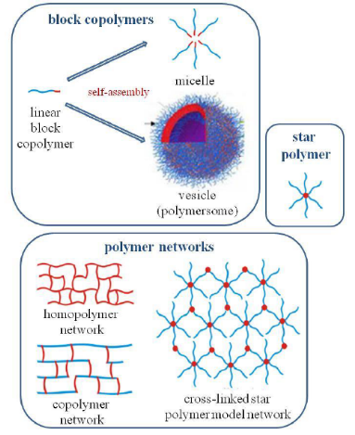
Figure: Polymeric nanostructures prepared by ‘Living’ polymerisation techniques.
Recent Publications
- Petropoulou A, Gibson TJ, Themistou E, Pispas S, Riziotis C (2016) Amphiphilic block copolymer-based photonic platform towards efficient protein detection. Front Matter: Proc. SPIE, 10025, Advanced Sensor Systems and Applications VII, 100250M.
- Spence S et al. (2015) Targeting Siglecs with Sialic Acid Ligand Abrogates Inflammation in an IL-10-dependent Manner. Science Translational Medicine, 7(303): 303ra140
- Ruiz-Perez L, Madsen J, Themistou E, Gaitzsch J, Messager L, Armes SP, Battaglia G (2015) Nanoscale Detection of Metal-labeled Copolymers in Patchy Polymersomes. Polymer Chemistry 6:2065-2068.
- Viswanathan P, Themistou E, Ngamkham K, Reilly G, Armes SP, Battaglia G (2015) Controlling Surface Topology and Functionality of Electrospun Fibers at the Nanoscale using Amphiphilic Block Copolymers to Direct Mesenchymal Progenitor Cell Adhesion. Biomacromolecules 16(1): 66-75.
- Themistou E, Battaglia G, Armes SP (2014) Facile Synthesis and Thiol-functionalized Amphiphilic Polylactide-Methacrylic Diblock Copolymers. Polymer Chemistry 5: 1405-1417.
- Madsen J at al. (2013) Nile blue-based nano-sized pH sensors for simultaneous far-red and near-infrared live bioimaging. Journal of American Chemical Society 135(39):14863-14870.

Biography
Dr Efrosyni Themistou is a chemical engineer with a PhD in Poymer Chemistry. She worked as a postdoctoral research associate in the University of Cyprus, the State University of New Yprk (SUNY) – University at Buffalo, USA and the University of Sheffield. She became a Lecturer in Materials in the School of Chemistry and Chemical Engineering at Queen’s University Belfast, UK in 2013. Her current research is on the synthesis of well-defined polymeric materials using various advanced polymerisation techniques. Techniques such as NMR, GPC, DLS, TEM, SEM and SAXS are used to characterize these materials. These polymers can find various applications as drug/protein/DNA delivery vehicles, sensors and tissue engineering matrices.
Email: e.themistou@qub.ac.uk

