Thermodynamics and kinetics of competitive crystallization pathways during devitrification of Al-Sm amorphous alloys
R.E. Napolitano, Department of Materials Science and Engineering, Iowa State University, Ames, Iowa, USA
S.H. Zhou, F. Meng, W. Wang, P. Ray, M.J. Kramer, Ames Laboratory, USDOE, Ames, Iowa, USA

Abstract
Amorphous alloys of Al-Sm exhibit competitive devitrification behavior upon reheating, involving competition between multiple metastable phases. These include large-unit-cell phases with cubic, hexagonal, and tetragonal symmetry, along with more conventional stable and metastable compounds of the Al_{x}Sm variety. Phase selection during crystallization is strongly path dependent, owing to effects of non-crystalline ordering and the role of diffusion and chemical partitioning in the morphological dynamics. In this work, devitrification kinetics are investigated and quantified using high energy X-ray diffraction, thermal analysis, and electron microscopy. Measurements are related to system thermodynamics in the highly driven regime highlighting principles of selection. Growth mechanisms are investigated in detail, with particular attention to chemical partitioning associated with the initial crystallization front. Implications with respect to other Al-RE (rare-earth) systems are also discussed. This work was supported by the U.S. Department of Energy, Office of Basic Energy Science, Division of Materials Sciences and Engineering. The research was performed at the Ames Laboratory, operated for the U.S. Department of Energy by Iowa State University under Contract No. DE-AC02-07CH11358.
Recent Publications
- I. Sargin, A. L. Genau, and R. E. Napolitano, Post-solidification effects in directionally grown Al-Ag₂Al-Al₂Cu eutectics, J. Phase Equilibrium and Diff., 37 (2016) 75-85.
- S.H. Zhou, Y. Huo, and Ralph E. Napolitano, Phase stability for the Pd-Si system: First principles, experiments, and solution-based modeling, Metallurgical and Materials Transactions A, 47A (2016) 194-208. DOI: 10.1007/s11661-015-3206-8.
- Ilkay Kalay, Matthew J. Kramer, Ralph E. Napolitano; Crystallization kinetics and phase transformation mechanisms in Cu₅₆Z₄₄ glassy alloy, Met. Mat. Trans., 46A (2015) 3356-3364. DOI: 10.1007/s11661-015-2921-5.
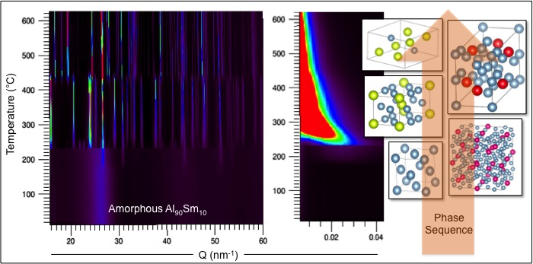
Fig. 1. Wide-angle and small-angle scattering results, obtained during continuous heating, revealing a complex devitrification sequence involving Al(fcc), Al₁₂₀Sm₂₂(cub), Al₄Sm(tet), Al₄Sm(orth), Al₃Sm(hex).

- T. Wang, F. Zhang, L. Yang, X.W. Fang, S.H. Zhou, M.J. Kramer, C.Z. Wang, K.M. Ho, R. E. Napolitano; A computational study of diffusion in a glass-forming metallic liquid, Scientific Reports, 5:10956 (2015) 1-9. DOI:10.1038/srep10956.
- Tim Cullinan, Ilkay Kalay, Y. Eren Kalay, Matt Kramer, Ralph Napolitano; Kinetics and mechanisms of isothermal devitrification in Amorphous Cu₅₀Zr₅₀, Metallurgical and Materials Transactions, 46A (2015) 600-613. DOI: 10.1007/s11661-014-2661-y.
- F. Zhang, M. Ji, X. Fang, C.Z. Wang, M.K. Kramer, R.E. Napolitano, K.M. Ho; Composition dependent stability of the medium-range order responsible for metallic glass formation, Acta Materialia 81 (2014) 337-344.
- S. Zhou, Y. Huo, L.-Q. Chen, R.E. Napolitano; Solution-based thermodynamic modeling of the Ni-Al-Mo system using first principles calculations, CALPHAD 46 (2014) 124-133.
- Tao Wang, T.E. Cullinan, R.E. Napolitano, A new method for measuring the thermodynamic properties of undercooled liquid and amorphous Cu-Zr alloys, Acta Materialia 62 (2014) 188-196. DOI: 10.1016/j.actamat.2013.09.047.

 Biography
R. E. Napolitano is Professor of Materials Science and Engineering at Iowa State University, where he serves as Associate Chair for Graduate Education and Research. He is an expert in solidification science and physical metallurgy, and he heads the Structures and Dynamics in Condensed Systems team within the Division of Materials Sciences and Engineering at the Ames Laboratory.
Email: ren1@iastate.edu

Notes/Comments:

