Adsorptive removal of sulfur compounds using Cu²⁺-based porous coordination polymers

Masashi Morita ª, Hidenobu Wakita ª, Takaiki Nomura ª, Yoichiro Tsujiª, Masakazu Higuchi ^{b}, Susumu Kitagawa ^{b}
ª Hydrogen And Energy Research Laboratory, Advanced Research Division, Panasonic Corporation, Japan
^{b} Institute for Integrated Cell-Material Sciences (iCeMS), Kyoto University, Japan

Abstract
Adsorptive removal of toxic substances is of crucial importance both in industry and in living environments. In general, porous materials such as zeolites and activated carbons are used as the adsorbents. Ag-Y zeolite is widely used for the adsorptive removal of sulfur compounds from natural gas at ambient temperatures in fuel cell cogeneration systems in spite of its low adsorption capacity and high cost. For the purpose of a more efficient and simple process, new types of porous materials for adsorbents are strongly required. In recent years, porous coordination polymers (PCPs) or metal‒organic frameworks (MOFs), which have high surface areas and act as molecular sieves owing to their micropores, have been studied due to their potential applications in gas storage, molecular separation and catalysts^{[1, 2]}. PCP/MOFs, as adsorbents, offer the advantages of having high surface area, ordered structures, and adjustable chemical functionality. the unique adsorptive reactions of various materials have been reported^{[3, 4]}.
Herein, we applied porous coordination polymers (PCPs) to adsorbents for the removal of sulfur compounds and also investigated how the metal ions highly dispersed in PCPs affected the adsorption capacity and how the open metal sites functioned as the adsorption sites^{[5]}. HKUST-1, which is composed of Cu(II) and trimesate, was examined to remove methanethiol (MT) from hydrocarbon gas at 30 °C. As a result, HKUST-1 showed high sulfur adsorption capacities for MT (8.4 wt%), compared with those on Ag-Y zeolite (3.0 wt%). Spectroscopic study revealed that a MT was adsorbed on Cu(II) site to produce a dimerized dimethyldisulfide (DMDS) accompanied by a reduction of Cu(II) to Cu(I).
To conclude, we have utilized HKUST-1 for the adsorptive removal of MT from hydrocarbon gas. It was experimentally shown that highly dispersive Cu(II) sites in HKUST-1 are effective for the removal of sulfur compounds.

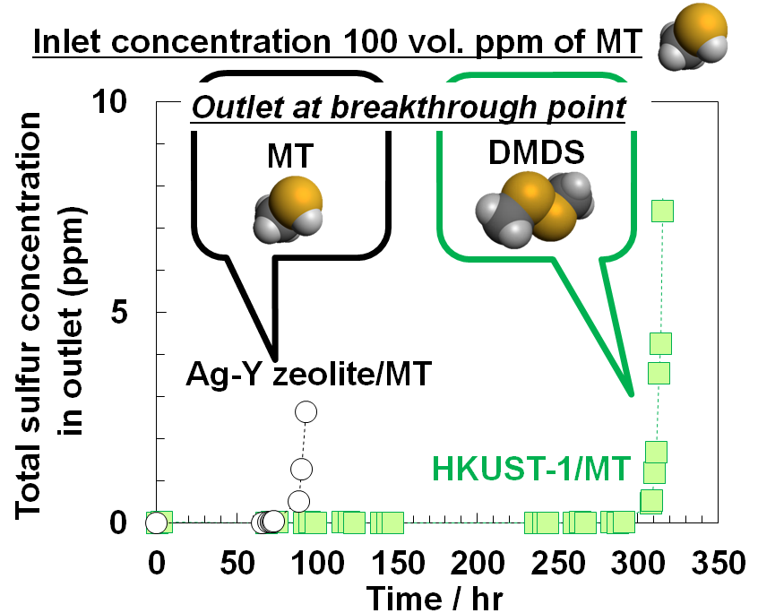

Fig. 1 Breakthrough curves of total sulfur concentration for MT adsorption.
Recent Publications
- Kitagawa S., Kitaura R., Noro S. (2004) Functional porous coordination polymers. Angew. Chem. Int. Ed. Engl. 43:2334-2375.
- Corma A., García H., Llabrés i Xamena F.X. (2010) Engineering Metal Organic Frameworks for Heterogeneous Catalysis. Chem. Rev. 110:4606-4655.
- Horike S., Sugimoto M., Kongpatpanich K., Hijikata Y., Inukai M., Umeyama D., Kitao S., Seto M., Kitagawa S. (2013) Fe²⁺-based layered porous coordination polymers and soft encapsulation of guests via redox activity. J. Mater. Chem. A 1:3675-.3679.
- Song J., Luo Z., Britt D.K., Furukawa H., Yaghi O.M., Hardcastle K.I., Hill C.L. (2011) A Multiunit Catalyst with Synergistic Stability and Reactivity: A Polyoxometalate-Metal Organic Framework for Aerobic Decontamination. J. Am. Chem. Soc. 133:16839-16846.
- Morita M., Wakita H., Nomura T., Higuchi M., Kitagawa S. (2017) Highly efficient oxidative adsorption of methanethiol from hydrocarbon gas using Cu²⁺-based porous coordination polymers. Microporous and Mesoporous Mater. 243:351-354.



Masashi Morita was born in Saitama, Japan, in 1988. He received his BS and MS degrees from Waseda University in 2011 and 2013 under the direction of Professor Makoto Ogawa. He joined Research & Development division, Panasonic Corporation as a researcher. From 2017, he became a senior researcher. His research interests include the synthesis and applications of porous materials toward adsorbents and catalysis.
Email: morita.masashi1008@jp.panasonic.com

