Mechanism of Spark Plasma Sintering of High Temperature Ceramics such as carbides (ZrC, B₄C)
Alexandre MAITRE, Professor, Laboratory SPCTS, University of Limoges, France
Nicolas PRADEILLES, Assistant Professor, Laboratory SPCTS, University of Limoges, France
Guy ANTOU, Assistant Professor, Laboratory SPCTS, University of Limoges, France

Abstract (300 word limit)
Spark Plasma Sintering (SPS) has proved is efficiency on the sintering on various materials which were known to be difficult to sinter without additives. In this presentation, the investigation of some thermomechanical properties will be illustrated on two different carbides Zirconium carbide and boron carbide.
Zirconium Carbide is interesting for high temperature application. Zirconium carbide (ZrCx) and oxycarbide (ZrCxOy) carbide was synthetized by carboreduction of zirconia and carbon and was then sintered by SPS. A complete study including composition, particles size evolution was done. The kinetics of spark plasma sintered ceramics has been investigated. A change of densification mechanism appears during the intermediate and final sintering stages. During this last stage, the deformation mechanism is similar to the one involved during creep of dense ceramics. The comparison of densification and creep strain rates seems to show that no specific effects strongly enhance strain rate during the final densification stage of Spark Plasma Sintering.
Boron carbide is a promising material for moderator in nuclear industry. The influence of preparation before SPS was studied: a liquid way was studied and compared. Different solvent were tested and green bodies were obtained. During this sintering, different chemical reactions were observed: oxides present in the native powder react and the composition of the carbide evolves. In a second step, thermomechanical properties were determined.
- Image

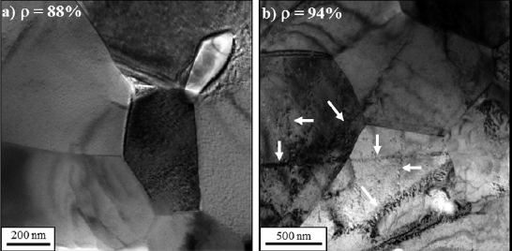

Figure 1. TEM micrographs of ZrC_{0.94}O_{0.05} samples: (a) sintered at 2006°C for 5 min under 25 MPa (relative density of 88%); (b) sintered at 2006°C for 2 min under 100MPa (relative density of 94%). The white arrows show the presence of dislocations walls.
Recent Publications (minimum 5)
- Belon R., Antou G., Pradeilles N., Maître A., Gosset D., Mechanical behaviour at high temperature of spark plasma sintered boron carbide ceramics, Ceramics International, 43 (8) (2017) 6631-6635.
- Antou G., Pradeilles N., Gendre M., Maître A., New approach of the evolution of densification mechanisms during Spark Plasma Sintering: Application to zirconium (oxy-)carbide ceramics, Scripta Materialia, 101 (2015) 103-106.
- Réjasse F., Trolliard G., Rapaud O., Maître A., David J. TEM study of the reaction mechanisms involved in the carbothermal reduction of hafnia, RSC Advances, 5 (56) (2015) 45341-45350.
- Lee W.E., Giorgi E., Harrison R., Maître A., Rapaud O., Nuclear Applications for Ultra-High Temperature Ceramics and MAX Phases (Book Chapter), Ultra-High Temperature Ceramics: Materials for Extreme Environment Applications, 2014, pp. 391-415.
- David, J., Trolliard, G., Gendre, M., Maître, A., TEM study of the reaction mechanisms involved in the carbothermal reduction of zirconia, Journal of the European Ceramic Society, 33 (1) (2013) 165-179.

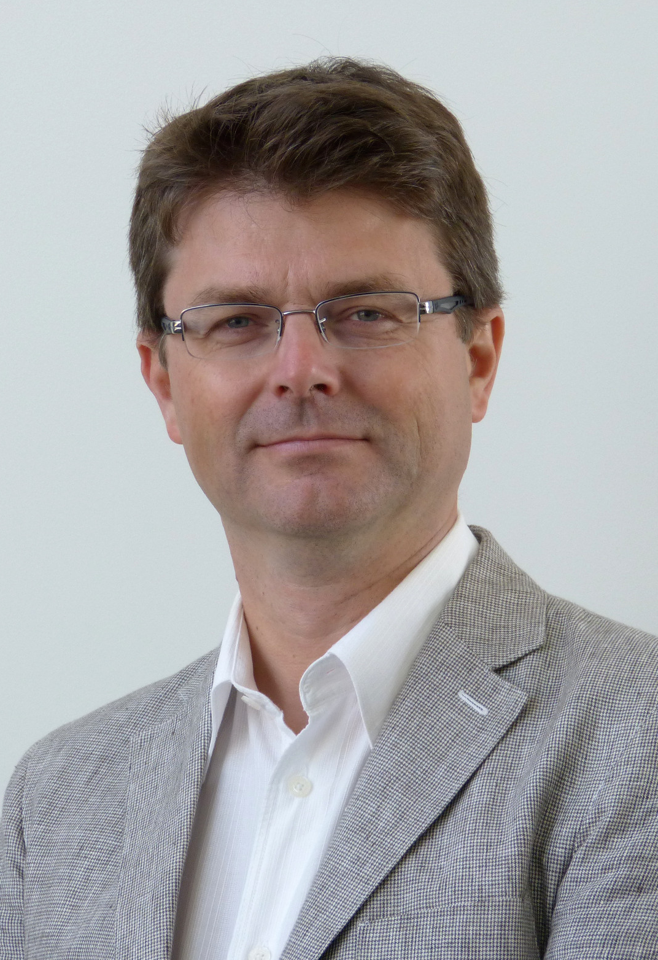 Biography (150 word limit)
Alexandre Maître is professor at the Science of Ceramic Processes and Surface Treatments laboratory at Limoges in France. His thesis diploma (1995-1998) was devoted to the kinetic and thermodynamic aspects of the synthesis of transition metal carbides by carbothermal reduction. In october 2000, he obtained a permanent position as CNRS researcher at the Laboratory of Chemistry of Inorganic Solid at Nancy to develop investigations concerning the thermodynamic modelling, the electrochemical behaviour in corrosive environment, the metallurgical aspects of lead-based alloys. In September 2004, he became assistant professor in SPCTS to implement research activities about the elaboration by Polymer Derived Ceramics (PDCs) route and the mechanisms of sintering of high temperature ceramics. His scientific production (h index: 16) is now composed of 92 publications in international journals, 22 invited conferences, 65 oral communications, 3 chapters of books, 3 grants, etc. He was responsible for at least 15 national or international projects.

Email: alexandre.maitre@unilim.fr

Notes/Comments:

