Atomically resolved structure of luminescent Zn_{k}In₂O_{3+k}
J. García-Fernández, A. Torres-Pardo, J. Ramirez-Castellanos and J. M. González-Calbet, Departamento de Química Inorgánica, Facultad de Químicas, Universidad Complutense de Madrid, 28040 Madrid, Spain
A. Cremades and J. Piqueras, Departamento de Física de Materiales, Facultad de Ciencias Físicas, Universidad Complutense de Madrid, 28040 Madrid, Spain

Abstract
Indium zinc oxides (IZOs) have attracted the interest due to their physical properties and high chemical stability. These materials constitute a large field of research due to its applications as transparent electrodes in transistors, flat panel displays, solar cells, sensors and photocatalysis properties. In this work, several terms of the homologous series Zn_{k}In₂O_{3+k} with 3≤k≤13 materials were prepared by the ceramic method. The microstructure of the materials has been elucidated by means of X-ray Diffraction (XRD), high-resolution transmission electron microscopy (HRTEM and STEM) and Raman spectroscopy. Additionally, luminescence properties were measured by cathodoluminescence in a scanning electron microscope.
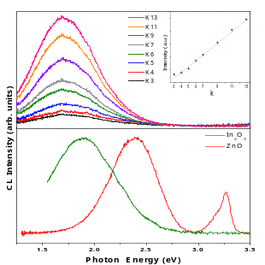
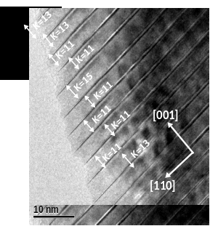
The structure can described based on a hexagonal symmetry, with R-3m space group for those terms with odd k, and P6₃/mmc for k even, although overlap of the diffraction maxima occurs for higher members of the series. HRTEM images show these materials are formed by the ordered intergrowth of layers of InO₂⁻ octahedral sharing edges with InZn_{k}O_{k+1}⁺ blocks stacked perpendicularly to the c-axis of the crystal, where zinc and indium occupy tetrahedral and trigonal bipyramid sites. The existence of extended defects such as twins, dislocations and disordered intergrowths were also observed (Figure 1). (S)TEM in High Angle Annular Dark Field (HAADF) and Annular Bright Field (ABF) modes show the indium and zinc distribution along [1-10] and [010] zones axes. The characteristic modulation of this homologous series (a zigzag pattern) is also visualized.
Cathodoluminescence (CL) measurements show the existence of a main emission band centered at 1.75 eV (Figure 2), associated to Zn vacancies. The variation of the intensity and width of the band depends on the chemical composition of the material. These results suggest that physical properties can be tailored for technological applications depending on the material composition.

Recent Publications
1. M. Andrea Peche-Herrero, David Maestre, Ana Cremades, Julio Ramírez-Castellanos, José M. González-Calbet And Javier Piqueras (2013) “Cr Doped Titania Microtubes And Microrods Synthesized by a Vapor-Solid Method”, Crystal Eng. Comm 15: 5490-5495
- M. A. Peche-Herrero, D. Maestre, J. Ramírez-Castellanos, A. Cremades, J. Piqueras And J. M. González-Calbet (2014) “Controlled Transition-Metal Doping Of SnO₂ Nanoparticles With Tunable Luminescence” Crystal Eng. Comm. 16 : 2969-2976
- G. Cristian Vásquez, M. Andrea Peche-Herrero, David Maestre, Belén Alemán, Julio Ramírez-Castellanos, Ana Cremades, José M. González-Calbet and Javier Piqueras (2014) “Influence Of Fe And Al Doping In The Stabilization Of The Anatase Phase In Tio₂ Nanoparticles”, J Mat. Chem C 48 (2): 10377-10385
- Julio Ramírez-Castellanos, Margarita-Andrea Peche-Herrero, Iñaki López, Emilio Nogales, Bianchi Mendez, Javier Piqueras And José María González-Calbet. (2014)"Epitaxial Growth of Luminescent Sn-Cr Doped β-Ga₂O₃ Nanowires". Mat. Res. Soc. 1707.
- G. Cristian Vásquez, M. Andrea Peche-Herrero , David Maestre, Alessandra Gianoncelli , Julio Ramírez-Castellanos , Ana Cremades , José María González-Calbet and Javier Piqueras (2015) “Laser Induced Anatase-To-Rutile Transition In Tio₂ Nanoparticles: Promotion And Inhibition Effects By Fe And Al Doping And Achievement Of Micropatterning”, J Phys. Chem C 119: 11965−11974

Biography
Julio Ramirez-Castellanos is expertise in synthesis and structural/microstructural characterizations of new functional inorganic materials by high-resolution electron microscopy. His acquired a high research experience working at different international laboratories (Laboratoire De Cristallograhie (C.N.R.S.), Grenoble, Physics Department, Warwick University, Coventry; Structural Chemistry Department, Arrhenius Laboratory, Stockholm; National Institute For Materials Science (NIMS), (Tsukuba); Applied Physics Institute (Engineering Department), Tsukuba University. Currently, he is professor at Complutense University, Madrid. He is co-author of more than 100 reviewed scientific publications, four invention patents, and more than 100 communications to international conferences.

Email: jrcastel@quim.ucm.s

Notes/Comments:

