Synthesis and characterization of lanthanides doped Tricalcium phosphates Ca₉Ln(PO₄)₇

Asmaa El Khouri, Mohammed Elaatmani, LAboratory of inorganic materials and their applications, Faculty of sciences Semlalia, Marrakech - Morocco
Francesco Capitelli, Istituto di Cristallografia – CNR, Via Salaria Km 29.300, 00016 Monterotondo (Rome), Italy

Abstract (300 word limit)

Tri-calcium Ca₃(PO₄)₂ phosphate materials (TCP) were investigated for their potential applications to create a new class of luminescent materials, with possible applications in biomedical diagnostics, electronics, and optic fields . In this study TCP were doped with trivalent lanthanides (Ln= La, Pr, Nd, Eu, Gd, Dy, Tm, Yb, Lu), in order to obtain powders, synthesized by means of solid state reaction at high temperature (T=1200°C) with CaCO₃, CaHPO₄, and Ln₂O₃ precursors . The so-obtained Ca₉Ln(PO₄)₇ powders (Ln-TCP) were characterized using X-ray diffractrometry (XRD), Fourier Transform InfraRed (FTIR) and Raman spectroscopy. Ln-TCP compounds crystallized with whitlockite-like structure (space group R3c) of

β-Ca₃(PO₄)₂, and their vibrational spectroscopy was reviewed

Starting from the scarce existing literature.

Image
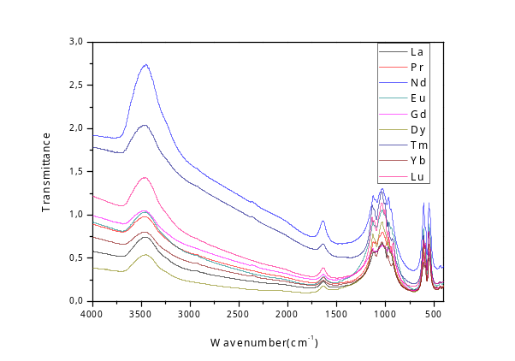
Figure 1.FTIR spectra of Ca₉Ln(PO₄)₇.

Biography (150 word limit)
El khouri asmaa phd student in laboratory of inorganic sciences and their applications at faculty of sciences semlalia Marrakech morocco, I work on calcium phosphates synthesis and characterization and their optical, biological applications , I had a master in analytical chemistry and bachelor in inorganic chemistry .
Email: elkhouriasma@gmail.com

Notes/Comments:

