Meso Porous Hybrid Silica Gel Frameworks for Low Temperature CO₂ Adsorption

Minju Ashok, A. Peer Mohamed, S. Ananthakumar, and S. Savithri*

Materials Science and Technology Division
Council of Scientific and Industrial research- National Institute for Interdisciplinary Science Technology Division Thiruvananthapuram, Kerala, INDIA

Abstract (300 word limit)
Meso porous inorganic silica gel supports have been processed via sol-gel technique from economically affordable water-glass precursors. An injectable gel was prepared first from water-glass which was then transformed into solid silica gel spheres through self-assembly route. Subsequently, the gel supports were chemically activated with various amine functional groups to develop gel-sorbents for CO₂ adsorption. The thermal stability, morphology, surface area and porosity features were assessed and correlated with the CO₂ adsorption efficiency.

Amine activated gel porous adsorbents showed working capacity as CO₂ adsorbent at temperatures as low as 100ºC, appears to be promising for CO₂ sorption in flue gas stream. CO₂ adsorption isotherms indicate the gel-sorbents activated with APTMS offered higher adsorption performance at 75 ºC. The sorbents prepared with the mixture of APTMS and TEPA offered a CO₂ adsorption capacity of 3.26 mmol g⁻¹ at 75 ºC. Inorganic hybrid gels combined with the appropriate pore engineering and chemical activation using multiple-amines permit effective accessibility for the CO₂ gas and its adsorption that ultimately result in enhanced adsorption at low operating temperatures.

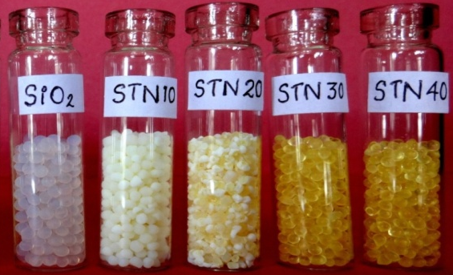

Recent Publications (minimum 5)
- N. Minju, P. Abhilash, Balagopal N. Nair, A. Peer Mohamed, S. Ananthakumar, (2015), Amine impregnated porous silica gel sorbents synthesized from water–glass precursors for CO2 capturing. Chemical Engineering Journal, 269,335-342.
- O.A. Esam, CO2 capture on porous adsorbents containing surface amino groups, Electronic Theses and Dissertations (2013) Paper 2304.,
- A.K. Mishra, S. Ramaprabhu, Polyaniline/multiwalled carbon nanotubes nanocomposite – an excellent reversible CO2 capture candidate, RSC Adv. 2 (2012) 1746–1750.
- A. Samanta, A. Zhao, G.K.H. Shimizu, P. Sarkar, R. Gupta, Post-combustion CO2 capture using solid sorbents: a review, Ind. Eng. Chem. Res. 51 (2012) 1438– 1463.

Biography
Dr. S. Savithri is working as a senior principal scientist in Computational Modeling and Simulation Section at the National Institute for Interdisciplinary Science & Technology which comes under Council of Scientific and Industrial Research(CSIR-NIIST) since 1992. She started her career in mathematical modelling and simulation area with a graduation and post graduation in Applied Mathematics from Maduari kamaraj University. She obtained her Ph.D. in 1992 from IIT, Madras. Her field of interests are
- Mathematical modelling of Solidification & Casting Process
- Technical software development
- CFD simulation of multiphase flows
- Discrete element simulation of granular flows

Email: sivakumarsavi@gmail.com

Notes/Comments:

