Polymeric nanoparticles and gels: modeling of dynamic behavior and properties using Discrete Element Method
Martin Kroupa Jose F. Wilson, Miroslav Soos and Juraj Kosek, University of Chemistry and Technology Prague, Czech Republic

Abstract (300 word limit)

Polymeric nanoparticles have a broad spectrum of applications including dispersion (emulsion) paints or thin films. However, the understanding of their behavior and properties, especially at high concentrations is still limited. We model the dispersions of polymeric nanoparticles using the dynamic model based on Discrete Element Method (DEM). The interaction model represents particles that are elastic, adhesive and electrostatically stabilized. The flow-field computation that is included in the model enables us to evaluate the rheological properties of the dispersion, which are crucial for its behavior. Further characterization of both dispersions and gels is done using oscillatory simulations, from which the viscoelastic properties are obtained. The model was successfully used to describe the dynamic behavior of a flowing dispersion including the processes of coagulation, fouling and breakage. These processes and their relative importance in a specific system determine the transition from a dispersed state to a gel. Due to their specific position on the boundary between solids and liquids, gels have unique properties that make them suitable to be used e.g., as a porous structures or matrices for drug delivery in the pharmaceutical industry.
Image
Figure 1: Colloidal aggregate produced by shear-induced aggregation. Result of a numerical simulation.
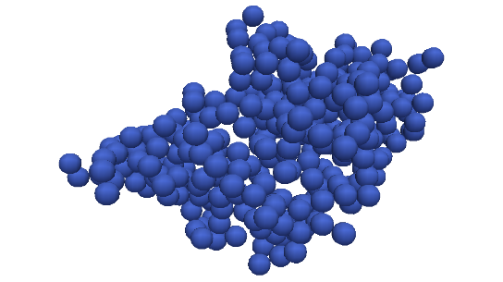
Recent Publications (minimum 5)
- Kroupa M., Soos M., Kosek J. (2017) Slip on Particle Surface as the Possible Origin of Shear Thinning in non-Brownian Suspensions. Physical Chemistry Chemical Physics 19: 5979-5984.
- Kroupa M., Vonka M., Soos M., Kosek J. (2016) Utilizing the Discrete Element Method for the Modeling of Viscosity in Concentrated Suspensions. Langmuir 32:8451–8460.
- Kroupa M., Offer G. J.., Kosek J. (2016) Modelling of Supercapacitors: Factors Influencing Performance. Journal of the Electrochemical Society 163: A2475–A2487.
- Kroupa M., Vonka M., Soos M., Kosek J. (2015) Size and Structure of Clusters Formed by Shear Induced Coagulation: Modeling by Discrete Element Method. Langmuir 31: 7727–7737.
5. Kroupa M., Vonka M., Kosek J. (2014) Modeling the Mechanism of Coagulum Formation in Dispersions. Langmuir 30:2693–2702.

Biography (150 word limit)
Martin Kroupa obtained his B.Sc. and M.Sc. at University of Chemistry and Technology Prague, Czech Republic. His research interests lie in the area of colloidal and interface science with the main focus on the dynamic behavior of concentrated colloidal dispersions and related phenomena such as coagulation and fouling. These phenomena are closely connected to the rheology and thus the modeling of rheological behavior is another large area of interest of M.K. He is also active in the field of electrochemistry.
Email: Martin.Kroupa@vscht.cz

Notes/Comments:

Address: Technicka 5, Prague 6, 16628, Czech Republic

