Catalytic Oxidation of Methane into Methanol over Copper Exchanged ZSM-5 Zeolites

Madina Ryssakova, MSc, The University of Edinburgh, Scotland, UK
F.R. García García, PhD, The University of Edinburgh, Scotland, UK
Juan Maria Gonzalez Carballo, PhD, Sasol Technology UK Ltd, Scotland, UK

Abstract
Methanol is one of the high potential products used as a key raw material to produce many other chemicals. Current industrial route for methanol production is a two-stage process including steam reforming of methane to synthesis gas and catalytic conversion of syngas to methanol. This method is considered as energy intensive and expensive. Therefore, investigation of technology for direct methane to methanol conversion (DMTM) will be an attractive alternative for conventional technology. In nature, materials such as methane monooxygenase (MMO) oxidizes methane by single step and Copper-Exchanged Zeolite Catalysts (Cu-ZSM-5) can mimic this exceptional activity of MMO.
The main objective of this work was to investigate catalytic performance of Cu-ZSM-5 for DMTM under mild isothermal conditions. The methodology was to incorporate copper at framework positions of zeolite, characterize Cu-ZSM-5 and test its activity for DMTM. As Al atoms within zeolite framework are believed to play an important role in the nature of copper active sites, samples with different Si/Al ratios were employed to observe the effect of catalyst acidity on methanol production.
The results on DMTM over Cu-ZSM-5 presented the formation methanol for all tested samples. Treatment of catalyst with air was found to be most favorable environment to form active copper clusters comparing with H₂O and H₂O/H₂. and Cu-ZSM-5 with high Al content had a higher product yield. These findings confirm the activity of copper-oxo sites in ZSM-5 towards methane to methanol oxidation and role of zeolite acidity in catalyst performance.

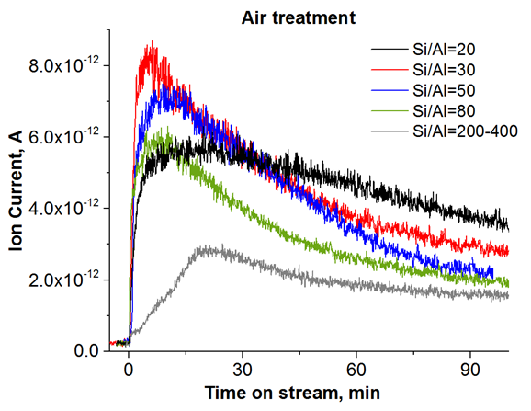
Figure 1 MS-detected signal of methanol after air treatment for five sample

Recent Publications
- S. Grundner, “Selective Methane Oxidation on Zeolite Stabilized Copper Oxide Clusters,” 2016.
- G. Li, P. Vassilev, M. Sanchez-Sanchez, J. A. Lercher, E. J. M. Hensen, and E. A. Pidko, “Stability and reactivity of copper oxo-clusters in ZSM-5 zeolite for selective methane oxidation to methanol,” J. Catal., vol. 338, pp. 305–312, 2016.
- T. Yumura, M. Takeuchi, H. Kobayashi, and Y. Kuroda, “Effects of ZSM-5 Zeolite Confinement on Reaction Intermediates during Dioxygen Activation by Enclosed Dicopper Cations,” Inorg. Chem., no. 48, pp. 507–517, 2009.
- K. Narsimhan, K. Iyoki, and K. Dinh, “Catalytic Oxidation of Methane into Methanol over Copper- Exchanged Zeolites with Oxygen at Low Temperature,” 2016.
- 5 E. M. Alayon, M. Nachtegaal, M. Ranocchiari, and J. A. van Bokhoven, “Catalytic conversion of methane to methanol over Cu–mordenite,” Chem. Commun., vol. 48, no. 3, pp. 404–406, 2012.


Biography

School of Engineering
The University of Edinburgh
Edinburgh EH9 3 FB, Scotland

Madina Ryssakova is a master student in Advanced Chemical Engineering program at University of Edinburgh. Her dissertation project focuses on studying catalytic activity of Cu-ZSM-5 for direct methane to methanol conversion. She worked on this project under the supervision of Dr. Francisco Garcia Garcia (University of Edinburgh) and with cooperation of Sasol Technology Ltd. as a project industrial partner.
.
Email: s1684937@sms.ed.ac.uk

