Hybrid polymer nanofibers
Stanislav Nevyhosteny, Technical university of Liberec Czech republic

Abstract (300 word limit)
Nanomaterials are an important aspect of contemporary technology. Although nanomaterials were always present in nature, mankind is only recently learning to create and utilize them. A good example is the "lotus effect" - hydrophobic surface of lotus leaves due to their nanomarphology. An equally interesting phenomenon is the coloration of butterfly wings due to the interference of light. There is also a substantial amount of fine carbon and oxidic particles in the environment, created by volcanic activity, fires or burning fossil fuels.
In recent decades, nanomaterials are receiving a major attention and are found in almost all areas of technology. These materials can be found in micro and nano electronics, polymer biomaterials, drug delivery systems, fuel cells, polymer films, nanofibers, litography, protective equipment and various other applications. Best properties are, however, in many cases achieved by combining nanomaterials with the usual materials, usually in a form of matrix for the nanostructures.
Nanocomposites based on polymers have become an important part of contemporary research and development. A very popular method for polymer processing has recently become electrospinning. Thanks to the simplicity, large amount of spinnable materials and unique properties, both the technology and it's products are receiving major attention. A variety of uses are also found for inorganic additives, which can be incorporated into the nanofibers in a form of particles or solutions to create hybrid fibers or nanocomposites. Using these materials, it was possible to produce a hybrid nanocomposite with higher than usual ionizing radiation attenuation properties, while being lighter and safer for the environment.

Image
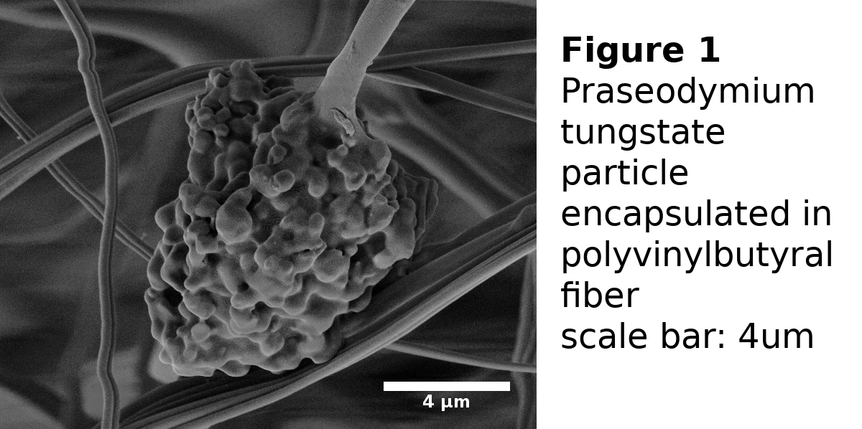
Recent Publications (minimum 5)
- Barakat, N.A.M. et.al (2010) Polymeric nanofibers containing solid nanoparticles prepared by elektrospinning and their applications. Chemical engineering jourmal 156:487-495
- Khanlou, H.M. et.al. (2015) A systematic study of maghemite/PMMA nanofibrous composite via an electrospinning process: synthesis and characterization. Measurement 70:179-187
- Venugopal, J.R. et.al. (2008) Nanobioengineered electrospun composite nanofibers and osteoblasts for bone regeneration. Artificial Organs 32:388-397
- Huang, Z.M. et.al. (2003) A review of polymer nanofibers by electrospinning and their applications in nanocmoposites. Composites science and technology 63:2223-2253
- Nambiar, S., Yeow, J.T.W. (2012) Polymer-composite materials for radiation protection. ACS Applied Materials and Interfaces 4:5717-5726
- Hu, X. et.al (2014)Electrospinning of polymeric nanofibers for drug delivery applications. Journal of Controlled Release 185:12-21

Biography (150 word limit)
Stanislav Nevyhosteny is a Ph.D. student at the department of nonwovens and nanofibrous materials, Faulty of textiles, Technical university of Liberec, Czech republic. He specializes in production of hybrid and inorganic nanofibers using the direct current and alternating current electrospinning. The main area of his research are hybrid nanocomposites for attenuating ionizing radiation. This is achieved through combination of inorganic and polymer chemistry.
Email: stanislav.nevyhosteny@tul.cz

Notes/Comments: The research was supported by grant Research of the possibilities for application of a new materials (focusing onnano-materials) and advanced technologies for protection of people against the exposure to CBRN materials, with emphasis on critical infrastructure; VG20102014049

