Fibers Made by Centrifugal Spinning Technology
Jana Hlavata, TU Liberec, Czech Republic
Eva Kuzelova Kostakova, TU Liberec, Czech Republic

Abstract
Centrifugal spinning, ForcespinningTM or rotary jet spinning, all these names represent relatively new and simple technology that allows production of fibers by using only centrifugal forces. These forces are caused by high-speed rotation of the spinneret unit and are necessary for drawing polymeric jet and fiber formation.
Two main ways of centrifugal spinning process depend on type of the spinneret unit. These are needle and needle-less technology. Besides that, it is possible to combine centrifugal forces with electric field to produce fibers by electro-centrifugal method. Fibers could be forming from solutions or melts as well.
Centrifugal spinning has several advantages in comparison to electrospinning such as spinnability of liquid form of materials (polymeric solution/melt, ceramic, metal), larger range of spinnable materials (no requirements on conductivity of material) and higher production rate. Fibers are arranged in one direction and gathered on collector. This homogenous fiber layer could be used in many different applications, I.e. in biomedical area, tissue scaffolds, drug delivery systems, filtration, energy industry etc.
Materials polycaprolactone (PCL), polyvinyl butyral (PVB), polyamide 6 (PA 6), polyvinyl alcohol (PVA), copolymer of polycaprolactone and lactid acid (PLC), collagen and other have previously been successfully spun.
Forcespun fibers generally have wide distribution of their diameters. Big variability in spinning devices, used materials and process conditions lead to production of modified fibers, such as porous fibers, bicomponent fibers and even hybrid and inorganic fibers.

Image
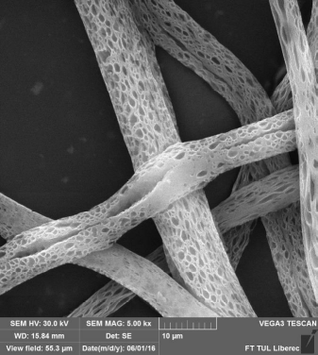
Figure 1: SEM picture of porous fibers made from PCL solution by needle-less way of centrifugal spinning technology. Fibers were produced at Department of Nonwovens and Nanofibrous Materials at Technical University of Liberec. Scale is 10 μm.

Recent Publications
- Golecki HMI (2014) Effect of Solvent Evaporation on Fiber Morphology in Rotary Jet Spinning. Langmuir 30:13369-13374.
- Hou T, et al. (2017) Highly Porous Fibers Prepared by Centrifugal Spinning. Material & Design 114:303-311.
- Khamforoush M, Asgari T (2015) A Modified Electro-Centrifugal Spinning Method to Enhance the Production Rate of Highly Aligned Nanofiber. NANO 10:1550016.
- Loordhuswamy AM (2014) Fabrication of Highly Aligned Fibrous Scaffolds for Tissue Regeneration by Centrifugal Spinning Technology. Material Science and Engineering: C 42:799-807.
- Xu H, et al. (2014) A Comparative Study of Jet Formation in Nozzle- and Nozzle-Less Centrifugal Spinning System. Journal of Polymer Science, Part B: Polymer Physics 52:1547-1559.
- Zander NE (2015) Formation of Melt and Solution Spun Polycaprolactone Fibers by Centrifugal Spinning. Journal of Applied Polymer Science 132:41269.
- Zhang X, Lu Y (2014) Centrifugal Spinning: An Alternative Approach to Fabricate Nanofibers at High Speed and Low Cost. Polymer Reviews 54:677-701.



Biography
Jana Hlavata is Ph.D. student at Department of Nonwovens and Nanofibrous Materials, Faculty of Textile Engineering at Technical University of Liberec, Czech Republic. She specializes in centrifugal spinning technology, especially in needle and needle-less way. Materials and modified fibers mentioned above have been successfully spun at two devices assembled at department. These devices are improved and upgrade according to her specifications and requirements. During her internship at University of Alabama at Birmingham she has been dealing with controlled morphology of porous fibers.

Email: jana.hlavata1@tul.cz

Acknowledgement:
The research presented in this article was supported by the Research Grant MPO FV10416 Nanofibrous wound dressing.

