Preparation of composite scaffolds from micro / nano fibers and biocompatible hydrogels

Radek Jirkovec, Technical University of Liberec, Czech Republic
Jakub Erben, Technical University of Liberec, Czech Republic
Jiří Chvojka, Technical University of Liberec, Czech Republic

Abstract

This paper deals with the preparation of composite scaffolds composed of micro / nano fibers and biocompatible hydrogel. An experiment of this work was focused on finding a suitable material that could be suitably applied while enabling cell migration and proliferation. Only natural polymers for hydrogel formation were used for testing due to their biocompatibility, natural biodegradability and biological functions. Five materials were selected for testing: collagen, gelatin, agarose, agar and hyaluronic acid, which were applied to the micro / nano fibrous layer from biocompatible polycaprolactone.
In the experiment itself, it was found that all materials could be applied without great difficulty, but subsequent in-vitro testing only enabled the collagen and hyaluronic acid hydrogel to allow cell proliferation and migration to fibrous material.

Image

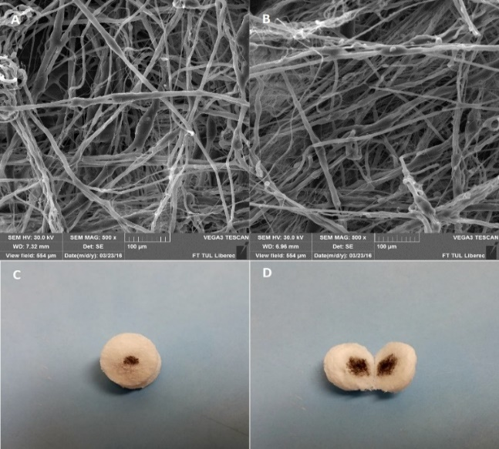Figure 1. A – B) SEM pictures of micro/nano fiber layer, C – D) Test of application with colored water to the center of the fiber layer.

Recent Publications

1. Shapiro M. J., Oyen L. M. (2013) Hydrogel Composite Materials for Tissue Engineering Scaffolds. Vol. 65, No. 4. 505-516.
2. Mohabatpour F., Karkhaneh A., Sharifi A. M. (2016) A hydrogel/fiber composite scaffold for chondrocyte encapsulation in cartilage tissue regeneration. 86.
3. Eslami M., Vrana N. E., Zorlutuna P. (2014) Fiber-reinforced hydrogel scaffolds for heart valve tissue engineering. Journal of Biomaterials Applications. Vol 29. 399-410.
4. Shelke B.N., Lee P., Anderson M. (2015) Neural tissue engineering: nanoﬁber-hydrogel based composite scaffolds. Polymers Advanced Technologies 27. 42-51.
5. Visser J., Melchels P. W. F., Jeon E. J. (2015) Reinforcement of hydrogels using three-dimensionally printed microfibers. Nature Communications 6.

Biography

Radek Jirkovec is a Ph.D. student at department of Nonwovens and Nanofibrous Materials at Technical University of Liberec, Czech Republic. His focus is bio-printing, hydrogels, preparation of scaffolds for tissue engineering. He has been working on these topics since his master's thesis and is currently expanding his knowledge of these topics in his dissertation.

Email: radek.jirkovec@tul.cz

