Hydrogen production from water using the sun via photocatalytic processes on Au/g-C₃N₄/TiO₂ materials

Clément Marchal, Pablo Calvo, Thomas Cottineau, Valérie Caps, Valérie Keller
ICPEES, Institute of Chemistry and Processes for Energy, Environment and Health,
25, rue Becquerel, 67087 Strasbourg Cedex
FRANCE

The direct conversion of solar energy through an energy carrier (fuel), storable and usable upon request, appears as an interesting alternative to find environmentally friendly ways to produce energy. Photocatalysis is a promising way to produce hydrogen from renewable energy sources. Indeed, the water dissociation (water-splitting) highlighted by Fujishima and Honda in a photoelectrocatalytic cell opened a promising way to produce hydrogen from light energy. Since, many efforts have focused on the development of the water-dissociation in photoelectro- and photo- catalytic systems.
Nowadays, one of the main challenges consist in the elaboration of semiconductor nanometarials able to absorb visible-light wavelengths, to transfer efficiently the photogenerated charges, while keeping high stability of their performances under UV activation. For that purpose, different strategies are studied: Synthesis of semiconductors with narrow band gaps, doping (cationic, anionic, co-doping) approaches of wide bang gap semiconductors, heterojunction formation between wide- and a narrow band gap semiconductors for solar light harvesting, deposition of metal nanoparticles inducing surface plasmon effects, use of different morphologies (1D, 2D, 3D) and assembly of semiconductors

Here, amongst these different approaches, we will focus on the elaboration of Au/gC₃N₄/TiO₂ photocatalysts, in order to optimize the different functions of the composite materials: optimization of the synthesis of C₃N₄ (under different atmospheres) and TiO₂ (influence of the morphology) semiconductors, high quality heterojunction formation, improved Au deposition leading to enhanced electron traps and co-catalyst properties and study of the SPR (Surface Plasmon Resonance) properties induced by Au NPs.

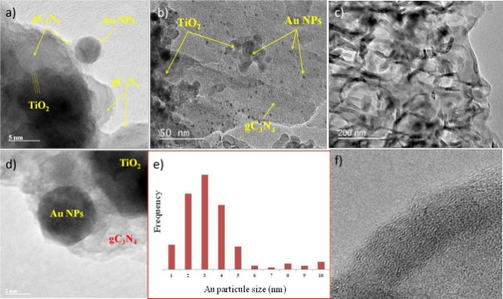

Figure 1. (a, b and d) TEM micrographs of 0,5 wt.% Au/(TiO₂-gC₃N₄) (95-5) nanostructures. (c) TEM micrographs of bare g-C₃N₄. (e) Histogramm showing Au NPs size distribution. (f) TEM micrographs of 0,5 wt.% Au/ TiO₂-gC₃N₄ (95-5) nanostructures, magnification of gC₃N₄ nanosheet.
Recent Publications (minimum 5)
- Rosseler, O., Muthukonda, V.S., Karkmaz-Le Du, M., Schmidlin, L., Keller, N., Keller, V. Solar light photocatalytic hydrogen production from water over Pt and Au/TiO₂ (anatase/rutile) photocatalysts : Influence of noble metal and porogen promotion. J. Catal. 269, 179-190 (2010).
- Marchal, C., Behr, M., Vigneron, F., Caps, V., Keller V. Au/TiO₂ photocatalyst prepared by solid grinding for artificial solar-light water splitting. New J. Chem. 40, 4428-4435 (2016).
- Cottineau, T., Béalu, N., Gross, P.-A., Pronkin, S.N., Keller, N., Savinova, E.R., Keller, V. One step synthesis of niobium doped titanium dioxide nanotube arrays by anodization to form (N,Nb) co-doped TiO₂ with an enhanced visible light photoelectrochemical activity. J. Mater. Chemistry 1(6), 2151-2160 (2013).
- Marchal, C., Piquet, A., Behr, M., Cottineau, T., Papaefthimiou, V., Keller, V., Caps. Solar water splitting photocatalysts prepared by solid grinding. Journal of Catalysis, 352 (2017) 22-34: impact of the atmosphere of the activation step.
- Marchal, C., Behr, M., Vigneron,, F. Caps, V. Keller, V. Au/TiO₂ photocatalysts prepared by solid grinding for solar-light water splitting. New Journal of Chemistry 40 (2016) 4428-4435

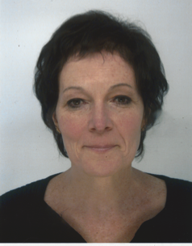
Biography

Valérie Keller is a senior scientist at ICPEES in Strasbourg. She received her Ph.D. degree in Chemistry and Catalysis from the University Louis Pasteur of Strasbourg in 1993. In 1996 she returned to Strasbourg and was appointed as researcher in CNRS, where she is now responsible of the Team “Photocatalysis and Photoconversion”. Her main research activities concern photocatalysis for environmental, energy and health applications, and the synthesis and characterization of nanomaterials for photoconversion purposes. She is the author of over 100 publications in peer-reviewed journals and more than 85 oral communications in international conferences and symposium. She is also the author of 15 patents. In 2013 she was awarded the 1st Price of the Strategic Reflection (awarded by the French prime Minister).
Email: vkeller@unistra.fr

