The study of point defect properties of Fe-Cr alloys: First-principles calculations.
Marcin R. Zemlaª, Jan S. Wrobel PhDª, Tomasz Wejrzanowsk PhDiª, Duc Nguyen-Manh PhD^{b}, Sergei L. Dudarev Prof^{b}
a Warsaw University of Technology
b CCFE, Culham Science Centre

Abstract
Ferritic Fe-Cr steels are proposed as structural materials in fusion and fission nuclear power plants. To understand radiation damage effects in Fe-Cr alloys, it is necessary to investigate point defect properties, which are dependent on the concentration of Cr, the short-range ordering of alloy and the local environment of a defect. This kind of information, on the atomic level, can be derived from ab initio simulations. Spin-polarized density functional theory calculations are performed by using VASP code, with generalized gradient approximation (GGA) of Perdew-Burke-Ernzerhof (PBE) for exchange-correlation. Representative structures are generated using DFT-based Monte Carlo simulations [1]. The chemical potentials, formation energies and relaxation volumes of defects as well as changes of magnetic moments caused by the presence of point defects are studied as functions of the local environment, the short-range ordering and the concentration of Cr in Fe-Cr alloys.

Image
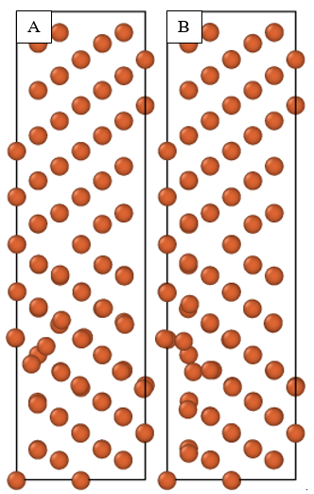

Figure 1. Σ3 GB with SIA Dumbbell on A – [100]; B – [110] direction.

Recent Publications
- J. S. Wróbel, D. Nguyen-Manh, M. Yu. Lavrentiev, M. Muzyk, S. L. Dudarev, Phase stability of ternary fcc and bcc Fe-Cr-Ni alloys. Physical Review B 91 (024108) 2015.
- D. Nguyen-Manh, Pui-Wai Ma, M. Yu. Lavrentiev, S. L. Dudarev, Constrained non-collinear magnetism in disordered Fe and Fe-Cr alloys. Annals of Nuclear Energy 77 (2015) 246.
- M. R. Zemła, J. S. Wróbel, T. Wejrzanowski, D. Nguyen-Manh, K. J. Kurzydłowski, The helium effect at grain boundaries in Fe-Cr alloys: A first-principles study. Nuclear Instruments and Methods in Physics Research Section B Beam Interactions with Materials and Atoms 393:118 (2017).
- J. S. Wróbel, D. Nguyen-Manh, S. L. Dudarev, K. J. Kurzydłowski, Pint defect properties of ternary fcc Fe-Cr-Ni alloys. Nuclear Instruments and Methods in Physics Research Section B Beam Interactions with Materials and Atoms 393:126 (2017).
- M. Yu. Lavrentiev J. S. Wróbel, D. Nguyen-Manh, S. L. Dudarev, M. H. Ganchenkova. Magnetic Cluster Expansion model for random and ordered magnetic face-centered cubic Fe-Ni-Cr alloys. Journal of Applied Physics 120(4) (2015).


Biography
Marcin Zemla is a PhD student in Warsaw University of Technology and also MSc student in University of Warsaw. He has his expertise in first-principles calculations based on Density Functional Theory (DFT). He is mainly interested in defects interactions in Fe-Cr alloys, especially grain boundaries interactions. In his research he is using DFT implemented into VASP code. Currently he is studying Fe-Cr point defects into both bulk and grain boundary structures. Nevertheless, he works on it and develops a methodology also in another project, in which he recently published a paper DOI: 10.1039/C7CP03109B.
Email: marcin.zemla@wimpw.edu.pl

Notes/Comments:

