Modeling of nanoparticle surface charge for targeting glioblastoma

Ana Miranda^{1,2}, Tânia Cova^{3*}, Maria Mendes^{1,2}, João Sousa^{1,2}, Carla Vitorino^{1,2}, Alberto Pais³
¹Faculty of Pharmacy, University of Coimbra, Portugal
²Pharmacometrics Group of the Centre for Neurosciences and Cell Biology (CNC), University of Coimbra, Portugal
³Coimbra Chemistry Center, Department of Chemistry, University of Coimbra, Portugal
*tfirmino@qui.uc.pt

Glioblastoma multiforme (GBM) is an aggressive brain tumor with poor prognosis, mainly because standard treatment is not always effective enough in reaching tumor cells. Blood-brain barrier (BBB) is pointed out as one of great challenges in this field. [1] Considering the negative charge of BBB surface and its restricted permeability to small compounds, positively-charged nanoparticles have been developed to facilitate the transport of drugs through the BBB. [2]
This work aimed at studying the interaction of different cationic surfactants used in lipid nanoparticle (LN) formulations with BBB, using atomistic simulations. Surfactants incorporating natural structural motifs, specifically serine, were chosen instead of the conventional synthetic surfactants, due to the lower cytotoxicity and higher biodegradability, thus being environmentally friendly.[2] Molecular dynamics simulations were performed on 4 systems containing different serine-based surfactants, two of them monomeric (16SerTFA and 12SerTFA) and the other two dimeric ((12ser)₂CON12 and (12ser)₂N5), in a fully hydrated palmitoyloleoylphosphatidylcholine (POPC) lipid model, intended to mimic cell membranes of both the BBB and tumor.
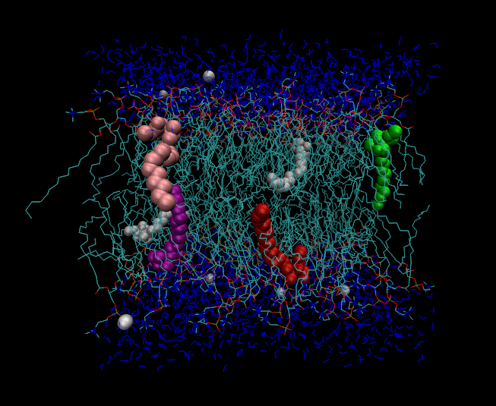
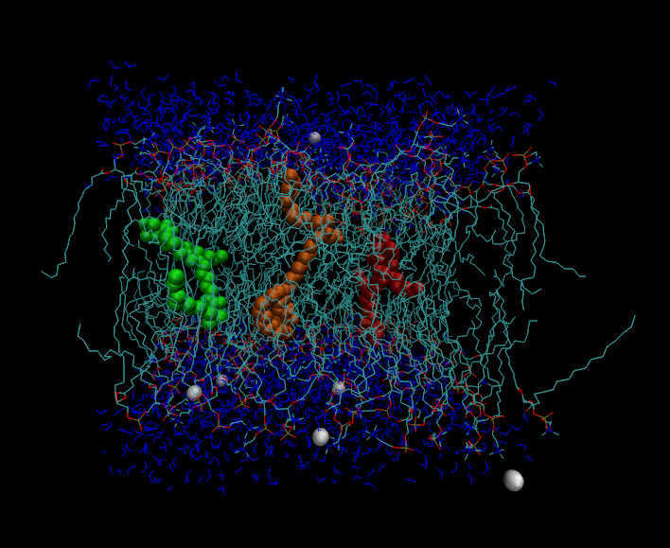
The systems were evaluated in terms of effects induced by the surfactants in this type of membranes and rationalize the interactions at molecular level. The results showed an integration of all surfactants into the POPC membrane. Longer chain length surfactants tended to induce the highest membrane stabilization, as evidenced by 16serTFA. Conversely, the dimeric (12ser)₂CON12 led to the greater disturbance in the membrane structure, probably due to bridging phenomena. This may antecipate a better BBB cross ability of LN containing (12ser)₂CON12. Overall, this computational study suggests the viability of cationic serine-based surfactants as appealing compounds in LN formulations for targeted GBM therapy.

POPC/(12ser)₂CON12
POPC/16serTFA

Figure 1. Snapshots illustrating the positioning of serine-based surfactants embedded in the lipid membrane.

Acknowledgements: This work was supported by Fundação para a Ciência e a Tecnologia (FCT), Portuguese Agency for Scientific Research, through the Research Project n.º 016648 (Ref. PTDC/CTM-NAN/2658/2014), the project PEst-UID/NEU/04539/2013, and COMPETE (Ref. POCI-01-0145-FEDER-007440). T. Cova also acknowledges the PhD research Grant SFRH/BD/95459/2013.

Refereces:
[1] F. Pourgholi, M. Hajivalili, J.N. Farhad, H.S. Kafil, M. Yousefi, Nanoparticles: Novel vehicles in treatment of Glioblastoma, Biomedicine & pharmacotherapy = Biomedecine & pharmacotherapie, 77 (2016) 98-107.
[2] D.K.F. Santos, R.D. Rufino, J.M. Luna, V.A. Santos, L.A. Sarubbo, Biosurfactants: Multifunctional Biomolecules of the 21st Century, International journal of molecular sciences, 17 (2016) 401.

