Direct observation of full flux closure domains in strained ferroelectric thin films
Y. L. Zhu, Prof. Dr.,
Shenyang National Lab for Materials Science, Institute of Metal Research, Chinese Academy of Sciences, Shenyang, China

Abstract (300 word limit)
Atomic-scale information is of critical importance for understanding intrinsic characteristics of advanced functional materials such as ferroelectrics, magnets, superconductors and catalysts. For example, it is often the small deviations from symmetry in atom positions and the resultant strains that allow ferroelectric oxides, used in computer memory chips, to store charge/information or to resonate with magnets as composite multiferroics. Ferroelectric crystals feature asymmetric or polar structures that are switchable under an external field, holding promise for random access memories, thin-film capacitors and actuators. Nanoscale ferroelectrics are expected to exhibit various exotic domain configurations, such as the full flux-closure pattern well-known in ferromagnetic materials. Here we observe not only the atomic morphology of the flux-closure quadrant but also a periodic array of flux-closures in ferroelectric PbTiO₃ films, mediated by tensile strain on a GdScO₃ substrate. Using aberration-corrected scanning transmission electron microscopy, we directly visualize an alternating array of clockwise and counter-clockwise flux-closures, whose periodicity depends on the PbTiO₃ film thickness. In the vicinity of the core, the strain is sufficient to rupture the lattice, with strain gradients up to 10⁹/m. Engineering strain at the nanoscale may facilitate the development of nanoscale ferroelectric devices.

Image

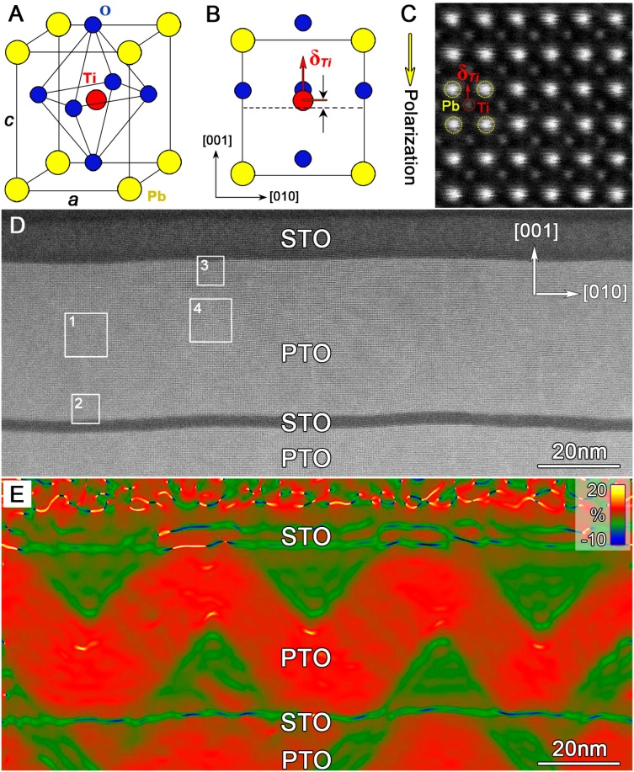

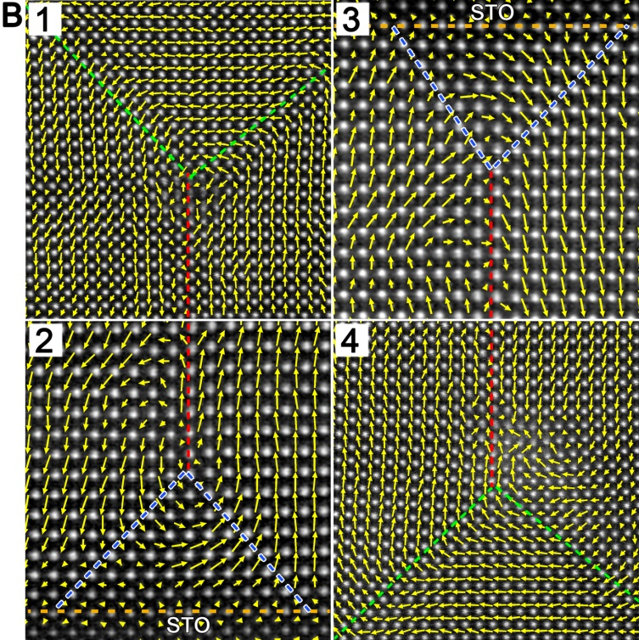

Recent Publications (minimum 5)
- Liu Y, Zhu Y.L.*, Tang Y.L, Wang Y.J, Jiang Y.X., Xu Y.B, Zhang B., and Ma X.L.*, (2017): Local enhancement of polarization at PbTiO₃/BiFeO₃ interfaces mediated by charge transfer. Nano Letters, DOI: 10.1021/acs.nanolett.7b00788.
- Li S, Zhu Y.L.*, Tang Y.L., Liu Y., Zhang S.R., Wang Y.J., and Ma X.L., (2017): Thickness dependent a₁/a₂ domain evolution in ferroelectric PbTiO₃ films. Acta Mater, 131, 123-130.
- Wang W.Y., Zhu Y.L.*, Tang Y.L., Xu Y.B., Liu Y., Li.S., Zhang S.R., Wang Y.J., and Ma X.L., (2016): Large scale arrays of four-state vortex domains in BiFeO₃ thin film. Appl. Phys. Lett. 2016 (109): 202904
- Liu Y., Tang Y.L., Zhu Y.L., Wang W.Y., and X.-L. Ma*. Spatial Coupling of Ferroelectric Domain Walls and Crystallographic Defects in the PbTiO₃ Films. Adv. Mater. Interfaces. 2016 (3): 1600342.
- Tang† Y. L., Zhu Y. L.†,. Ma X. L *, Borisevich A. Y., Morozovska A. N., Eliseev E. A., Wang W. Y., Wang Y. J., Xu Y. B., Zhang Z. D., and Pennycook S. J. (2015) : Observation of a periodic array of flux-closure quadrants in strain ferroelectric PbTiO₃ films. Science, 348，547-551.
- Wang W. Y.†, Tang Y. L.†, Zhu Y. L.*, Xu Y. B., Liu Y., Wang Y. J., Jagadeesh S., and Ma X. L.* , (2015): Atomic level one-dimensional structural modulations at the negatively charged domain walls in BiFeO₃ films. Advanced Materials Interfaces. DOI: 10.1002/admi.201500024

Biography (150 word limit)
Dr. Yinlian Zhu has interests in Transmission electron microscopy. Her research focuses on the microstructure and microanalysis of low-dimensional functional oxides, and the relationships with the properties. She has expertise in Growth of perovskite-based oxide heterointerfaces by PLD technique.
She has about 100 papers published in distinguished international journals such as Science, Nature Communications, Nano Letters, Acta Materialia, Appl. Phys. Lett., J. Mater. Res., and Phil. Mag. (Lett). etc.

Email: ylzhu@imr.ac.cn

Notes/Comments:

