Permanent Magnets in Energy Applications for the Clean Environment
Marko Soderžnik, Kristina Žagar, Spomenka Kobe, Jožef Stefan Institute, SI-1000 Ljubljana

Abstract
Rare-Earth Transition Metals permanent magnets are vital components in the rapidly-developing renewable energy sector, where the motors for electric vehicles and the generators in wind turbines require strong magnets with the ability to operate at temperatures well over 100°C. To achieve high coercivity, remanence and consequently high-energy product at elevated temperatures the addition of heavy rare earth (HRE) to the basic Nd-Fe-B composition is needed. On the list of Critical Raw Materials published by the EC in 2014, HRE is on the very top of it. To drastically reduce the use of HRE we focused on developing a new method, which should enable us to achieve the properties needed for high-temperature application with the lowest amount of scarce elements.
The significant progress was attained by using electrophoretic deposition as a method for accurately positioning the HRE on the surface of a sintered Nd-Fe-B magnet before its diffusion into the microstructure. After the additional annealing, this process locally increased the coercivity of final magnet, thereby substantially reducing the dependence on the HREs, Dy, and Tb¹⁻³. By our new inventive technique further transferred to a pilot production, we could minimize the amount of HRE used, down to 0.2 at %, the improvement of coercivity was 30 % with minimal loss in remanence. The total saving of the HRE is 16-times less need for the same performance, which is a significant contribution to the world economy and clean environment.
In studying the mechanism for such an improvement in coercivity without significantly decreasing the remanence, a detailed microstructure investigation was performed by using high-resolution transmission microscopy and analysis at the nano level (Fig. 1).
Besides the use of these new developed high energy magnets for electric and hybrid cars and the wind turbine generators the important application is also as the source of the magnetic field in the development of the new magnetic cooling devices.

Image

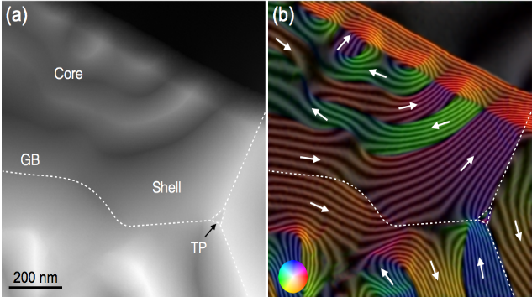

Recent Publications
Fig. 1. Electron Holography of the core/shell region. (a) Total phase image with marked location of the grain boundaries (GB) and the triple pocket (TP). (b) Reconstructed phase showing the magnetic flux distribution and color maps. The contour spacing is π/2.

- P.J. McGuiness, M. Soderžnik, S. Šturm, K. Žagar, S. Kobe et al. Replacement and Original Magnet Engineering Options (ROMEOs) : a European seventh framework project to develop advanced permanent magnets without, or with reduced use of, critical raw materials. JOM, ISSN 1047-4838, 2015, vol. 67, issue 6, pp. 1306-1317.
- M. Soderžnik, M. Korent, K. Žagar, M. Katter, KATTER, Ü, Kaan, S. Kobe, High-coercivity Nd-Fe-B magnets obtained with the electrophoretic deposition of submicron TbF3 followed by the grain-boundary diffusion process. Acta materialia, ISSN 1359-6454. [Print ed.], 2016, vol. 115, pp. 278-284.
- K. Žagar, A. Kocjan, S. Kobe, Magnetic and microstructural investigation of high-coercivity net-shape Nd-Fe-B-type magnets produced from spark-plasma-sintered melt-spun ribbons blended with DyF₃. Journal of Magnetism and Magnetic Materials, ISSN 0304-8853, 2016, vol. 403, pp. 90-96.
- L. Kelhar, J. Zavašnik, P.J.McGuiness, S. Kobe, The impact of processing parameters on the properties of Zn-bonded Nd-Fe-B magnet. Journal of Magnetism and Magnetic Materials, ISSN 0304-8853, 2016, vol. 419, pp. 171-175.
- P. Jenuš, M. Topole, P.J. McGuiness, S. Kobe, K. Žužek, et al. Ferrite-based exchange-coupled hard-soft magnets fabricated by spark plasma sintering. Journal of the American Ceramic Society, ISSN 0002-7820, 2016, vol. 99, iss. 6, pp.. 1927-1934.

 Biography
Prof. Spomenka Kobe is Scientific Advisor, Head of the Department for Nanostructured Materials and a Member of the Scientific Council at the Jožef Stefan Institute. She is a full professor at the International Postgraduate School “Jožef Stefan”. Prof. Kobe is the Leader of the National Research Programme “Nanostructured Materials”. She is the recipient of two State Awards for Scientific Research and two Innovation Awards from industry for the successful transfer of technology. Her scientific work is documented in more than 150 refereed publications, 7 chapters in a book and invited talks at international conferences. Her applied research achievements include 5 patents (2 EP), 3 innovations and 5 successful transfers of technology to the industrial production. Prof. Kobe is also the previous President of the Academic Society for Science and Engineering (SATENA) and an acting Vice-Chair for the European Commission. She supervised 15 doctoral students.
Email: spomenka.kobe@ijs.si

Notes/Comments:

