Low friction, wear resistant quasicrystalline coatings
Jean-Marie Dubois
Institut Jean Lamour (UMR 7198 CNRS – Université de Lorraine), Parc de Saurupt, CS50840, 54011 Nancy, France.
Department for Nanostructured Materials, Jozef Stefan Institute, Jamova Cesta 39, 1000 Ljubljana, Slovenia.

Abstract
Quasicrystals were discovered in 1982 by Shechtman,¹ Nobel Prize in Chemistry 2011, and have since been the focus of intense research regarding their atomic structure, their properties and potential usefulness.2 Among the few niches of application that were sorted out so far is the possibility to use them as a low friction counterpart in mechanical devices. Typical friction coefficients pointed out against hard steel is indeed about half that observed with conventional metallic metals or with hard steel sliding against itself. Wear during short pin-on-disk tests is also very much reduced. The intrinsic brittleness of quasicrystals is however very much detrimental to such an application, which therefore could not be implemented on realistic devices. We came however to a totally different issue in recent years when we could show3 that an appropriately prepared quasicrystalline coating can produce friction as low as 6% against hard steel and sintered tungsten carbide whereas wear is negligible for extremely long pin-on-disk tests (i.e. lasting for at least 5 km), see left hand side of the image.
The talk will summarize our findings in this area and show how low friction is related to the specific electronic structure of quasicrystals, which determines their surface energy⁴. An overview on other characteristic application niches of quasicrystals will be given.⁵

Recent Publications

- D. Shechtman et al., Phys. Rev. Lett. 53(20) (1984) 1951-1955.
- J.M. Dubois, Useful Quasicrystals, World Scientific, Singapore, 2005.
- B.A. Silva Guedes de Lima et al., STAM 17-1 (2016) 71-79.
- J.M. Dubois & E. Belin-Ferré, STAM 15 (2014) 034804 (20pp).
- J.M. Dubois, Chem. Soc. Rev. 41 (2012) 4760-4777.

Image
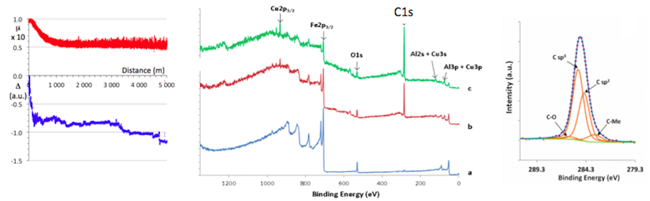
Left, red curve: pin-on-disk trace of a spherical hard steel ball sliding on a quasicrystalline coating produced by high-velocity oxygen-fuel spraying; blue curve: wear observed during the same test. Middle: XPS signals recorded on the Ar-sputtered surface of a specimen cut perpendicular to the plane of the coating, showing the presence of carbon in the bond coat underneath the coating and in the coating itself but not in the substrate; right: identification of sp2 and sp3 carbon as lubricating material.

 Biography
Jean-Marie Dubois is a director of research emeritus at CNRS, France and a part time scientific adviser at Jozef Stefan Institute in Ljubljana, Slovenia. He has dedicated a large fraction of his research efforts to promoting specific applications of quasicrystalline materials (tribology, adhesion, heat insulation) in parallel to his fundamental studies of the atomic structure, electronic structure and electron transport properties of this new type of aperiodic matter.
Email: jean-marie.dubois@ijs.si

Notes/Comments:

